AQA GCE A

COMPUTER SCIENCE PROJECT

H446-03

Name: Ali Rana

Candidate Number: <INSERT CANDIDATE NUMBER>

Institution Name: City of Wolverhampton College

Title of Project:

H446-03 – Project CONTENTS

Table of Contents

A. Analysis 3

B. Design 3

Systems diagram 3

C. Developing the coded solution (“The development story”) 3

D. Evaluation 3

Project Appendixes 4

# A. Analysis

## Description of the Problem:

### An Outline of the Project:

Project Investigation: The problem that I will be solving requires me to create an Autonomous Robotic car that can drive itself independently through a maze, where it will map all the possible routes to reach the exit and determine the quickest way. It will use sensors a camera to detect objects to manoeuvre around. I will also need to be able to add the necessary graph traversal algorithms and data structures to store the data inside, this will allow me to implement an A* search algorithm.

Purpose of solving the problem:

The purpose of solving this problem is to show to the user the quickest way to travel through the maze, so the user has a better understanding on how to get to the exit or destination. The algorithms would save the different routes and prints the optimal routes to take.

Stakeholders:

A stakeholder who would use the product I'm creating would be a person who would need a solution to how to travel from point A to point B. This can both be a normal person or an official government body or service. A normal person may use the product to simply find the best route to their destination; this may be to reduce the amount of times it would take them to travel to their destination or what would be the best route for their specific needs. This may be because they have specific needs or requirements like what type of terrain or type of road the car would have to travel along. Another need a normal person may use the product for is to solve a maze that would be beyond a humans’ capability to solve effectively. My product would be able to meet their needs because the product would record and store all the possible routes and find the quickest way to the destination. A government service may use my product in scenarios where a human may not be able to operate properly without being in some form of danger. An example would be in the Fire-Fighting or a retrieval service in an obscure part of the world like Antartica. The product would have to be autonomous as having a human operate it during very harsh or dangerous conditions would be impractical. This would require the product to be robust and durable but also independent enough so that it would be able to avoid any object that may damage it or ham the end user. In my project, I will use my computing teacher and my fellow peers to be able to model a normal person’s interaction with the product, I am using them because I would be able to interact with them on a regular basis, so I can make an informed decision based on their opinion of the product during its development and make any necessary improvements to better the performance of the Car. Also, many people would want to invest in a product that not only is capable of finding a destination independently but also one that can be easily controlled from a wireless device. Many motor companies are interested with an Autonomous car similar to what I'm doing for my project but on a more complex level, however they would still be interested on how other Autonomous Cars operate.

# Computational solutions to the problem

How is it solvable/computational?

The problem is suited to a computer program because the different routes of the maze can be portrayed as a graph/tree. By doing it like this I will be able to utilise Tree Traversal Algorithms as I would use an A* or Breath First Algorithm. The inputs into the program can easily be converted into a graph or tree as the distances the ultrasonic detector is detecting can represent the weighting on the graph or the possible paths decisions on a tree. These weighting would then be able to be used in an A* algorithm.

The data being used can be stored in data structures as it would be an easy way to store and use. The data being held here would be the directions and distances in which the autonomous car can or have travelled. As I have already said, the transition between raw data to a data structure and then that data structure being used is simple as the information is easy to translate. The directions being taken by the robotic car is determined by the collision detection algorithm, depending on what the distance detector has detected then it either will continue forwards or will try to go around. The directions could be held in a stack, so that the directions can be shown to the user or so that the programs can use it to retrace itself and find the quickest route back. The collision detection algorithm will implement the movement, distance detection and the servo systems to accurately control the robotic car. I will also be implementing an algorithm that will allow it to follow a Line drawn at the base of the maze, this will help the robotic car to move in a straight line when traversing the maze. I will have to program the robotic car using object-oriented programming as it will allow me to operate multiple sub programs and algorithms concurrently, which would improve the robot performance as it has more data to operate from. This is because the amount of calculations needed at the same time is beyond a human's capabilities which requires the use of computers, by using these different pieces of hardware and software it will allow the robotic car to solve the maze autonomously while avoiding any potential collisions with objects.

Thinking abstractly & visualisation:

To make this project feasible I will have to abstract the information that is relevant to the robotic car to the most basic fundamentals. This will be the directions and distances the robot will take, by only using this I will reduce the number of calculations needed to operate the car but still also provide enough data for the car to work correctly. I won’t need any other types of data as they won’t have an impact on the various algorithms, I will be using to control the car. This is because most of my programs use the distance measured from the distance detector to control the variables, i.e. the collision detections algorithm will either move forwards if there is nothing in its way or if there is an object in its way then it will reverse and then try to go around the object. If the user is operating the robotic car wirelessly then it will use pre-programmed commands to move and navigate through the terrain. These pre-programmed commands are the same ones that will be used by the different programs to operate the car reducing the amount of code needed.

This will allow me to simplify the routes available as I can store the information in a data structure, this will reduce the number of excess variables being used. By storing the data together in a data structure, it will allow me to access it quickly and effectively as the distance and the direction taken is stored in a way to link the two numbers together. By having these two values linked to each other, the program will know whether the data that would’ve had to be combined is correct i.e. the program has taken the right value for the distance for a certain direction. Apart from the distance and direction being recorded, the program will also check whether the car has followed the line, to remove unnecessary data it will only check whether it is on or off the line.

All other details will be ignored or omitted as they would use extra resources and have no real impact to the outcome of the program, therefore I am keeping it very simple by only keeping the distance and direction. This should hopefully simplify the programming and calculations needed.

Thinking ahead inputs and data:

There is a lot of input data for the car to process to be able to determine which direction to take. The input data for the car would be:

* Distance from car
* Routes taken (Left/Right)
* Distance Travelled
* User Controls
* Collision Detection
* Line Detection
* Light Detection

All these inputs need to be analysed at a regular interval as a single input can change the output, also many of these inputs need to be checked simultaneously as one may influence the other. Such as how the Line Detector and Light Detector affect each other as one may detect an object whereas the other may not because they are only detecting a single variable. Other inputs are used to just update current information so that the car would have all the data it needs to be able to make an informed decision. In addition, I would have to separate the inputs for when the car is acting autonomously and when the user is controlling the car, as the user may require a different set of instructions and programs to be able to have full control.

Thinking Logically:

In order to solve this problem, I will need to be able to apply a logical and methodical approach. I will need to use decomposition and abstraction to understand how I will solve the problems effectively. I will be using pre-constructed algorithmic structures along with my own to solve the various problems. The main few algorithms which may be of use are Breadth-First, A* and Depth-First algorithms. These algorithms are useful for me to solve a maze as it simplifies the graphs being used to represent the directions and distances recorded. Junctions in a maze where there is a choice of possible routes can be represented as nodes on a graph. With graphs there are obvious branching and repetition needed so I will have to include this in the algorithms to solve it. I am aware that the depth-first algorithm can also use recursion to search through the graph. Depth-First also uses a stack, which is implemented automatically during the execution of a recursive routine to hold variables, parameters and return addresses each time a subroutine is called. Alternatively, the non-recursive routine can also be written to implement a stack. This is useful as it stores the data in a data structure, simplifying what is needed to be done. Dead ends can also be represented on the graph so that the robotic car can recognise that route as one. The graph traversal algorithms need to be able to be compatible with the other algorithms so that it can solve the other problems together in one structured program in OOP. These other algorithms utilise iteration and loops to collect data from the sensors and detectors, meaning that I will have to program the graph traversal algorithm to include the variables and routines from the collision detection and line follower routines. The movement should also be done like this as many routines will call it, meaning it must be accessible to all of them for it to be useful. The individual movement, left, right, forward and back should be represented by a variable that can be changed depending on what movement is needed and if that movement needs to be adjusted accordingly.

The robotic car also needs to be able to override certain decisions or inputs, if the user commands the car to do something that it cannot or should not do then it needs to be able to stop. An example of this is if the user commands the robotic car to go forwards when the collision detection has decided that it is necessary to stop. The Raspberry Pi must be able to override some bits of data or decisions for the best outcome and performance of the car as it needs to be able to determine which to ignore or omit. I will decide on which to do closer to the completion of the project but giving the collision detection algorithm priority over the user may be the better choice long term. The collision detection algorithm could still be wrong by not detecting an object in its way which means that the user should be able to have some access to override the system. I will need to find a balance between the two solutions so that any potential errors from either the user or the algorithms is reduced.

Thinking concurrently:

During the operation of the car, there are a multitude of things that are required to run concurrently for the car to operate effectively. To accommodate for this, I will be writing my code in an Object-Oriented Programming structure, this will allow me to run all the necessary algorithms in a single program. Of the many programs that are running concurrently, the sensors are instrumental in the operation of the car as they control the decisions and outcomes. Therefore, the distances and directions will be checked at regular intervals so that the data collected is accurate and non-redundant. The sensors are needed to be run concurrently as they need to provide the data for the different algorithms that are being used, if they weren’t run concurrently then the car would not be able to operate as there is no data for the variable to use.

Movement of the car will be done by pre-programmed directions. I will need to program in a way so that depending on the collision detection and line follower algorithmics it will make the corresponding movement. This is another example of it running concurrently as it will have to calculate the variables but also be able to run the directional programs.

Also, there will be iterative and looping methods throughout the program which will run simultaneously. There will be many algorithms that utilise these methods which means various problems will be solved at the same time. This is to reduce running time and potential resources usage that could affect the performance of the Raspberry Pi and the robotic car as the amount of calculations needed is large. By using iterative methods to solve individual tasks by automation and decomposition it will ensure that the car will be able to reproduce the results required.

# Research:

There are many potential algorithms which can be used to find the solution to a complex maze and find the shortest path. In the A-Level specification you learn about the Depth-First and Breath-First algorithms. These are the typical algorithms used to solve this problem, there are also other algorithms like the A* and Dijkstra's Shortest Path. From these, I will then make my decision and then implement it into my program along with the Distance, Line and Collision Detection algorithms. While all of these algorithms could potentially be a good solution, I believe that the A* algorithm will be the best suited to the problem, however I will be able to make a better, more informed decision once I have researched these algorithms in greater detail.

Breath-First Algorithm:

The Breath-First algorithm is a method for traversing a graph that visits the nodes closest to the starting point. By starting from the Root node, it will explore all the neighbours of the current vertex whilst working down the graph. A queue is used to keep track of the nodes that have been visited.

Here is how you trace through the algorithm:

* The node that will be visited first will be appended to the empty queue, in this case it will append A

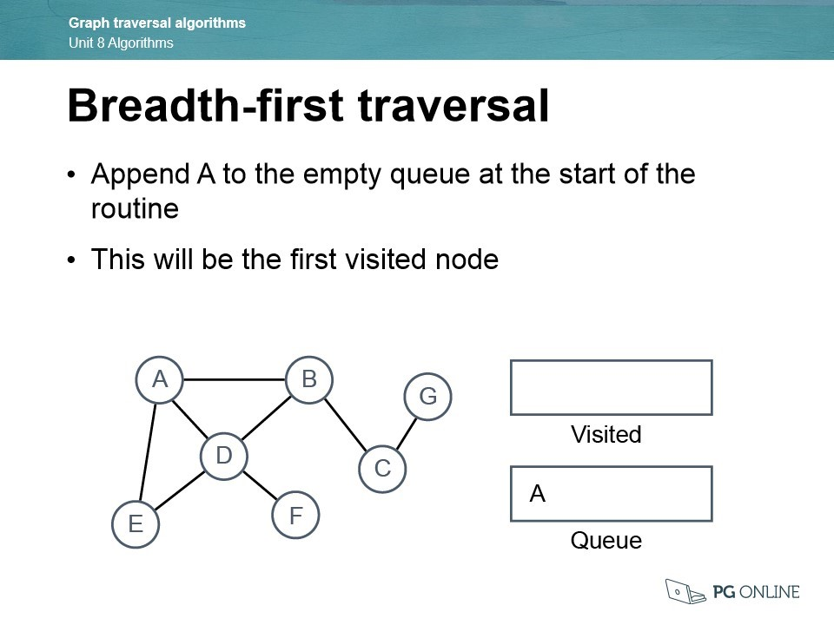

* Dequeue A and append it to the Visited list

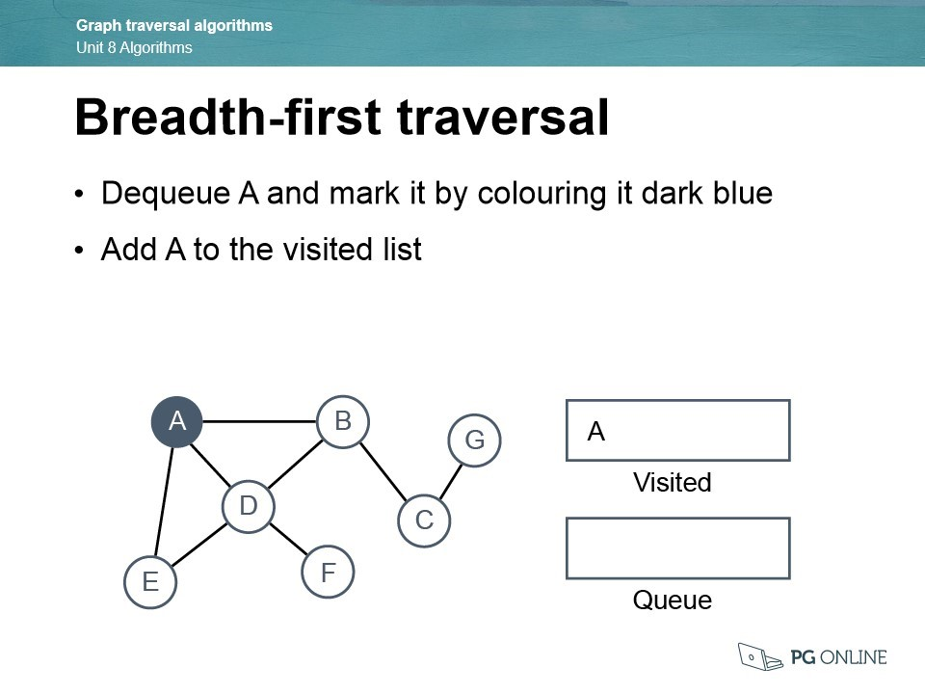

* It will then Queue each of A’s adjacent nodes, in this case it will be B, D and E in order

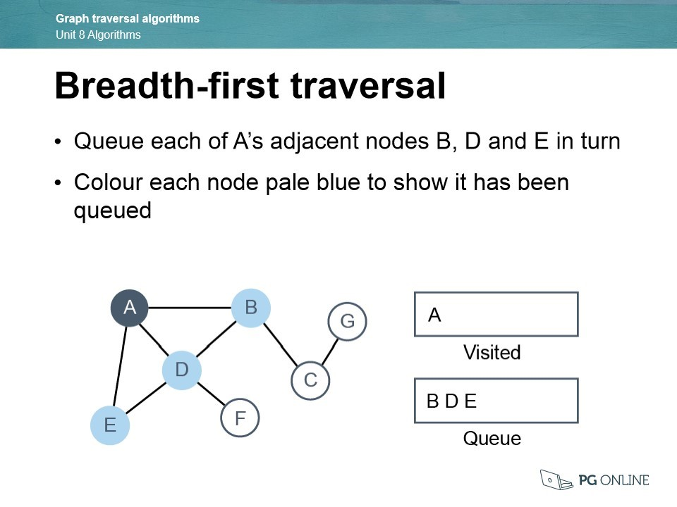

* You have finished with node A, so you can now dequeue the first item in the queue, which will be B.

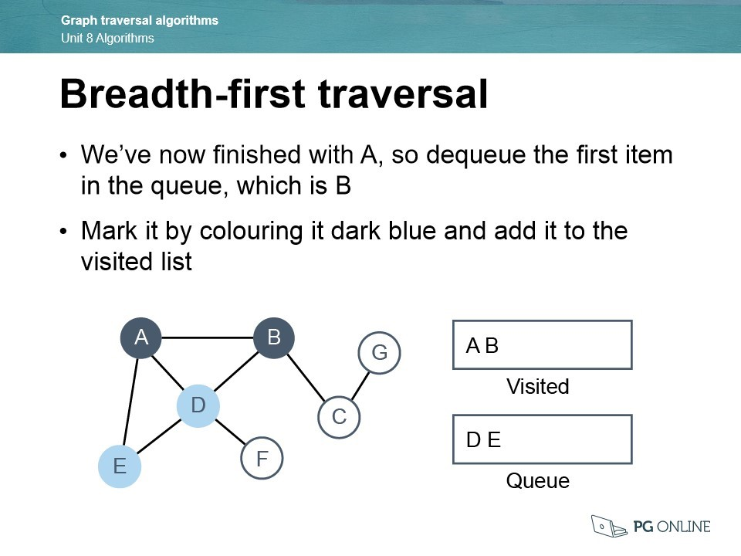

* Going to the next level, Queue B’s remaining neighbour is C

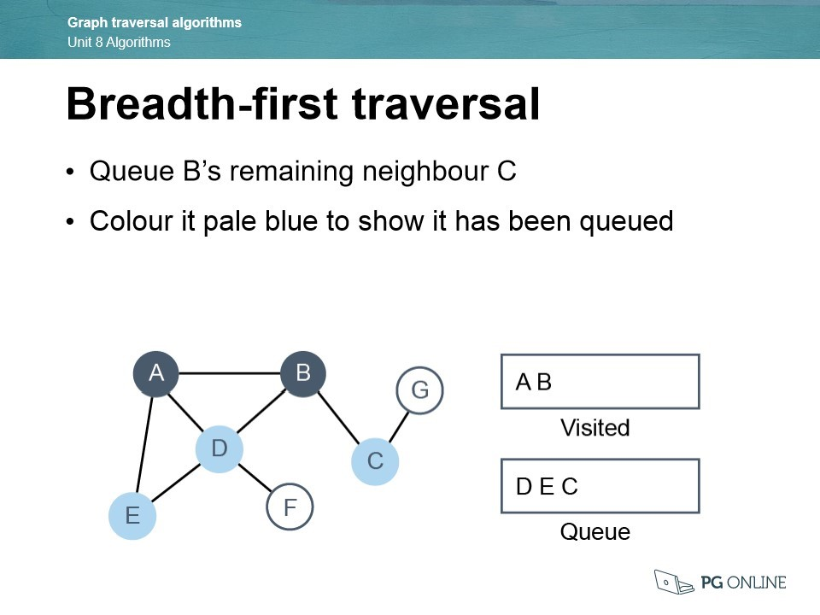

* All of B’s neighbours are visited, so dequeue the first item in the queue, this is going to be D

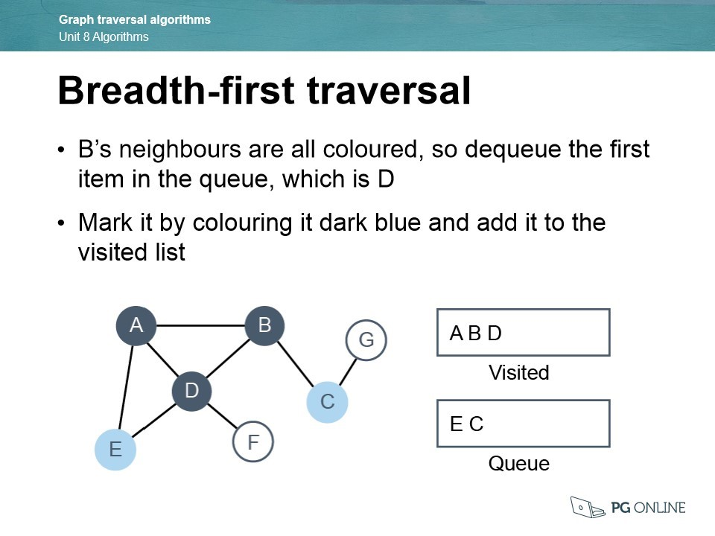

* Node E, which is adjacent to node D, has already been queued, so you add D’s other adjacent node which is F to the queue.

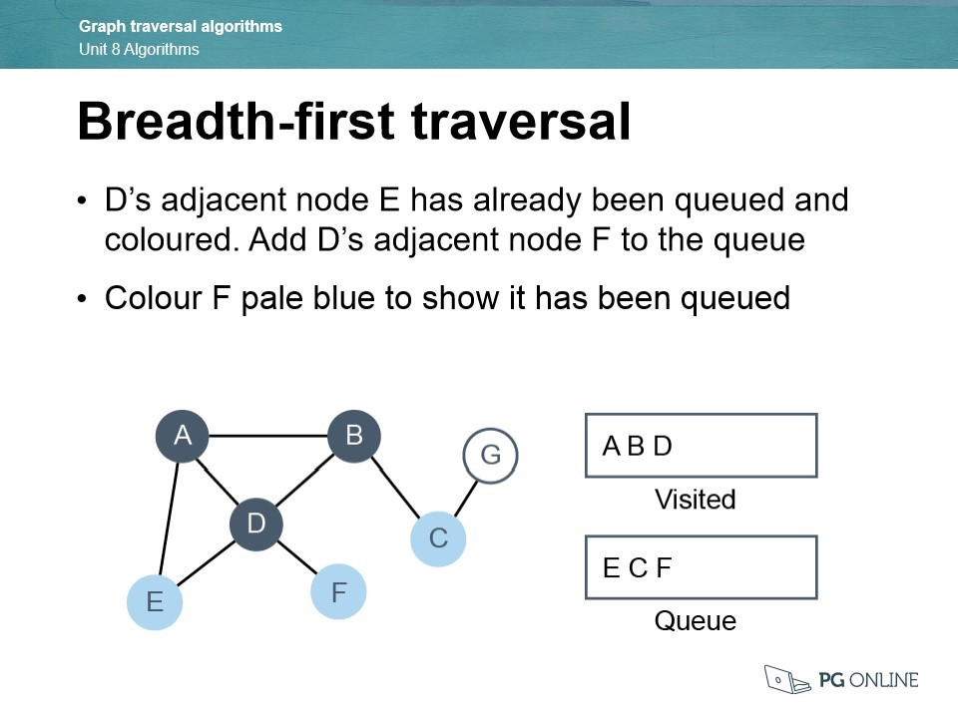

* You then dequeue the first item which is node E

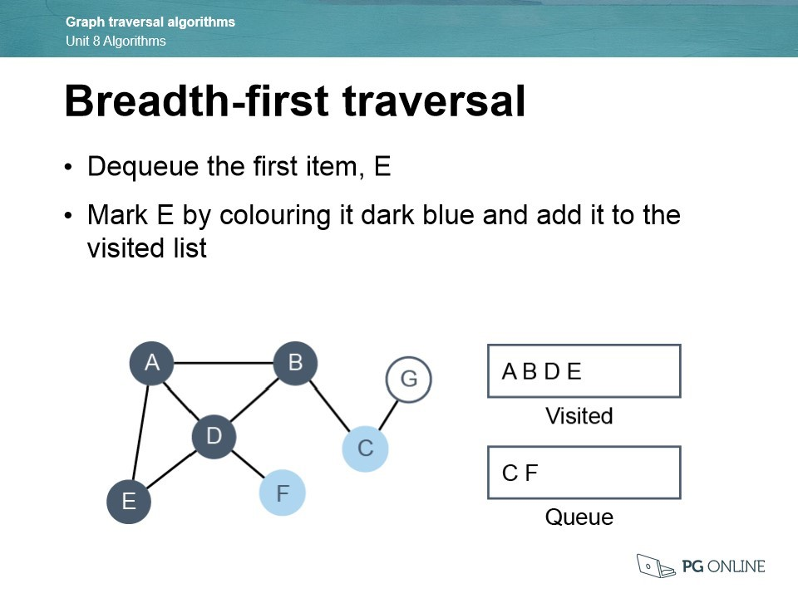

* Since all of E’s neighbours have been visited, you need to dequeue the next item which is node C

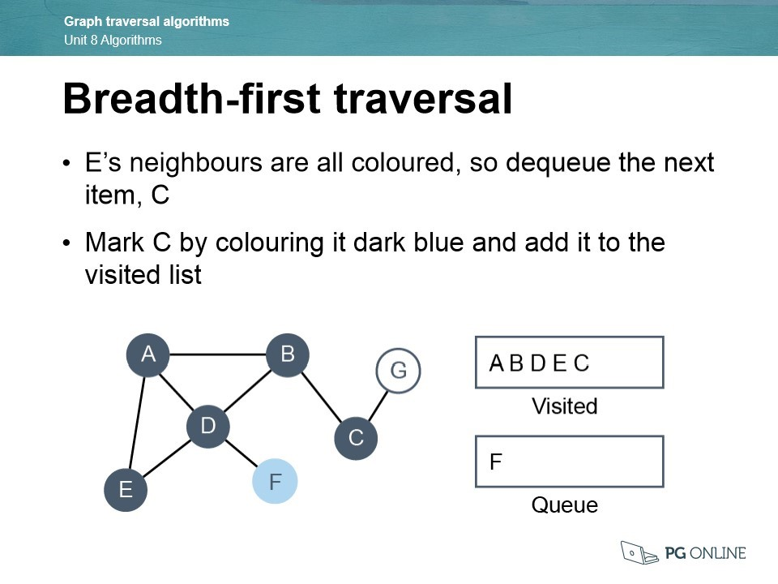

* C’s adjacent node is G, it adds this node to the queue

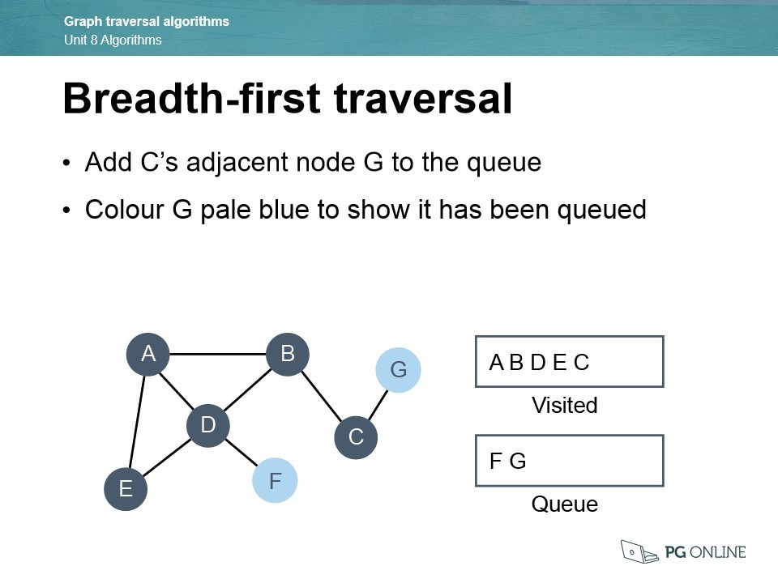

* Since all of C’s neighours have been checked, it will dequeue the node F. It will then add it to the visited list

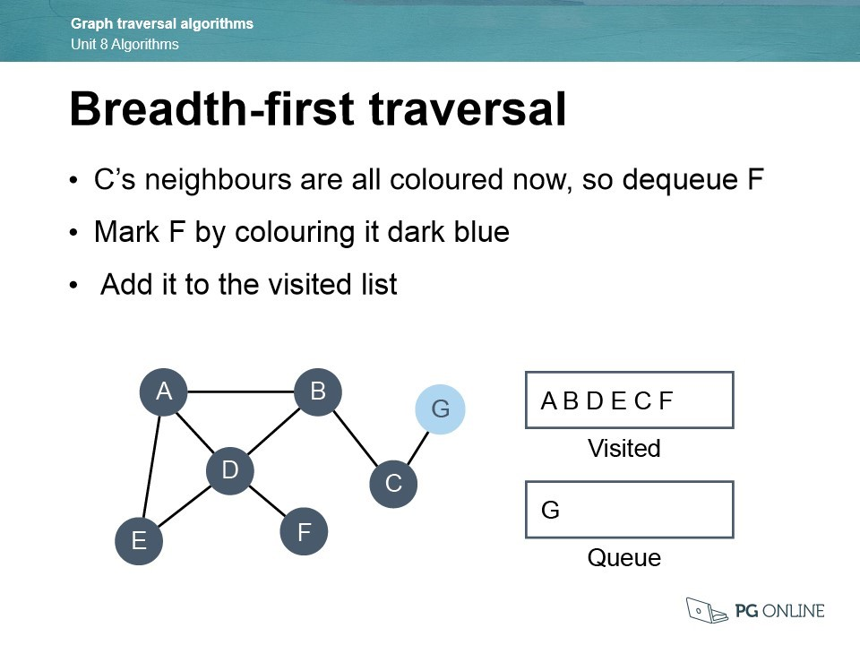

* Finally, it will dequeue G and add it to the visited list. The queue is now empty, and all the nodes have been visited.

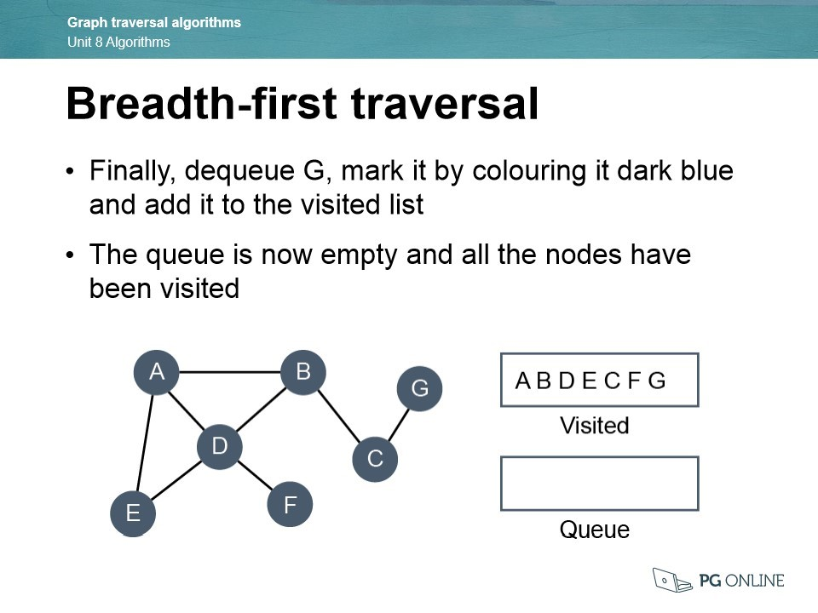

Depth-First Algorithm:

Depth-First is a method that explores as deep as possible into the graph before backtracking to visit unvisited nodes where it will explore all the neighbours of the current vertex from left to right. The Depth-First Algorithm is often implemented using a recursive algorithm.

Here is how you trace through the algorithm:

* You will have to create a dictionary data structure so that you can traverse the graph, the data structure will represent the nodes of the graph.

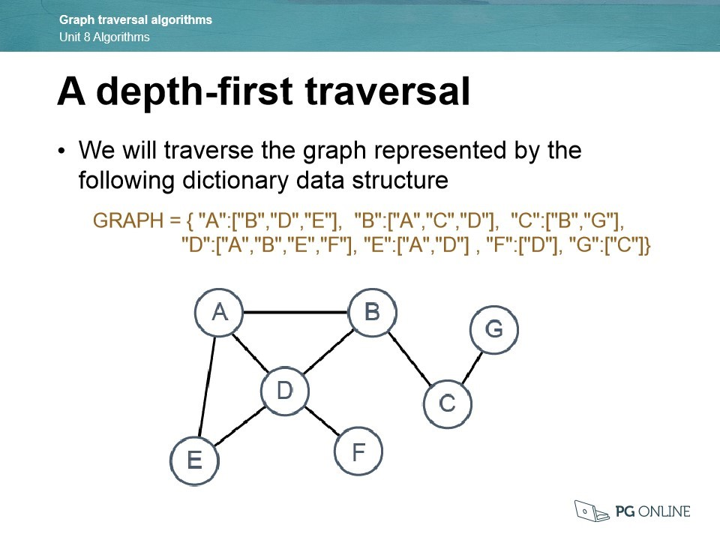

* The algorithm uses a stack to keep track of the latest node visited, this is implemented with a list to hold the names of the nodes that have been visited. Start with an empty list and stack so that you can append and add the nodes.

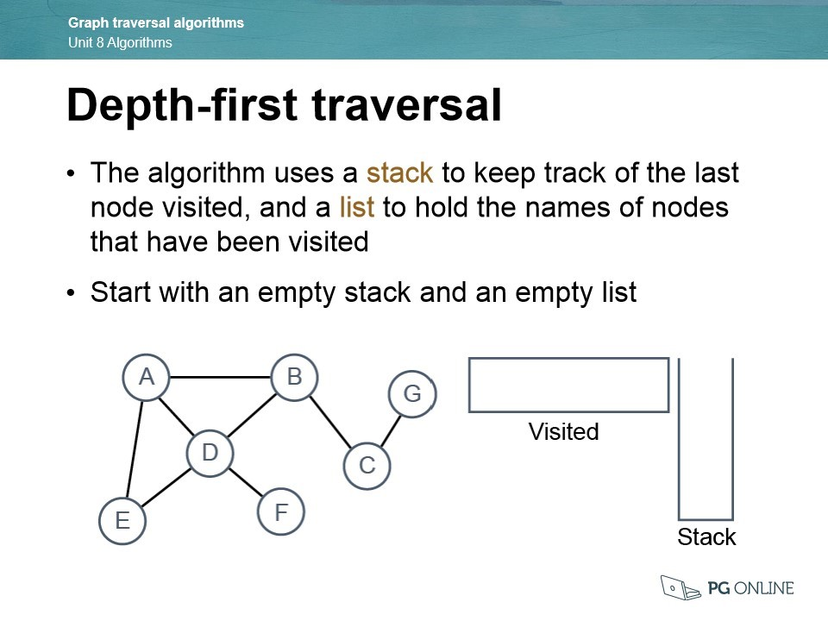

* The algorithm will visit A first and will add it to the visited list.

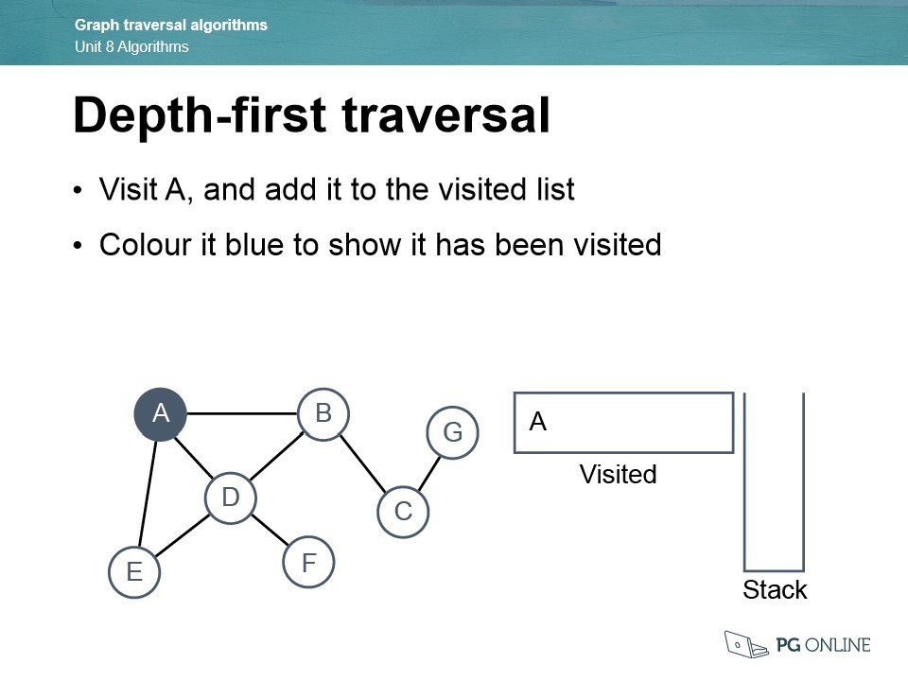

* It will then push A onto the Stack so that it can keep track of where we have come from. It will visit A’s first neighbour which is B. It will then add it to the visited list.

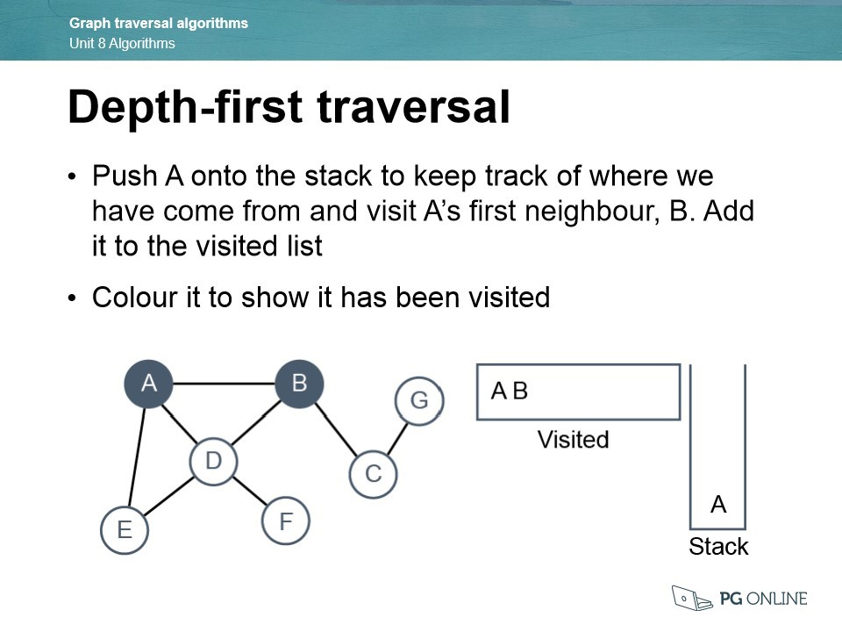

* After visiting B, push it onto the stack. From node B, visit the next unvisited node which is C. It will add node C to the visited list.

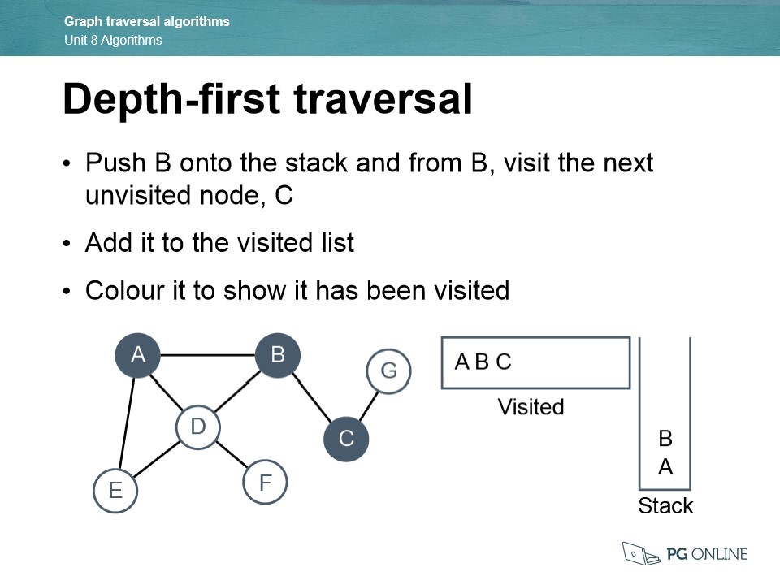

* Again, push node C onto the Stack. From node C visit the next unvisited node which is G. Add G to the visited list.

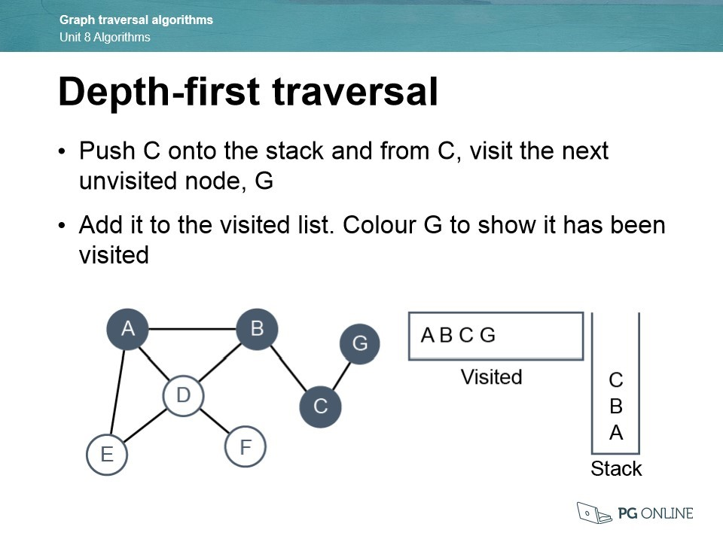

* At node G, there is no unvisited nodes so the program will have to backtrack. It will do this by popping the previous node C off the top of the stack and return it to node C
* 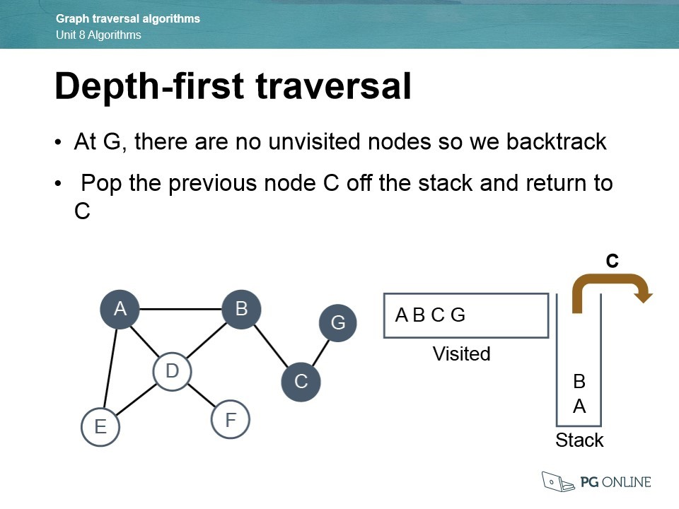From C, all the adjacent nodes have been visited, so you will need to backtrack again. Do this by popping B off the Stack and return to B.
* 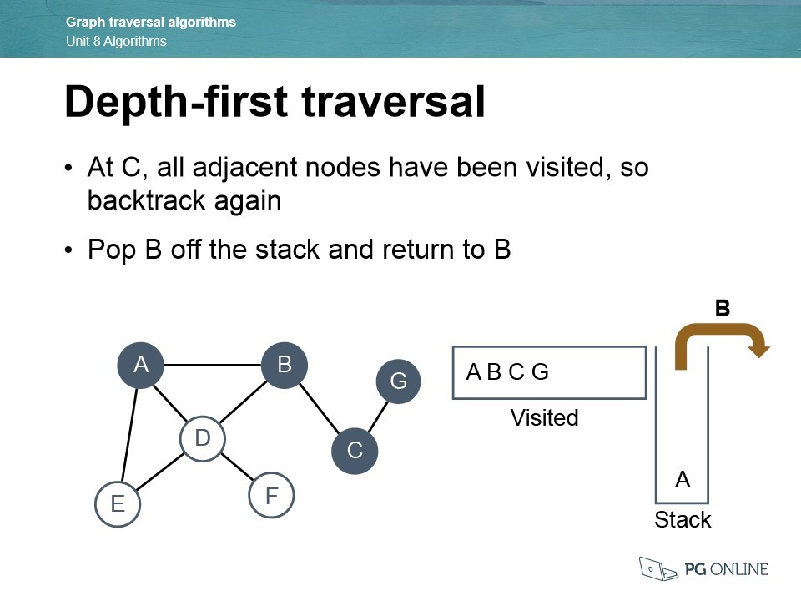Push B back onto the top of the Stack to keep track of where we have come from and visit D. You then add this to the visited list.

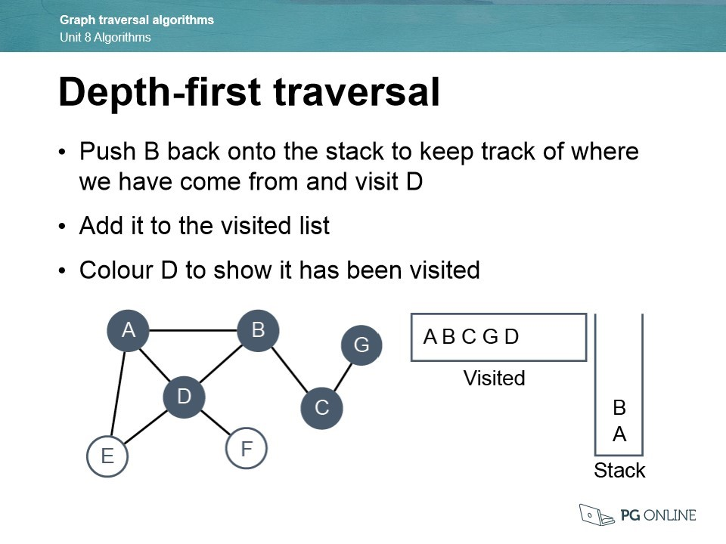

* Again, push D back onto the stack and then it will visit node E. Add E to the visited list.

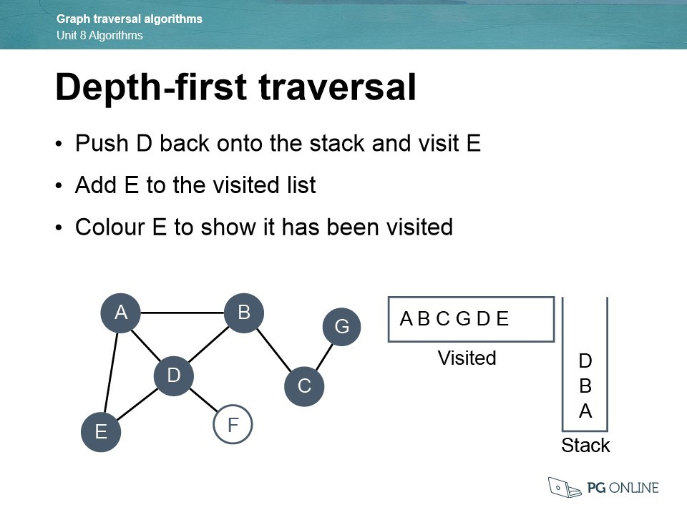

* From node E, the adjacent nodes have already been visited so it will pop D off the Stack and return to D.

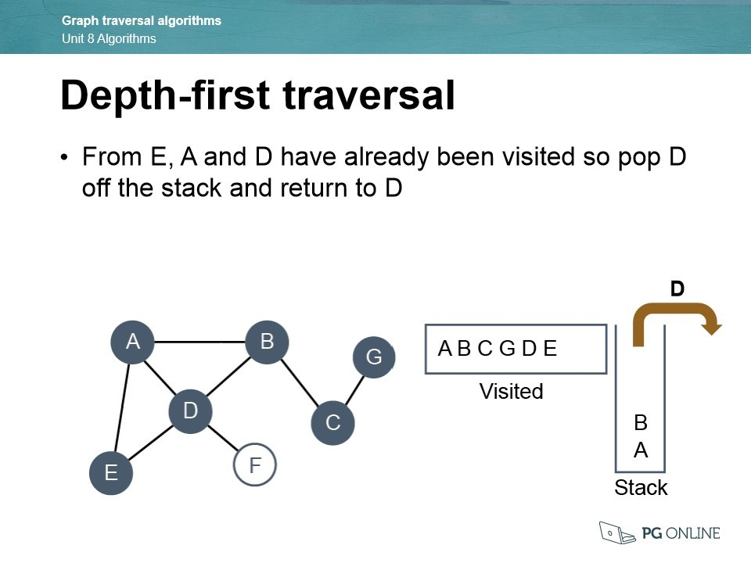

* It will need to push D onto the Stack where it will visit F. Add this to the visited list.

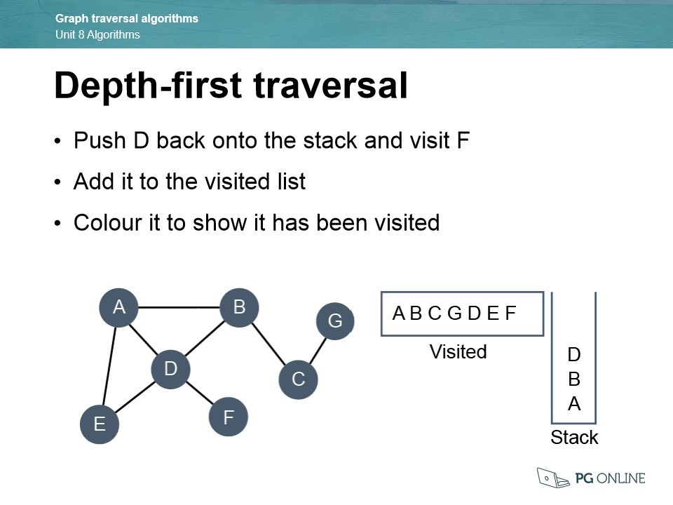

* From F, there are no unvisited nodes so it will pop D

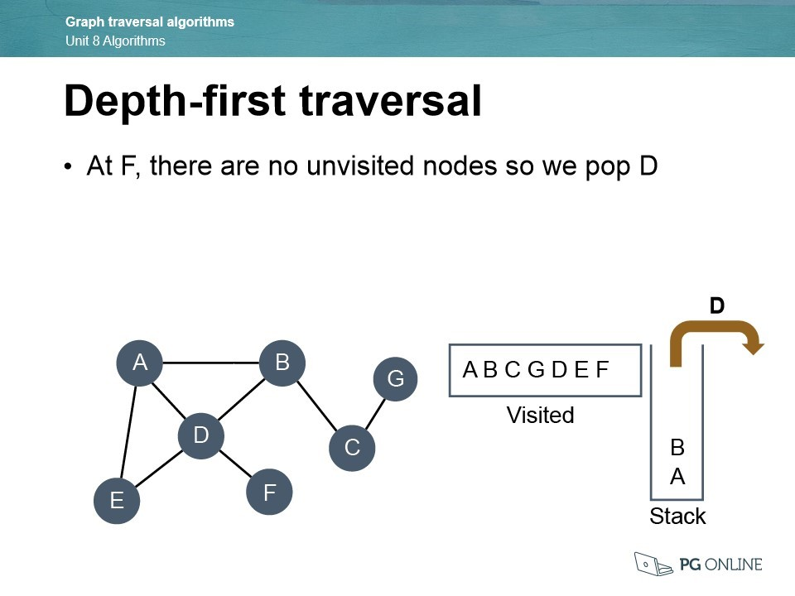

* Pop B from the Stack

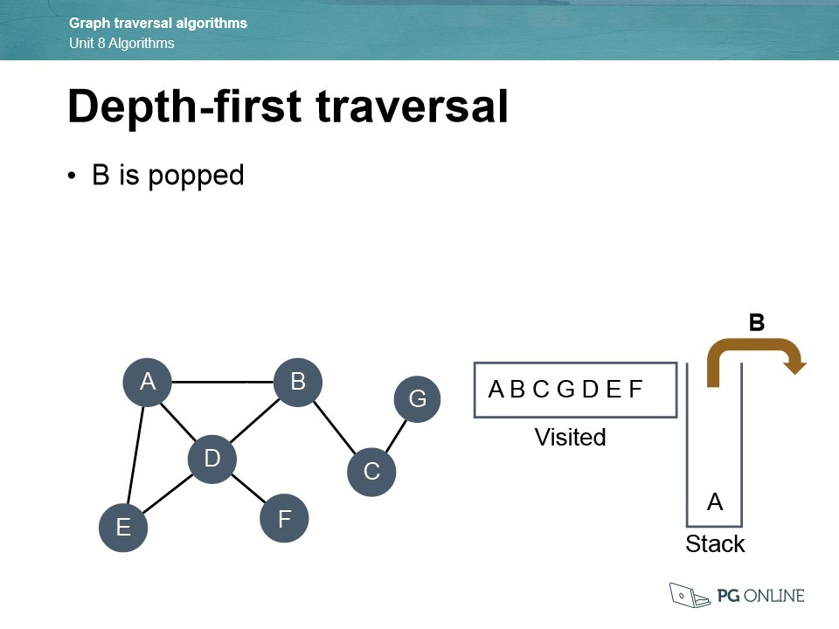

* Pop A from the Stack. The Stack is now empty which means that every node has been visited and the algorithm has been completed.

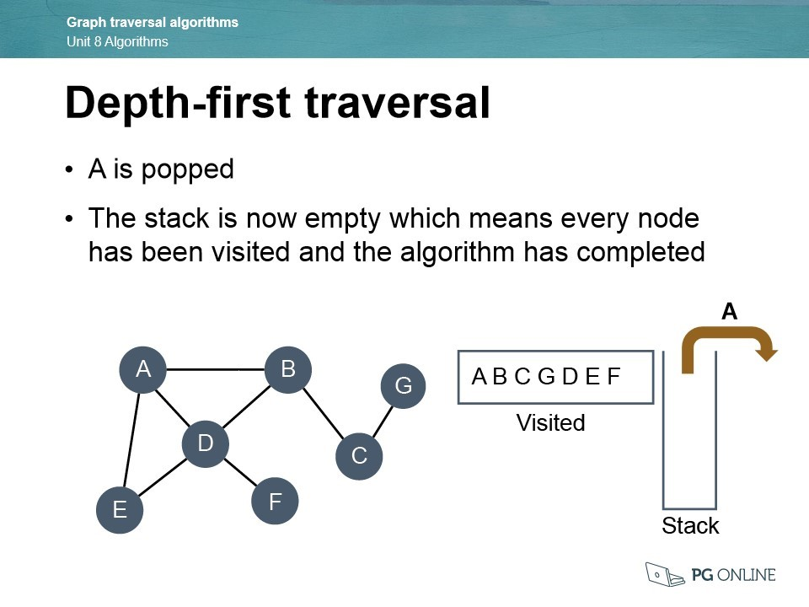

Pseudocode:

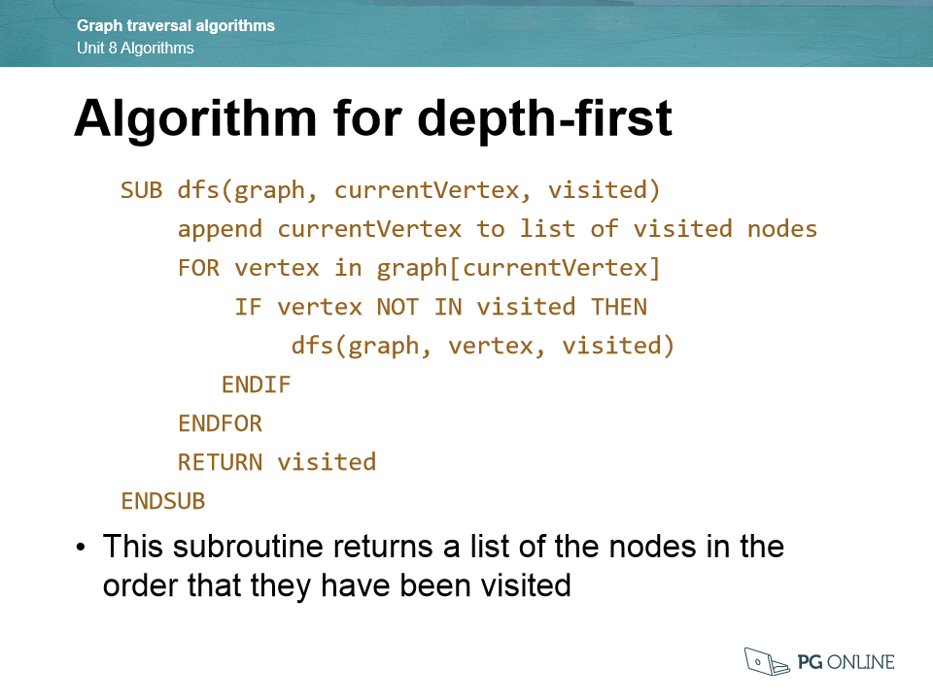

A* Algorithm:

<https://www.101computing.net/a-star-search-algorithm/>

The A* algorithm is a heuristic method that uses a weighted graph to make an informed search. It is similar to the Best-First Search algorithm. The algorithm starts from a specific starting node on the graph and aims to find the path to the end node whilst having the smallest cost, which in this case will be the shortest distance. It is able to do this by maintaining a tree of the possible paths originating at the start node and extending these paths one edge at a time until it terminates. The A* algorithm decides on the best path based on the cost of the path and an estimate of the cost required for the path to reach all the way to the goal.

Here is how you trace through the algorithm:

* This is how the graph is presented visually, each node shows what it is connected to and what the weighting of each path is, the numbers in orange are the straight-line heuristic values

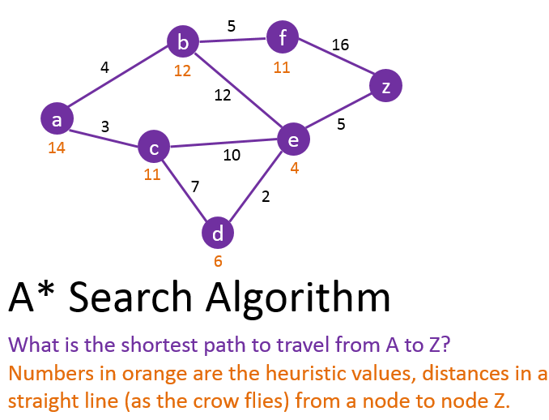

* Start by setting node A as the current node

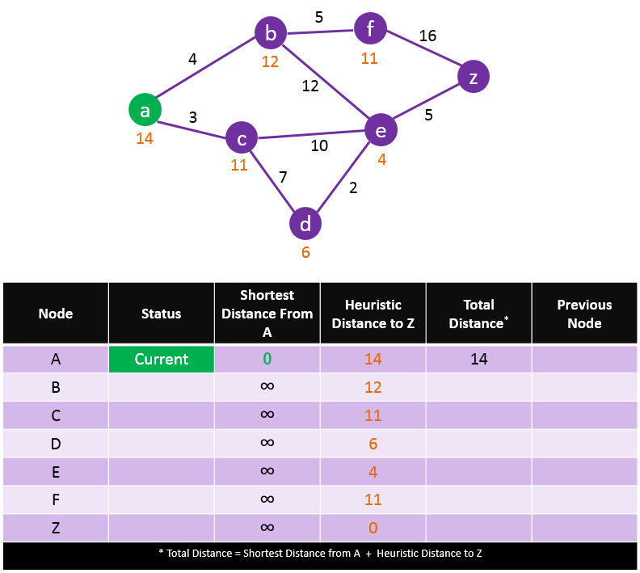

* Check all adjacent nodes connect to A and update their “Shortest Distance from A”. Then set their “previous node” to A. Update their total distances by finding the shortest distance from A and also the heuristic distance to Z.

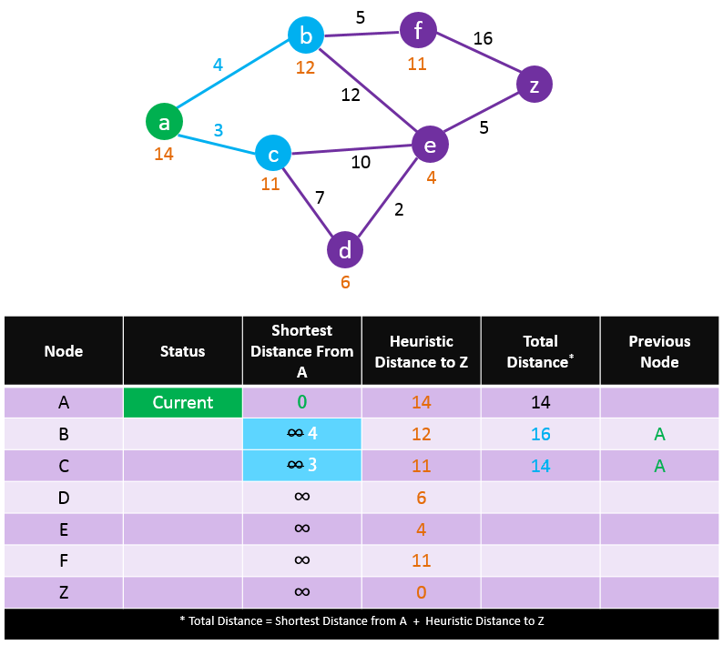

* Make the unvisited node with the smallest estimated distance the current node and set node A as visited. Check all unvisited nodes adjacent to the current node and add the distance from A to C, which has the smallest estimated distance, to all distances connected to the nodes. If the new value is smaller than the current value, then you replace the current value with the newly calculated one.

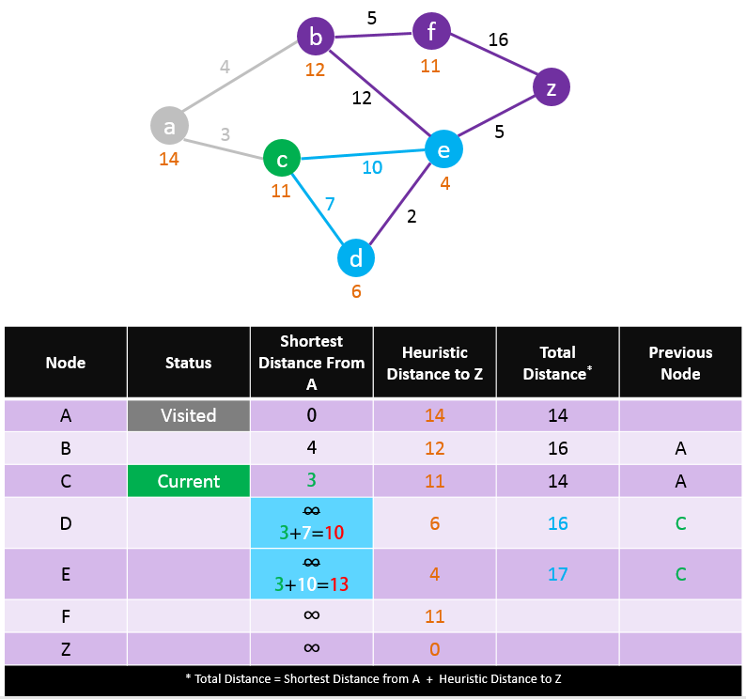

* The current node is B, from here check all unvisited nodes and add the distance from A to C to all the distances that are recorded to the connected node. Again, replace their values only if the new distance is lower than the previous one. The closest unvisited node is D, this becomes the current node.

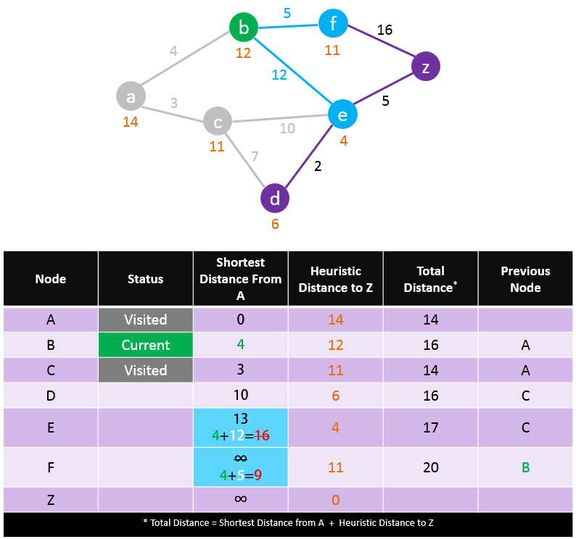

* From node D check all unvisited nodes and add the distance from A to D to the recorded distances for the connected nodes. Again, replace their values only if the new distance is lower than the previous. The closest unvisited node is E, this becomes the current node.

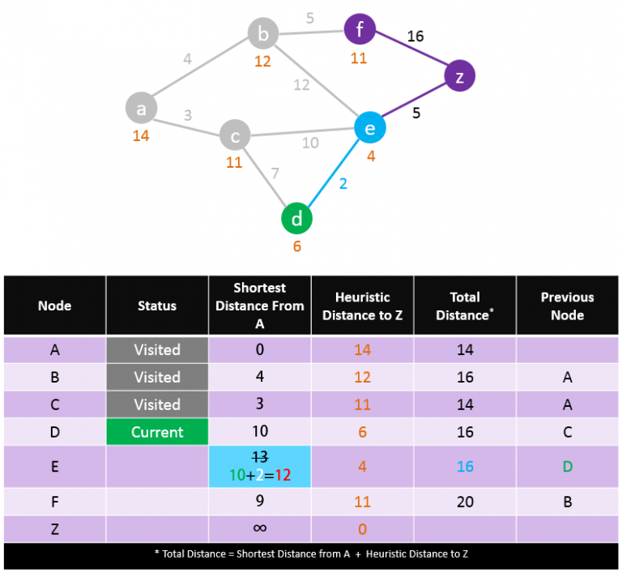

* From node E check all unvisited nodes and add the distance from A to E to the recorded distances for the connected nodes. Again, replace their values only if the new distance is lower than the previous. The closest unvisited node is E, this becomes the current node.

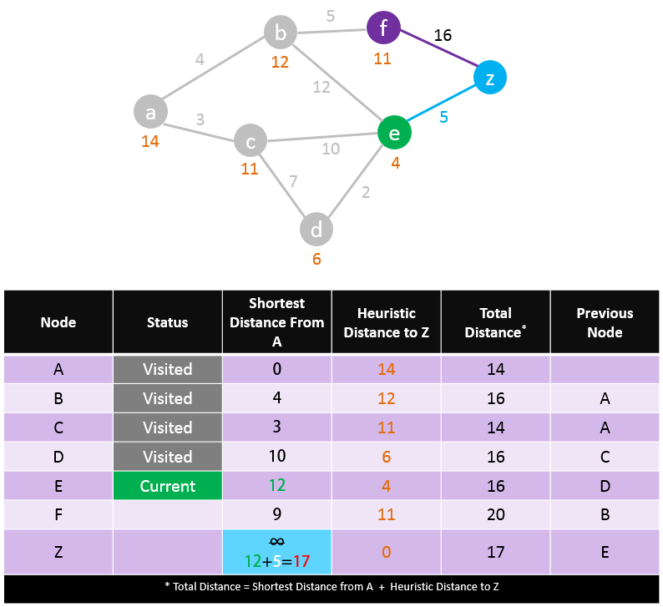

* The program has reached the goal, it needs to check whether the path is the shortest one. It checks all unvisited nodes, which in this case is only node F. The distance of F is already 20 which is greater than the calculated distance from A to Z (17). Therefore, there is no need to visit node F as it will not lead to a shorter path. By using the previous nodes column, you can read the direction for the shortest path.

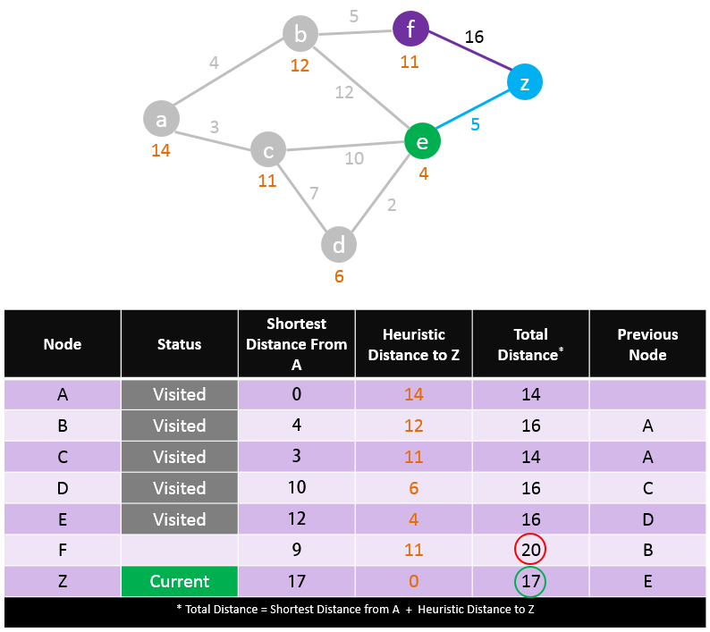

In this example the shortest-path is:

***A-C-D-E-Z with a cost of 17***

***Here is the trace table for the A* algorithm:***



Dijkstra’s Shortest Path Algorithm:

<https://www.101computing.net/dijkstras-shortest-path-algorithm/>

Dijkstra’s shortest path algorithm calculates the shortest distance between a beginning node and the end node on a graph data type. The algorithm can be used to find the shortest path by checking from one node to all the other nodes in the graph. This is able to do this based on the weighting of the graph.

Here is how you trace through the algorithm:

* This is a weighted graph that the algorithm will be finding the shortest path for

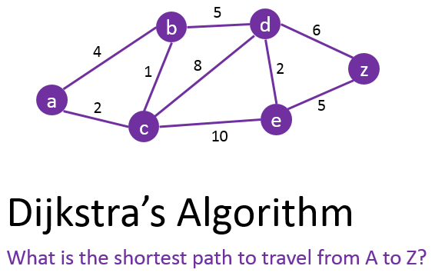

* Set the current node as A

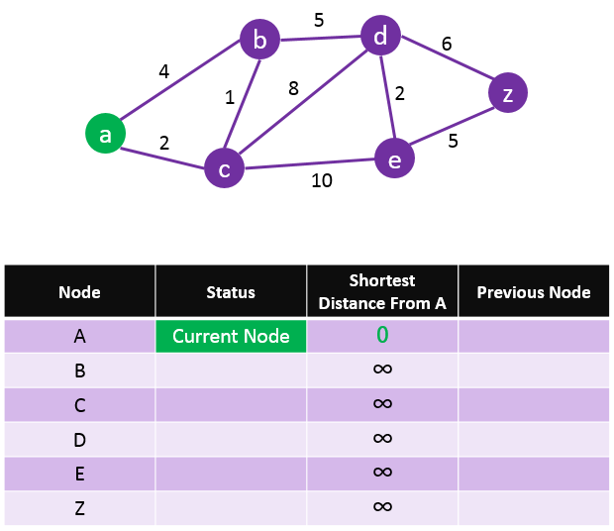

* Check all unvisited nodes connected to the current node. Update their distance from the beginning node and set node A as the previous node.

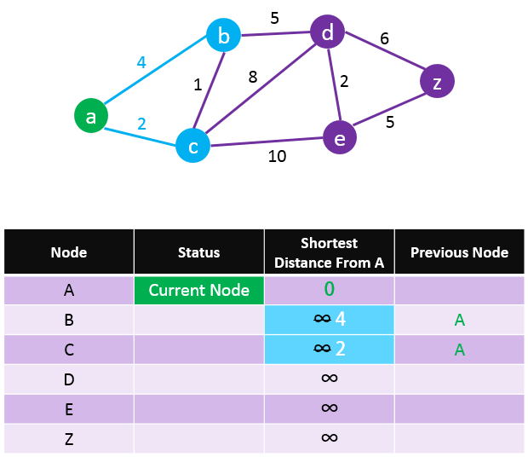

* Set node A as visited, and make the closest unvisited node as the current node

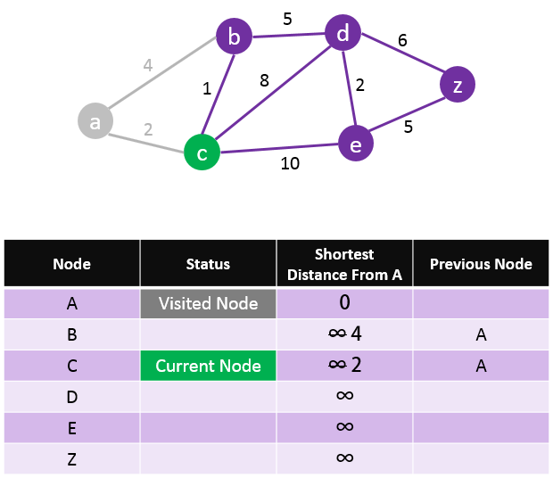

* Check all adjacent nodes connected to the current node. Add the distance from A to C to the distances recorded for all the connected distances. Again, only if the new value is lower do you replace the previous one.

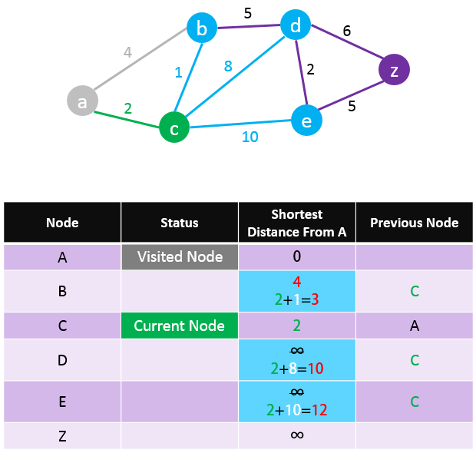

* Change node C’s status to visited. Keep repeating the same process for picking the closest unvisited node to A as the current node. Node B will become the current node in the example.

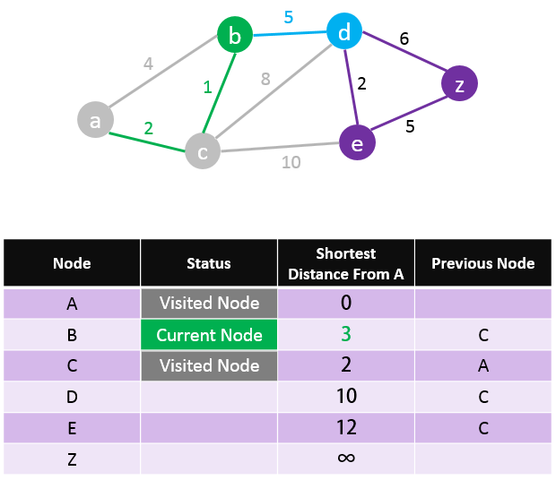

* The next current node will be D as it is the closest unvisited node

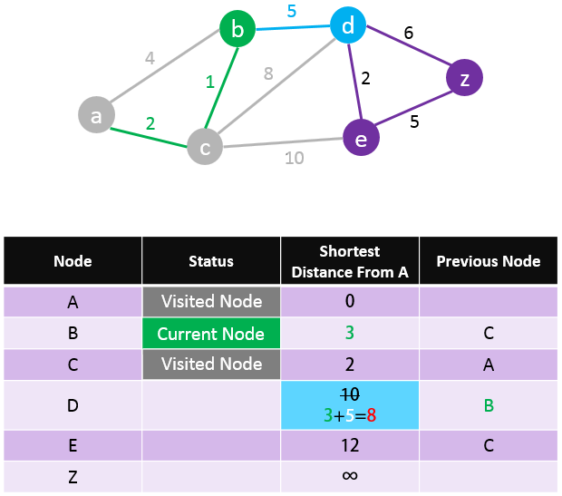

* A path from A to Z has been found, however it may not be the shortest path. Therefore, the program will carry on with the processes.

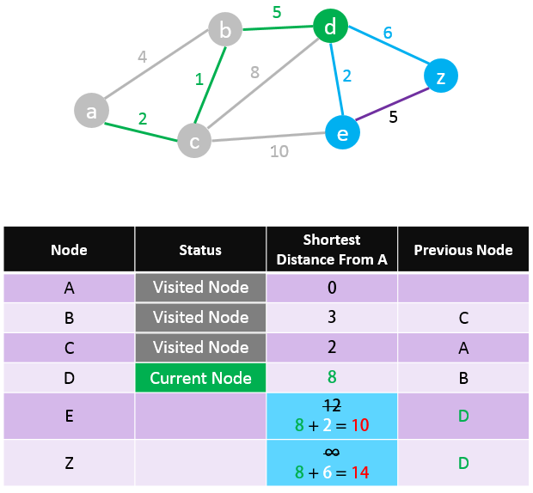

* We do not change nodes to Z, this is because our current values is already lower

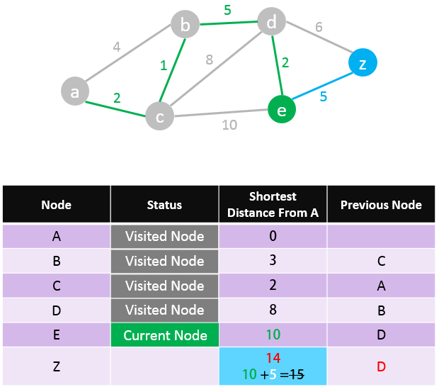

* The program has found the shortest path from A to Z, by reading the values from the previous node it can form the shortest path.

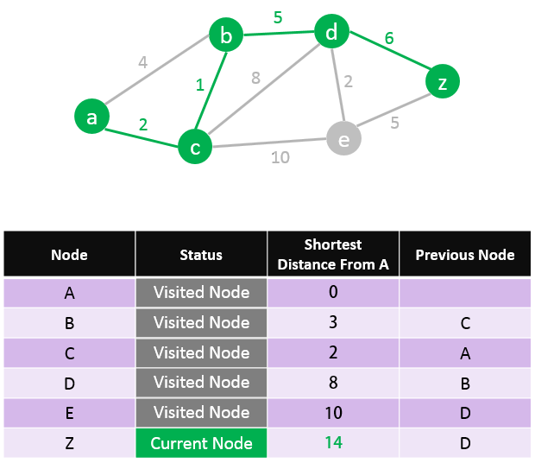

In this example the shortest-path is:

***A-C-B-D-Z with a cost of 14***

***Here is the trace table for Dijkstra’s Shortest Path algorithm:***



Other similar products available:

The most basic example of a product that is already on the market that is similar to mine is the Arduino Car. It is used as an easy way to educate students on programming and electronics. The Arduino car is very similar to the Raspberry Pi; however, I personally prefer the Raspberry Pi as I've had more experience using it and I feel as if it provides me with more flexibility to do different things. The Arduino car comes from a kit as well so both would be a good option either way if I decide to use it as a base.

An old example would be the Space Rovers, they are highly developed and robust vehicles that can survive the dangerous environment of the other planets. It is like my product because the scientist and computer experts would have to code what they want the Rover to do during the day as the far distances between Earth and the other planet causes a long delay between the transmission being sent and it being received by the rover. The concept of coding what the vehicle needs to do before it does it is something that I will transfer to my product. They are also researching on ways to reduce the time delay between transmission and reception and even making the Rovers completely Autonomous so that it can make any crucial decisions on its own

Tesla Cars are the modern-day equivalent of what my product could be, it can be completely Autonomous by using an array of cameras, ultrasonic sensors and light detectors. By using this technology, it is possible for the car to be able to go to the user’s destination entirely Autonomously. This level of independence is something I would like to implement into my product.

Typical GPS

Features of my proposed solution:

The features of my solution that I must include into my project is the ability to retain all data collected when traversing the maze. This is so that the robotic car can reproduce the same results to inform the user after the car has gone into the maze. This is so that the user will be able to trace through the movement of the car as it has happened.

As the data could potentially be stored in a stack, I can use a Last-In First-Out principle for the car to find the quickest way back to the entrance. I can effectively find the quickest way by removing dead ends or longer routes until only the relevant information is left. This is an important part of my solution as this is the method that will solve the maze. I will also want to display this information on the user’s device to inform the user. This would only be possible if I use a stack in my coded solution.

I would also want the robotic car to be able to be controlled wirelessly, this is because I want the car to be autonomous but also allow a user to solve a maze from a distance. This is a proposed feature as it will add extra versatility to the product making it more useful to different occasions. This would hopefully be done by SSH.

I would also need to include collision detection into my solution as the car wouldn’t be able to autonomously solve the maze otherwise. The collision detection algorithm is needed so that if there is an object that has been detected the car would be able to notice it in time for it to stop and manoeuvre around. If the collision detection wasn’t implemented, then there would be numerous problems stopping the robotic car from operating. It is an important algorithm that will run constantly so that the robotic car can perform to the user’s requirements and standards.

Here are my proposed features:

* Retains all the data
* Can be controlled by a wireless controller
* Can travel the quickest way back/ display it
* Displays the data collision detection

Hardware and software requirements:

The main hardware requirements for my product is to be able to use a powerful Raspberry Pi motherboard and Processor Kit to be able to control the cars performance. It has to be powerful enough to be able to process the large amount of data needed to run an autonomous vehicle and also all the inputs the sensors are detecting. The memory storage of the product has to be big enough to be able to store all the information to solve even the longest of mazes, eventually the memory would run out if the maze is too long however the memory needs to be big enough to solve the majority of cases. The processor has to be programmable as I would need to make improvements to the code constantly to keep the car operating at its best potential.

I would also need to use a Line and Light Detector to be able to recognise an obstacle in the car's way. These will have to be able to have a strong enough signal to be able to detect the object from a far enough distance to give the car enough time to react to it. They also have to be able to repeat a signal to the CPU at a fast-enough rate to be able to give it enough information to make an informed decision as a sensor could detect something at any moment, so it has to be fast enough to be able to relay that information before the CPU has already made a decision.

The battery or power source has to be able to provide sufficient energy to power the electric motors for the wheels and other components so that they are able to operate as well as they were intended as we’re using quality products and components. The battery has to be especially powerful because I want it to be able to supply a set of big motors, this is so that it can provide more traction and torque, increasing the off-road capabilities of the product.

The rest of the components will come from the Raspberry Pi Kit as I’m using that as a base, or we will order individual pieces if we need to improve a particular thing about the car to improve its overall performance.

Additional Utilities:

The only additional utility that I require to implement my solution is a Raspberry Pi laptop that can connect to the Raspberry Pi via a Micro-USB, HDMI and USB. I will be using a Motorola Atrix Lap Dock that has been specially designed to connect to an external device and interact with it like I would for a computer. The output of the Raspberry Pi will be outputted to the Motorola Lap Dock’s 11-inch screen. That way I will be able to directly program the Raspberry Pi from any location. I chose this Lap Dock as it was highly recommended and achieved everything that I needed from it. I will have to be physically connected to the Pi initially but as the code and the car nears its completion, I will control it via SSH to conduct any testing.

Acceptable Limitations:

While there aren’t many limitations to my projects, there are still four main possible limitations that my project could suffer from. The first limitation that I would have to face is that the memory may run out eventually if the terrain is too long or the maze too complex. This is because the program would save the routes and distances that have been travelled to the memory; the memory would be used up very fast as many different data’s types would be needed to analysis the data to find the best route back to the entrance. To solve this, I will have to ensure that the memory is large enough to be able to solve the majority of mazes, while there still would be a possibility that the memory could run out an 8Gb memory card should be able to meet the demands of the system and produce good results.

The other limitation that the product could face is if the terrain is too awkward for the car to be able to navigate easily, while the car can avoid objects, it may try to traverse an area of land that is beyond its capabilities to traverse since it won’t be able to detect the type of terrain from its sensors. This is because the sensors would only be able to sense an object that is vertically in front of the vehicle. As the car is autonomous it won’t be able to differentiate between normal terrain and awkward/dangerous terrain. Therefore, I have decided to make the car more robust and durable so that if the car does choose a more dangerous direction it wouldn’t be as badly affected as if it weren’t protected. Also, I have implemented a line follower so that it can stay within the confines of the maze unless avoiding an object.

The last limitation is that the car requires a form of power. Petrol or diesel engine wouldn’t work that well for a car the size of the product because of the costs and the lack of efficiency. Also, the added weight and danger of carrying fuel makes it an impractical choice. That is why the only way to power the car is by electricity. While using a battery will make the car significantly lighter than using a battery pack powered by mains it comes with its own downfalls. It may not be strong enough to give enough power to the wheel or have the capacity to be able to be used for an extended amount of time. This will mean that if the maze or destination is long or far enough then the car may run out of power before reaching the end. To solve this problem, I will have to be able to make a compromise on whether I want power and sustainability or portability and ease of use. I have decided on using a 9V battery supply as I have found it capable of easily powering the motors enough to move with speed as well as the other pieces of hardware.

The last limitation that my Robotic Car will face is that it must enter the maze from the top down, this is because I coded the solution to have a maze that is stored as a 2D array. By starting at the top of the maze I will be able to code the solution more effectively as I can program the directions for when the index in the x or y increases or decreases. I did it like this because if the robotic car entered the maze from the bottom of the maze then the index would be decreasing when it goes forwards, which I found to be more awkward. Either way the robotic car must enter the maze from a certain direction for the movement direction to work correctly. Therefore, it must enter from the top of the maze, however it can enter at any index from the top of the maze.

### Human-Computer Interaction:

The product is designed to have minimal interaction with the user except for at the beginning and end of the process or when the user is controlling the car. The user will simply have to put the car at the start of the maze and instruct it to go for it to autonomously solve it until it reaches the exit, or a solution is reached.

The user would therefore have to collect it when it has solved the maze, but the car would have returned to the start anyway so there is limited effort required for the user to retrieve it. This makes it easier for the user because instead of going to the end to retrieve the car, you can get the car from the same place as you placed it in the beginning. It is also quicker finding its way back as it knows the shortest route back to its origin.

The user will use a phone or tablet wirelessly to control the car, the device would display the options for the car that the user could execute, these would be basic commands such as forwards, backwards, left and right and any other commands the user may use. I am still to decide on how I will present the option graphically to the user, however it will be displayed on the user’s device. When the car is carrying out the instructions there will be a display log recording all the commands and positive used, this is to inform the user of what they have just done so they have a better understanding on how they have got to their position or how to retrace their steps.

I would also need to include a way to inform the user of any potential errors when the robotic car is operating. This is so that if there are any errors detected then the user would know that he or she would have to retrieve the car or troubleshoot. This is useful as it would reduce anytime that could’ve been wasted by any faults caused by the environment or robotic car as the user is informed of the problems rather than having to find it themselves. I would also need to implement exception handling into the program so that if there are any problems that arise, I can separate the genuine problems from the technical issues that won’t have an impact on the operation of the robotic car. A common problem that could occur that should be an exception is an error that is shown when the distance is recorded as being too close, the program should not be stopped but instead should try to manoeuvre around using the collision detection algorithm. This should also work similarly for the use of the line follower as the robotic car could lose the line.

By limiting the interaction with the robotic car except for when any problems occur will allow it to perform autonomously, this will achieve the success criteria of the project of the robotic car being able to solve a maze independently.

## First-Interview:

Selection of user Group:

To mimic my potential end user, I will be using the students at my sixth form to discuss the user requirements and feedback of my robot throughout its development. In order to discover my success criteria and project features that are desired by my user group I will be conducting a series of interviews with both student and staff who are all above the age of 16.

### Investigation and Analysis:

I intend to interview a range of students and staff above the age of 16 from my sixth form, and I will be giving them a Questionnaire to complete in order for me to get a better understanding of the end user.

Questionnaire 1:

* Have you ever had any experience with a maze solving software?
* If so, what was the name or type of Software used?
* Were there any features of the maze solving software that you particularly liked?
* Were there any features of the maze solving software that you disliked?
* Have you ever seen or interacted with an autonomous car?
* If so, was the autonomous car able to move independently whilst being safe?
* If the Autonomous car was able to move independently, was it able to avoid objects in its way?
* Have you ever controlled a robot from a wireless device?
* If so, did it output anything to your device and how was it outputted?

### Initial Interview Results:

I have interviewed five students and two teachers from my end user group, here I will compile all the sensible responses, in order of frequency with which they occurred. The responses will go to a summarised answer that represents that section of the user groups opinion and any similar answers will go to that answer.

Have you ever had any experience with a maze solving software?

Yes (7)

If so, what was the name or type of Software used?

A* Algorithm (3)

Breadth-First (2)

Depth-First (2)

Were there any features of the maze solving software that you particularly liked?

Fast Execute Time (4)

Efficient (1)

Easy to Code/Understand (2)

Were there any features of the maze solving software that you disliked?

Slow Execute Time (4)

Bad/Inefficient Route (3)

Have you ever seen or interacted with an autonomous car?

Yes (7)

If so, was the autonomous car able to move independently whilst being safe?

Yes (4)

No (3)

If the Autonomous car was able to move independently, was it able to avoid objects in its way?

Yes (4)

No (3)

Have you ever controlled a robot from a wireless device?

Yes (5)

No (2)

If so, did it output anything to your device and how was it outputted?

Yes (2)

No (3)

N/A (2)

### Analysis of Initial Interview Results:

All of my interviewees have used a maze solving piece of software before, these are mostly the A-Level search algorithms you learn in Computer Science, which is where they most likely learnt it. The interviewees all answered giving a search algorithm as an example, they knew the A*, Depth First and Breath First algorithms. From learning this I will conduct research into these algorithms as they may provide extra insight on how they operate. Also, everyone from the user group have either seen or have interacted with an Autonomous Car or robot. This is an encouraging result as I now know that I have users who have an interest and basic background knowledge in my project. When I asked about whether they have seen a car that is able to move independently but safely four replied with a yes, however there are three people who believed that they haven’t seen one that was safe enough for them to trust. This then has a direct link to the next question where three of the seven interviewees haven’t seen an autonomous car avoid an object in its way. I believe that more of the interviewees would have more confidence in the safety of the car if it could consistently avoid the objects. Another question I asked was whether they have controlled a robot using a wireless device before, the majority of the group replied with a yes however there where two who replied with a no. This is probably because they weren't as interested in robotics as the others. I finally asked about what they liked and disliked about the current systems out there in the market so that I can understand what features to implement and what features I should improve or replace. The majority of the group decided that a slow execute time and a Bad/Inefficient Route was what let these other products down compared to others. They also said that fast execute times along with good efficiency and easy to understand code was what gave them the advantage. Most of the interviewees had opinions that were affected by the decision of another question, which tells me that by fixing these problems the opinions of the other questions would then improve.

Based on the results of the initial interview, together with the considerations of the feature requirements, I have decided on the following criteria.

Success Criteria:

Here are my success criteria for my project, all of these criteria's can be demonstrated through testing as the program goes through the development phases and when the project is completed.

* Be able to solve the maze
* Be able to find the quickest way
* To be able to store all the data and print the route to the user
* To be able to continue until the exit is found
* Avoid any objects in its way (collision detection)
* Be able to be controlled by the user (phone or tablet)
* Output the data on the user's phone or electronic device
* Move (Forwards/Backwards)
* Turn (Left/Right)
* Diagonal Movement
* If collided with object, has it tried to correct its course
* It is able to follow the black line using the line follower

### Second Interview:

To determine whether the variable features satisfy my user group’s requirements, and to decide upon details such as screen designs, aesthetics and additional features. I will follow the same format to the interview as I have done for the first one. Again, I will show the frequency of the answer however it will be more worded as I'm compressing the interviewees opinion.

### Questionnaire 2:

* How big do you think the memory on the Raspberry Pi needs to be for it to be useful?
* What is the minimum distance you believe the ultrasonic detector should detect?
* How wide do you think the black lines at the base of the maze need to be?
* How heavy do you think a small Robotic Car should weigh?
* How fast should a small robotic car travel when solving a maze?
* How quickly should a small robotic car solve a complex maze?
* How would you want the data to be outputted?
* What data would you want to know while the robot is operating?
* Should the program print a visual diagram of the best route/ of the whole maze to the screen?
* Would you prefer the robotic car to be to travel across different/ difficult terrain?
* What material do you think the Robotic car should be made up of?
* Do you think the robotic car should be resilient and durable?

### Secondary Interview Results:

How big do you think the memory on the Raspberry Pi needs to be for it to be useful?

Less than 4Gb (1)

4Gb (2)

8Gb (4)

What is the minimum distance you believe the ultrasonic detector should detect?

100cm (5)

50cm (2)

How wide do you think the black lines at the base of the maze need to be?

5cm (3)

2.5cm (4)

How heavy do you think a small Robotic Car should weigh?

250g (4)

500g (3)

How fast should a small robotic car travel when solving a maze?

10 cm/s

20cm/s

How quickly should a small robotic car solve a complex maze?

2 Min (3)

4 Min (2)

5Min (2)

How would you want the data to be outputted?

Printed to screen (7)

What data would you want to know while the robot is operating?

Distance (7)

Direction (7)

Path Taken (5)

Should the program print a visual diagram of the best route/ of the whole maze to the screen?

Yes (5)

No (2)

Would you prefer the robotic car to be to travel across different/ difficult terrain?

Yes (2)

Preferably (5)

No (1)

What material do you think the Robotic car should be made up of?

Plastic (4)

Metal (3)

Do you think the robotic car should be resilient and durable?

Yes (4)

No (3)

### Analysis of Second Interview:

The majority of the user group decided that it was better for the Raspberry Pi to have a greater memory size, this is expected as solving a maze requires a lot of data that needs to be stored continuously. This should mean that it will be able to solve more complex mazes. They also said that the Ultrasonic detector should be able to measure up to 100cm, by using 100cm instead of 50cm it allows more time for the Raspberry Pi to process the data. The question about how long it should take to solve the maze was awkward for the interviewees to answer correctly as they had differing opinions as the mazes where too complex for them to understand well enough to estimate an accurate time as a maze could look very complex to them whilst being easy for the computer. It was therefore decided that it was best for the project to have the robotic car solve the maze by the quickest route. This is because the quickest route is also the fastest, meaning that if you find the fastest route you would also solve it the fastest time. All the interviewees wanted the data to be printed to the screen. This is probably because in the next question where I asked them what they would want printed to them, all seven decided that it was a good idea to show the user the Distance and Direction. Five of the seven also wanted the path taken to be shown as it will give them a better understanding of what is happening. From this I now understand that my user group want as much information given to them, however I will have to hide some information or data to not over load them with anything irrelevant. The last questions I asked was about the resilience of the car and its durability. Most preferred a robotic car that can manoeuvre around difficult terrain however they suggested that it wasn’t as important if it affected the performance of the car. I then asked what material would be best suited for the robotic car and they replied with either plastic or metal. While a metal frame will be more durable, I believe plastic would be the best option as it provides a good balance.

### Variable Requirements:

* 8 Gb Memory
* Ultrasonic Distance Detector (Greater than 100cm Range)
* Find the shortest route to the exit
* Print the outputs to the user screen
* Print the Distance, Direction and Path Taken to user screen
* Build a durable frame for the Robotic Car

***How do you want the menus to look like?***

***Does the robotic car feel that it has a quality build to it?***

***What camera quality would you expect from the robotic car to serve your needs?***

***Was the robotic car able to avoid any collisions with any objects in its way?***

***Was the product easy to use?***

***Was the product safe to use?***

***Was the quickest route provided by the car actually the quickest route?***

***Was your interaction with the menus easy/quick?***

***How useful do you think this product was?***

***How much would you pay for this product?***

***Would this product solve any of your problems/needs?***

***How would you improve the look of the product?***

Success Criteria:

Here are my success criteria for my project, all of these criteria's can be demonstrated through testing as the program goes through the development phases and when the project is completed.

DETAILED SUMMARY OF THE PROCESS INCLUDING KEY INCLUDING KEY VARIABLES AND STRUCTURES:What Criteria’s are achievable:

I believe that I will be able to achieve the majority of my success criteria before the end of the project. This is because the algorithms that I will be using are popular and are readily available. Meaning that I will be able to code the solutions for the A*, Collision Detection, Line Follower and Distance Detection algorithms. This allows the robotic cars to traverse the maze autonomously whilst avoiding any obstacles. As it is traversing the maze it will find the shortest path to the exit while storing the directions and distances in various data structures which meet most of my success criteria. However, the criteria’s that I believe I may not be able to solve is connecting the end user’s electronic device to the robotic car so that the user can control the car for their device whilst important information is displayed to the user’s screen. I may not be able to do this because I have to connect the robotic car over an SSH connection, meaning I have to have internet access. If I am unauthorised or unable to get the information from the internet port, then I won’t be able to connect the device to the robotic car. I understand that there is a method that doesn’t need the internet to use SSH however the user’s device needs a way to send the commands across.

*Design*

Structure of the solution:

**13-15 marks**

* Broken the problem down systematically into a series of smaller problems suitable for computational solutions, explaining and justifying the process.
* Defined in detail the structure of the solution to be developed.
* Described the solution fully using appropriate and accurate algorithms justifying how these algorithms form a complete solution to the problem.
* Described, justifying choices made, the usability features to be included in the solution.
* Identified and justified the key variables / data structures / classes (as appropriate to the proposed solution) justifying and explaining any necessary validation.
* Identified and justified the test data to be used during the iterative development of the solution.
* Identified and justified any further data to be used in the post development phase.

Schematics:

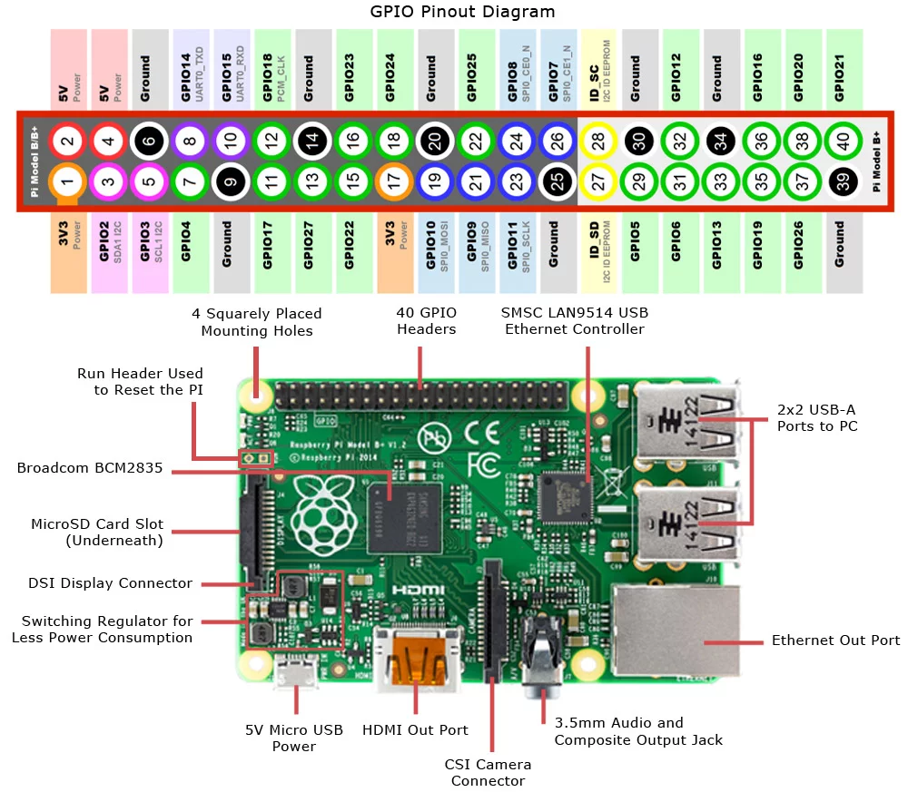

***MotorA:***

***ON = PIN11 (GPIO17)***

***Positive = PIN13 (GPIO27)***

***Negative = PIN15 (GPIO22)***

***MotorB:***

***ON = PIN22 (GPIO25)***

***POSITIVE = PIN16 (GPIO23)***

***NEGATIVE = PIN18 (GPIO24)***

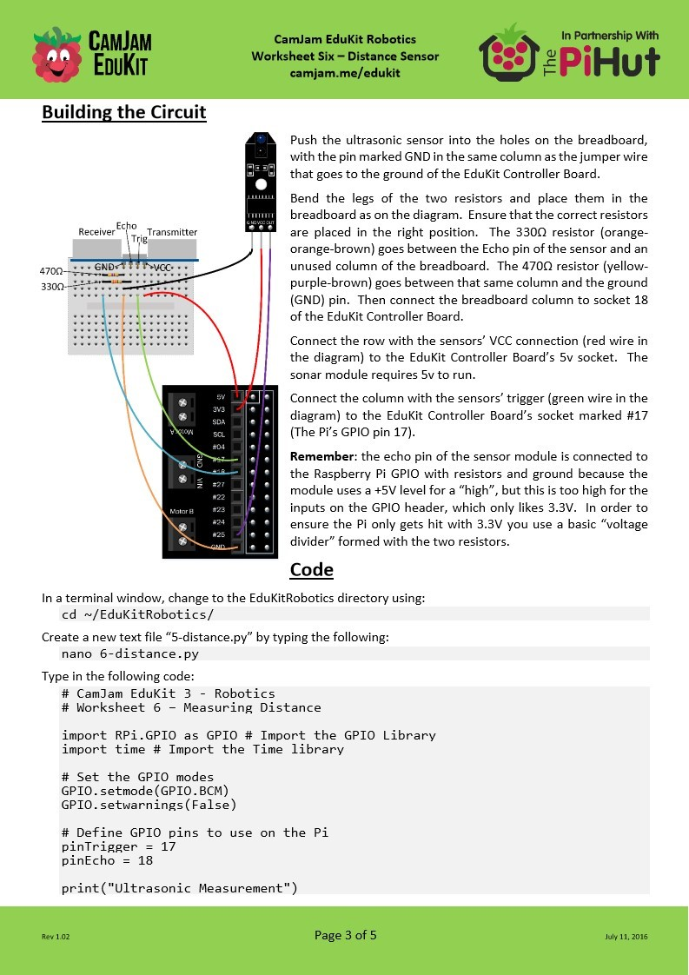

An overview of the structure of the solution (a system diagram):

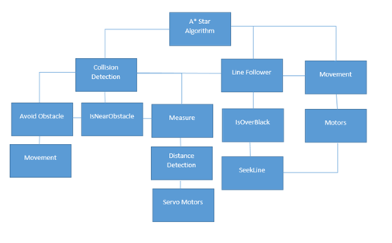

The diagram above is a top-down module design of my robotic car, in this diagram, it shows the structure of my solutions and how I would solve the problem using decomposition.

The main program that has control over the other systems is the A* Star algorithm, it will need to have access to the collision detection, line follower and movement programs so that it will be able to decide on the directions the robotic car will take.

Talk about the algorithm used (a*, Breath-First, Depth-First)

The movement program is used so that if the Robotic car has detected a variable using the collision detection algorithm then it will be able to stop, but if the direction is clear then it should be able to make the necessary movement to find the exit of the maze. For this I will have to program the motors to be able to move forwards, backwards, left and right. These are all the possible directions that the robotic car can take. I will program the motors so that either the left side or the right side of the car would move to imitate moving left or right. The motors on the left-hand side will be turned on to turn right and the motors on the right-hand side will be turned on to turn left. The motors on both sides will be turned on when going forwards. This way the robotic car can manoeuvre quickly around the maze. This is so that the other programs that require the robot to move can utilise this program.

I will be using the RPi.GPIO (general-purpose input/output) library module to control the pins and software of the Raspberry Pi. By importing this library module, you can tell the Raspberry Pi whether the pin is an input or output. By determining whether a pin is an input or output it controls the direction of the information and instructions but also the power. I will also be importing the time library to be involved in the calculations for the distances.

The line follower is the next system that is used to ensure that the robotic car stays in a straight line, this is so that the robotic car can move safely and accurately while traversing a maze. The line follower will use the routines IsOverBlack and SeekLine to function correctly. The line follower is programmed like this so that when the car is moving it will use the IsOverBlack to check if the robotic car is on the line. The line will have to be black as this way it will be able to be detected as the black line will be distinguishable against the floor as the line follower detects the reflection of light, this will return a True or False variable. Depending on the output it will either continue if the routine shows that it is on the line or if it is not on the line then it will call SeekLine. SeekLine is a routine that goes and looks for the line by moving in either direction. It will then call IsOverBlack to check if it has found the line. If it does detect the line, then it will stop the motors and give the controls of the movement back to the main system.

The distance detector is an integral routine of the program as it will find the distance to the nearest object. This is used so that it can avoid any objects but also to be able to use it to know how far to travel to the next point. The distance detection algorithm is simple as it mostly relies on mathematical calculations and thinking logically. It is able to measure the distances by timing how long it will take for a signal to hit its target and echo back to the receiver. This is then multiplied by a constant to get a distance in cm’s. The distance detection algorithm will also be connected to the servo motors so that it will be able to rotate the distance detector, this is so that it can have a full scan of the surrounding area.

The collision detection algorithm is very important to the function of the robotic car, it controls the movement and interaction with the surroundings. It utilises the distance detection and movement algorithms so that it will be able to detect and avoid objects. The Measure routine uses both the distance detection and servo motors to know how far the nearest object is around the car. This then leads onto the routines IsNearObstacle and AvoidObstacle. IsNearObstacle checks the distance an object is to the robotic car and checks it against a constant value, if it is greater than the value then it will return False otherwise it will return True. This output will then tell the AvoidObstacle routine whether it needs to move out of the object's way or not. This stops the robotic car from avoiding objects unnecessarily while allowing it to avoid objects that are too close.

DECOMPOSITION OF THE PROBLEM:

PROPOSED SCREEN DESIGNS AND USABILITY features:

The proposed screen design for the program is through the Python Shell, this is because there are no features that are required to be presented in another way. It is easier for me to write and present the information in one single place rather than have separate places unnecessarily. By using SSH to control the robotic car, the data being outputted will be outputted on the user’s device who is using the SSH. The program will print both important information that it has collected as well as informing the user of any decisions it has made. This provides all the necessary information the user may need as it is telling you what processes the robot is following. The distance to an object and whether the robot can see the object will be regularly outputted as many programs run through this. I have included the following outputs as they allow the user to understand what the robotic car is doing while it is solving the maze. This will make the program easier for the user as they will be well informed. I have displayed the information according to the requests of the user group that I interviewed in the analysis section.

***Here are the typical outputs:***

* “You’re too close for me to see”
* “Direction, (I.e Left, Right, Forwards and Backwards)”
* “Seeking the Line”
* “Looking Direction”
* “Following the Line”
* “Ultrasonic Measurement”

The print screens below show the typical output to the screen, this will give a better idea to the user on what to expect

***Here are the print screens from the python shell:***

***Collision Detection:***

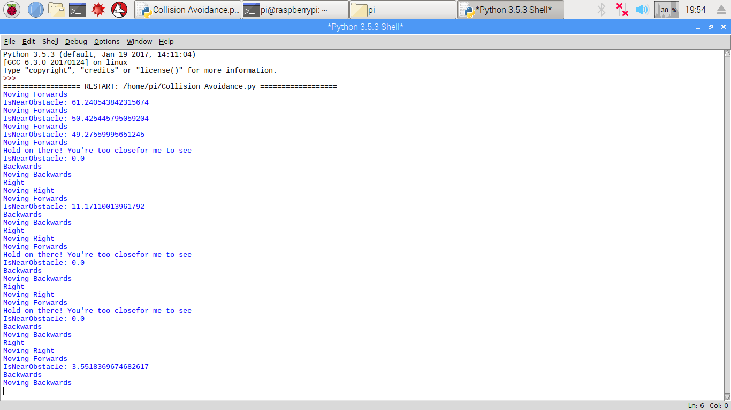

***Line Follower:***

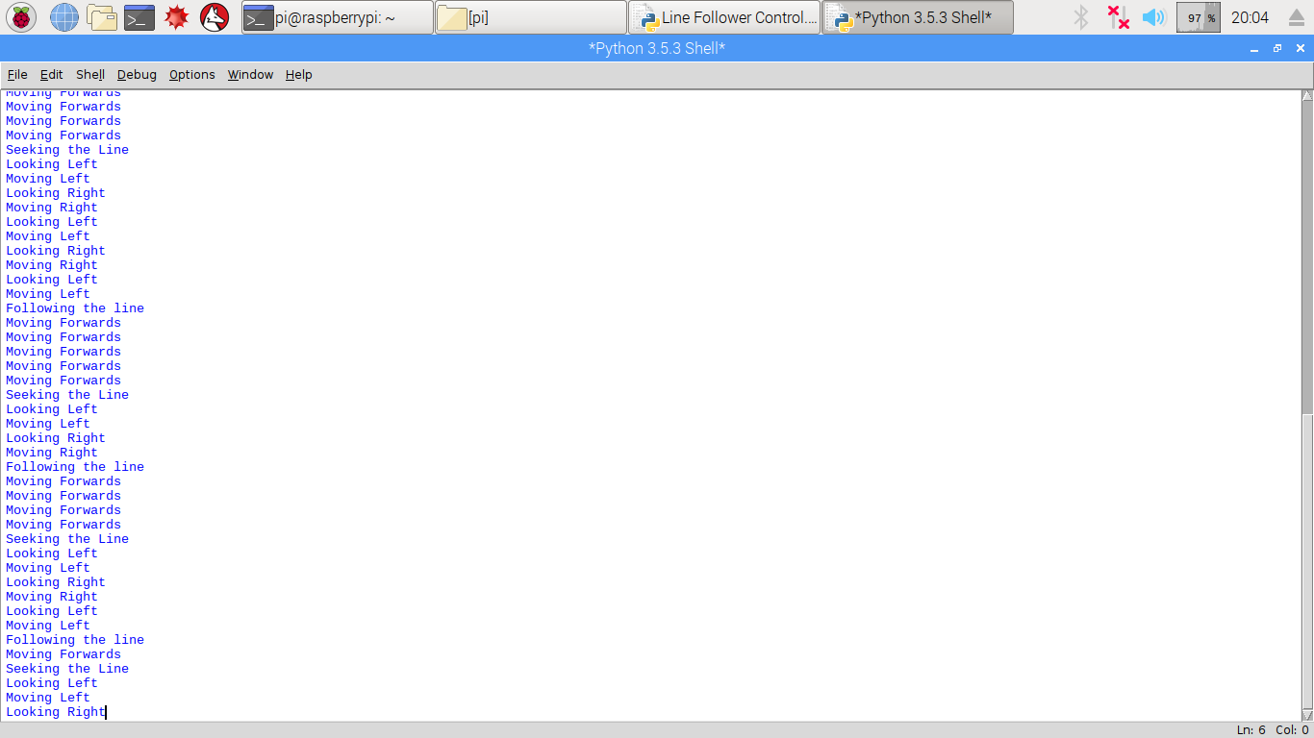

***Distance detection:***

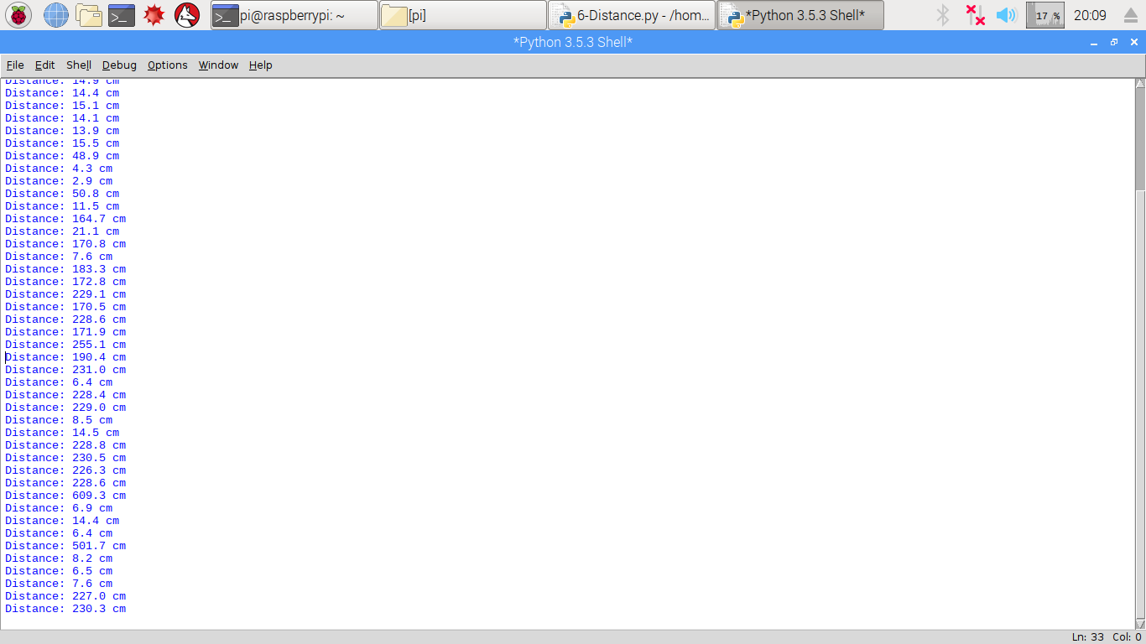

Detailed summary of the process including key including key variables and structures:

Test data for development and alpha testing:

I will be using various test data to check the robustness of the program, as I will be using obstacles to block the movement of the robotic car as it traverses the maze. The movement of the robotic car is fundamental to the function and performance of the autonomous car. It needs to be able to move in a straight line and be able to have the ability to vary its speed to solve the maze in a fast-enough time. The program also needs to be able to turn in the correct direction the program has instructed it to go. In addition, if the robotic car has detected an object then it needs to be able to use the collision detection algorithm to manoeuvre around the object. I will also check the distance detector and line follower. For the distance detection, I will be using a range of distances to check its accuracy and to see whether it can function close and far. For the line follower I will check what will happen when there is a black line to follow from the beginning and when there is no black line to follow from the beginning. This is to see if there is any data that can make the program erroneous and break the system.

Here are the potential Test Data that I will be using:

* Turn Left
* Turn Right
* Short Distance
* Long Distance
* Higher or Lower Voltage/Frequency
* Blocking Path Forward
* Blocking Path Backwards (When detecting collision detection)

A DETAILED SUMMARY OF THE PROCESS INCLUDING KEY VARIABLES AND STRUCTURES:

Algorithms:

<https://medium.com/@nicholas.w.swift/easy-a-star-pathfinding-7e6689c7f7b2>

In order for me to test each algorithm for functionality, I have performed dry-run tests to check whether the basic operations work as intended.

A* Algorithm:

A* Method:

1. Add the starting node to the open list (ListOpen).
2. Repeat the following:
   1. Look for the lowest TotalCost cost node in ListOpen. We will refer to this as the CurrentNode
   2. Switch it to ListClosed.
   3. For each of the 8 nodes adjacent to this current node …
   * If it is not walkable or if it is in the ListClosed, ignore it. Otherwise do the following.
   * If it isn’t in ListOpen, add it to ListOpen. Make the CurrentNode the Parent of this node. Record the TotalCost, Distance and Heuristic costs of the node.
   * If it is in ListOpen already, check to see if this Path to that node is better, using the Distance cost as the measure. A lower Distance cost means that this is a better path. If so, change the Parent of the node to the CurrentNode, and recalculate the Distance and TotalCost scores of the nodes. If you are keeping ListOpen sorted by the TotalDistance score, you may need to resort the list to account for the change.
3. Stop when you:

* Add the EndNode to ListClosed, in which case the Path has been found, or
* Fail to find EndNode, and the ListOpen is empty. In this case, there is no Path.

4. Save the Path. Working backwards from the EndNode, go from each node to its Parent node until you reach the starting node. That is your Path.

Here is the pseudocode for my A* Algorithm, this is how it will find the shortest path. Although I have already talked about the A* algorithm before in my Research section, this algorithm will be more specific to my needs and will be closer to the coded solution.

A* Algorithm

##A* (Star) Pathfinding

#Initialize both open and closed list,  
let ListOpen be equal to the empty list of nodes and let ListClosed equal to the empty list of nodes

#Add the start node,  
put the StartNode on the ListOpen (leave it's TotalCost at zero)

#LOOP until you find the EndPosition,  
WHILE the ListOpen is not empty

#Get the current node,  
 let the CurrentNode equal the node with the least TotalCost value  
 remove the CurrentNode from the ListOpen  
 add the CurrentNode to the ListClosed

#Found the goal  
 IF CurrentNode is the goal  
 Congratz! You've found the end!

Backtrack to get Path

#Generate Children  
 let the Children of the CurrentNode equal the adjacent nodes

FOR each Child in the Children

#Child is on the ListClosed  
 IF Child is in the ListClosed  
 continue to beginning of FOR LOOP

#Create the TotalCost, Distance, and Heuristic values  
Child.Distance = CurrentNode.Distance + distance between Child and Current  
Child.Heuristic = distance from Child to EndPosition  
Child.TotalCost = Child.Distance + Child.Heuristic

#Child is already in ListOpen  
 IF Child.Position is in the ListOpen's nodes positions  
 IF the Child.Distance is higher than the ListOpen node's Distance  
 continue to beginning of FOR lOOP

#Add the Child to the ListOpen  
 add the Child to the ListOpen

Dry-Run Test:

Here is the maze the algorithm is running through, I printed it to the shell so that the user could see what maze the robotic car is traversing. A zero in the list represents a node that the robotic car can take whereas a 1 represents a wall. This is the same maze that I included in the code, which show that the program is running through the correct list.

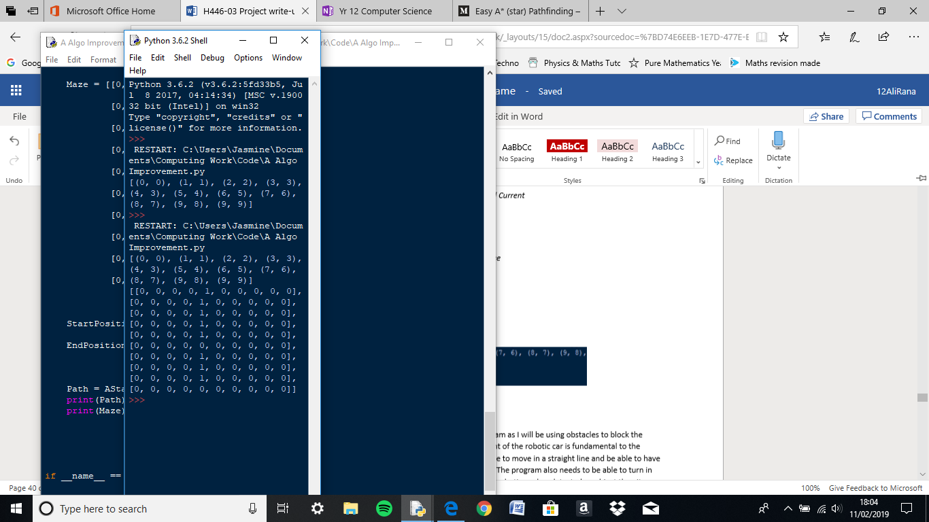

Here it shows the shortest path, it is presented as the index of a list. I have checked whether this path is actually the shortest path and it seems as if this is correct as I couldn’t find a shorter path. This shows the program works as intended as it uses the information from the maze to find the shortest path and then print it to the user’s screen.

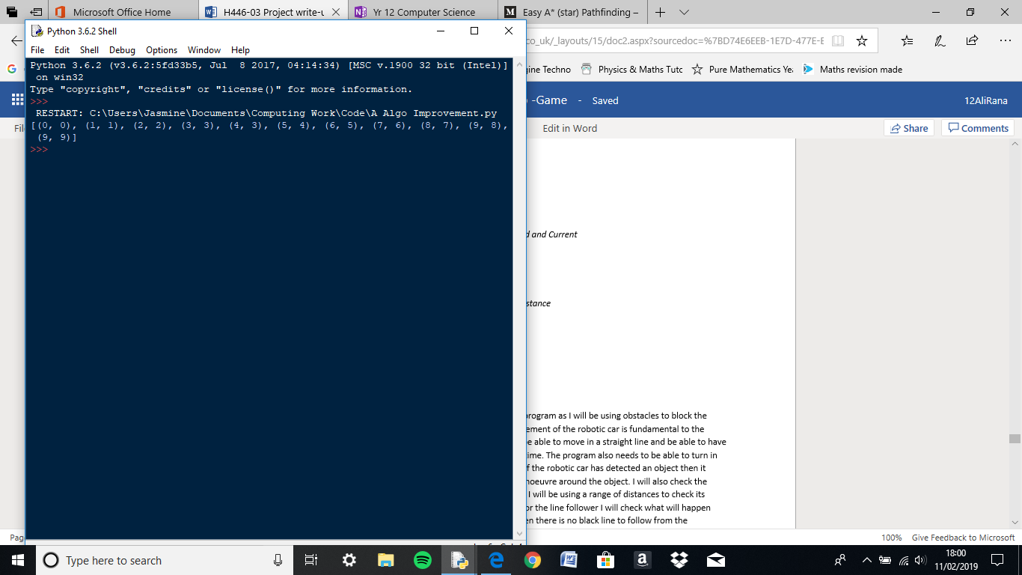

|  |  |  |  |
| --- | --- | --- | --- |
| Name | Data Type | Comments | Validation |
| StartNode | Variable | This is the node that you start from |  |
| EndNode | Variable | This is the node that you End the program with once you reach it |  |
| ListOpen | List | An empty list that values are added to when the program is running |  |
| ListClosed | List | An empty list that values are added to when the program is running |  |
| CurrentNode | Variable | This is the node the program is currently at |  |
| Path | List | This is the path the program has taken to get to its current destination |  |
| Children | List | The set of children nodes |  |
| ChildNode | Variable | This is a variable to represent the child node of the parent |  |
| ChildNode_Closed |  | An empty list that represents a closed list |  |
| NewNode | Variable | A variable created for a new node |  |
| NodePosition | Variable | This is the nodes position in the Maze |  |
| StartPosition |  | The position where the A* process will start in the Maze |  |
| EndPosition |  | The position where the A* process will end in the Maze |  |
| Maze | List | A list that holds the structure of the maze the A* Algorithm will be solving |  |
| Node |  | A variable to represent a node |  |
| AStar() |  | The function for the A* Algorithm |  |
| _init_() |  | A function to initialize the attributes of a class. |  |
| _eq_() |  | A function to compare wehther to attributes are equal or have equality |  |
| Main() |  | This is the main program where it will call all the other necessary programs |  |

Collision Detection:

You will have to setup the collision detection by making the variables equal to the pin values. This is done to stop the repetition of finding the correct pin numbers and also reduces the chance of any potential errors. These will be variables for the Motors, Trigger, Echo, Frequency and Duty Cycles. You will have to setup the motors using the PWM (Pulse Width Modulation) technique to control the power provided by the 9V. You have two duty cycles for both side of the robotic car, you have them as the two motors won’t inline properly, so you need two separate values that are easily changeable to allow the car to travel in a straight line. You will also need to set the PWM of the motors to the variable, Frequency. This is the same for the movement of the robotic car.

The first subroutine is Measure, it records the time from which the Boolean for the Trigger is True to when it returns False. This is where the StarTime and StopTime variables are included as they hold the values timed. You will have to implement a WHILE loop as it will check whether the Echo has returned a 1 or a 0. If the input is equal to 1 then you check if the time it took for the signal to be sent and then received is greater than or equal to a certain value. You will then need to include a break into the WHILE loop to exit it. You then have an ElapsedTime variable which holds StopTime-StartTime to get the time taken for the signal to be sent and then received.

The second subroutine is IsNearObstacle which gets the distance value from the Measure subroutine and stores it in a variable. It then checks if the Distance variable is less than the variable from the main program, HowNear. This is a parameter that is passed to the IsNearObstacle routine.This tell the program if it has seen an object or not. If the ultrasonic detector sees an obstacle it will return True, otherwise it will return False.

The last subroutine for the Collision Detection algorithm is AvoidObstacle, which is used when the IsNearObstacle returns true. It utilises the movement routines to reverse and go around the object, it will then stop the motors after it has moved.

The main program for the Collision detection will use a try statement to run through the routines. It will set the Trigger to False, which represents a Low voltage supply. The program uses a WHILE True loop to run the section forever. In this section is the Forward function and an IF statement that calls the IsNearObstacle routine that has the parameter HowNear. It then calls StopMotors and AvoidObstacle to be able to check every process as the robotic car is run.

All the variables or constants are typically used for integer calculations or to pass data to, which means the program does not require it to be declared. There are no specific data types used in this program.

Here are the key variables and for the collision detection:

* Measure()
* IsNearObstacle()
* AvoidObstacle()
* HowNear
* StopTime
* StartTime

Collision Detection Algorithm:

* Import RPi.GPIO as GPIO
* Import time
* Set the GPIO Pin mode to BCM ands set warnings to False
* Set variables for the GPIO Motors, Line Follower and Distance Detection Pins
* Set the value for the Frequency of the pin to 20 (How many times it turns on and off)
* Set Duty Cycle values to 75 (How long the pin stays on each cycle as a percentage)
* Set the Stop variable to 0
* Set the correct GPIO Pins to either inputs or outputs
* Setup the Distance variables
* Set the GPIO Pins for the motor to software PWM at Frequency Hertz
* Make all PWM variables equal to Stop from startup

Function StopMotors()

Make all PWM Pins equal to Stop

Function Forwards ()

Turn Motor A and Motor B on

Set Motor A and B forward variables to their respective DutyCycle

Print(“Moving Forwards”)

Function Backwards ()

Turn Motor A and Motor B on

Set Motor A and B Backwards variables to their respective DutyCycle

Function Right ()

Turn Motor A and B on

Set Motor A Forwards to DutyCycle and set Motor B Backwards variable to DutyCycle

Print (“Moving Right”)

Function Left ()

Turn Motor A and B on

Set Motor A Backwards to DutyCycle and make Motor B Forwards variable to DutyCycle

Function Measure ()

Make Trigger output True

Make the program sleep for a milisecond

Make Trigger output to False

Start_Time = time.time()

Stop_Time = Start_Time

WHILE Echo’s input is equal to 0 THEN

Start_Time = time.time()

Stop_Time = Start_Time

WHILE Echo’s input is equal to 1 THEN

Stop_Time = time.times()

IF Stop_Time-Start_Time >= 0.04 THEN

Print (“Hold on there! You’re too close for me to see”)

Stop_Time = Start_Time

BREAK

TimeElapsed= Stop_Time – Start_Time

CalculatedDistance = (TimeElapsed * 34326)/2

Return CalculatedDistance

Function IsNearObstacle(localHowNear)

CalculatedDistance + Measure()

Print(“IsNearObstacle: “+ STRING(CalculatedDistance))

IF CalculatedDistance < localHowNear THEN

return True

Else THEN

Return False

Function AvoidObstacle()

Print(“Backwards”)

Call the Backwards() function

Make the program sleep for as long as the Reverse_Time

Call the StopMotors() function

TRY THEN

Make Trigger output False

Make the program sleep for 0.1 seconds

WHILE True THEN

Call Forwards() function

Make program sleep for 0.1 seconds

IF IsNearObstacle(HowNear) THEN

Call StopMotors() function

Call AvoidObstacles() function

EXCEPT KeyboardInterrupt THEN

Cleanup GPIO pins

DRY-RUN Testing

Here is the output to the python shell when I run the Collision Detection code. As you can see in the print screen below the Collision Detection Algorithm has been able to detect the distance to the nearest object and has displayed how near the obstacle is to the robotic car in centimetres as it has called IsNearObstacles successfully and has shown what process are being followed. It has also showed that the Measure function has worked as it has recorded and calculated a value and has compared this to another variable to then print to the python shell “Hold on there! You’re too close for me to see”. AvoidObstacle has also worked as in the print screen it has detected that the robotic car is too close to an obstacle and has instructed the program to Reverse and manoeuvre around the object. This has shown that the Collision Detection Algorithm has worked as intended.



|  |  |  |  |
| --- | --- | --- | --- |
| Name | Data Type | Comments | Validation |
| MotorAON | Integer Variable | A variable to represent Pin 17 |  |
| MotorAForwards | Integer Variable | A variable to represent Pin 27 |  |
| MotorABackwards | Integer Variable | A variable to represent Pin 22 |  |
| MotorBON | Integer Variable | A variable to represent Pin 24 |  |
| MotorBForwards | Integer Variable | A variable to represent Pin 25 |  |
| MotorBBackwards | Integer Variable | A variable to represent Pin 23 |  |
| LineFollower | Integer Variable | A variable to represent Pin 14 |  |
| Trigger | Integer Variable | A variable to represent Pin 3 |  |
| Echo | Integer Variable | A variable to represent Pin 4 |  |
| Frequency | Integer Variable | A variable that holds the value for how many times to turn the pin on or off each second. |  |
| DutyCycleA | Integer Variable | A variable that holds the value for how long the pin stays on each cycle as a percentage |  |
| DutyCycleB | Integer Variable | A variable that holds the value for how long the pin stays on each cycle as a percentage |  |
| Stop | Constant | An integer that is set a value of 0 so that you can easily change the Duty Cycle so that it will can stop the motors |  |
| HowNear | Constant | An integer constant to determine whether the object is too close to detect properly. |  |
| Reverse_Time | Constant | An integer value that informs the program on how long to reverse for when avoiding an obstacle |  |
| Turn_Time | Constant | An integer value that informs the program on how long to turn to manoeuvre around the obstacle |  |
| PWM_MotorAON | Variable | PWM variable for MotorAON |  |
| PWM_ MotorAForwards | Variable | PWM variable for MotorAForwards |  |
| PWM_ MotorABackwards | Variable | PWM variable for MotorABackwards |  |
| PWM_ MotorBON | Variable | PWM variable for MotorBON |  |
| PWM_ MotorBForwards | Variable | PWM variable for MotorBForwards |  |
| PWM_ MotorBBackwards | Variable | PWM variable for MotorBBackwards |  |
| StopMotors() | Function | A function to stop the motors from moving |  |
| Forwards() | Function | A function to make the motors move Forward |  |
| Backwards() | Function | A function to make the motors move Backwards |  |
| Right() | Function | A function to turn the robotic car Right |  |
| Left() | Function | A function to turn the robotic car Left |  |
| Measure() | Function | A function to take a measurement of the Distance to the nearest object |  |
| Start_Time | Integer Variable | A variable that hold the time at that current moment of when the process is running |  |
| Stop_Time | Integer Variable | A variable that holds the time when the process running has finished |  |
| TimeElapsed | Integer Variable | The time difference between StartTime and StopTime |  |
| CalculatedDistance | Integer Variable | A variable that holds the calculated distance |  |
| IsNearObstacle(localHowNear) | Function | A function that checks whether the calculated distance is lower than or greater than a constant to determine if the object is too close |  |
| AvoidObstacle | Function | A function that tells the program how to avoid the object by calling other procedures |  |
| KeyBoardInterrupt | Built-In Command | A way to stop the process by pressing CTRL+C which cleans up the program. |  |

Distance Detector:

Setup the variables to the GPIO pins of the Raspberry Pi, the pinTrigger should be equal to pin 3 and pinEcho to 4 You then need to tell the Raspberry Pi whether the pins are going to be inputs or outputs, this is so that it knows the direction of the information. Again, you should set the trigger to False and then change the pinTrigger from True to False after 10us sleep. Similar to the code in the collision detection algorithm. You then start the timer for how long it takes for the signal to return. The start time is reset until the Echo pin has returned a 1 which is taken as a High. But if the Echo pin is no longer recognised as a High you stop and end the timing. The pinTrigger is made True, which then sends a 10us pulse. You then check whether if the object is too close by checking whether the time measured is greater than or less than a constant. You then insert a break into the code to exit the if statement. You then calculate the Elapsed time which is the StopTime minus the StartTime. You can then calculate the distance travelled by multiplying the Elapsed time by the speed of sound. This new value is then halved as this is the distance there and back. You then print this value found for the distance to the user’s screen.

Here are the key variables and for the Distance Detection:

* PinTrigger
* PinEcho
* Distance
* StartTime
* StopTime
* ElapsedTime

Import RPi.GPIO as GPIO

Import time

Set the GPIO Pin mode to BCM and set warnings to False

Set variables for the GPIO pins to use on the Pi

Print (“Ultrasonic Measurement”)  
Setup the GPIO pins as either an Input or Output

TRY THEN

WHILE TRUE THEN

Make Trigger output False

Make the program sleep for 0.5 seconds

Make Trigger output True to send a 10us pulse

Make the program sleep for 0.00001 seconds

Make Trigger output False

Start-Time = time.time()

WHILE Echo’s input is equal to 0 THEN

Start_Time = time.time()

WHILE Echo’s input is equal to 1 THEN

Stop-Time = time.time()

IF Stop_Time-Start-Time >= 0.04 THEN

Print (“Hold on there! You’re too close for me to see”)

Stop_Time = Start_Time

BREAK

TimeElapsed= Stop_Time – Start_Time

CalcuatedDistance = TimeElapsed * 34326

CalculatedDistance = CalculatedDistance / 2

Print (“Distance: %.if cm % CalculatedDistance)

Make the program sleep for 0.5 seconds

EXCEPT KeyboardInterrupt THEN

Cleanup GPIO pins

DRY-RUN TESTING

The Distance Detector is an easier coded solution compared to the others, hence why it also produces less outputs compared to them as well. The only way to see whether the program has worked was to check if a distance was printed to the python shell, as you can see from the print screen below the program has work correctly. It would have printed “Hold on there! You’re too close for me to see” in this program as well if the parameters where met however I have already provided the evidence of that working in the collision detection section, so I believed it was unnecessary. The distances calculated are also correct as I approximated the distance that was recorded myself and it seems as if the distances printed to the shell is correct and accurate.



|  |  |  |  |
| --- | --- | --- | --- |
| Name | Data Type | Comments | Validation |
| Trigger | Integer Variable | A variable to represent Pin 3 |  |
| Echo | Integer Variable | A variable to represent Pin 4 |  |
| Start_Time | Integer Variable | A variable that hold the time at that current moment of when the process is running |  |
| Stop_Time | Integer Variable | A variable that holds the time when the process running has finished |  |
| TimeElapsed | Integer Variable | The time difference between StartTime and StopTime |  |
| CalculatedDistance | Integer Variable | A variable that holds the calculated distance |  |
| KeyboardInterrupt | Built-In Command | A way to stop the process by pressing CTRL+C which cleans up the program. |  |

Line Detector:

You then set up the variables to the pins, these will be the same as the Movement routine. You will have to make the pinLineFollower equal to pin 14. You will include the whole code for the Movement system, these will be the potential directions taken. You then create another subroutine called IsOverBlack. This will return a True when the line detector has detected that it is over the line, if it is not then it will return False. If the IsOverBlack has returned a False, then the SeekLine routine has been called. This subroutine will try to find the black line by searching in either direction until it has found the line or the SeekCount has met the MaxSeekCount. While the SeekCount is less than MaxSeekCount, set a SeekTime which is the product of the SeekSize and SeekCount. You then implement another while loop which checks if the time searching is less than the SeekTime. The SeekTime is a variable that tells you how long you should try to search for the black line until you should give up as you have lost the line. The routine will return True if found but will return a False otherwise. You then use a try statement which will repeat the section of code forever. It will use a while True to check whether the sensor has been returning a low (0) which shows that the robotic car is on the line. If the sensor is returning 0 then it runs the IsOverBlack routine and tells the robot to move forwards, else it will stop the motors. If SeekLine is equal to False, then it will stop the motors as well.

Here are the Key Variables for the Line Follower:

* IsOverBlack()
* SeekLine()
* PinLineFollower
* SeekCount
* MaxSeekCount

Line Detector Algorithm:

Import RPi.GPIO as GPIO

Import time

Set the GPIO Pin mode to BCM and set warnings to False

Set variables for the GPIO Motors, Line Follower and Distance Detection Pins

Set the value for the Frequency of the pin to 20 (How many times it turns on and off)

Set Duty Cycle values to 80 (How long the pin stays on each cycle as a percentage)

Set the Stop variable to 0

Set the correct GPIO Pins to either inputs or outputs

Setup the Distance variables

Set the GPIO Pins for the motor to software PWM at Frequency Hertz

Make all PWM variables equal to Stop from startup

Function StopMotors()

Make all PWM Pins equal to Stop

Function Forwards ()

Turn Motor A and Motor B on

Set Motor A and B forward variables to their respective DutyCycle

Print (“Moving Forwards”)

Function Backwards ()

Turn Motor A and Motor B on

Set Motor A and B Backwards variables to their respective DutyCycle

Function Right ()

Turn Motor A and B on

Set Motor A Forwards to DutyCycle and set Motor B Backwards variable to DutyCycle

Print (“Moving Right”)

Function Left ()

Turn Motor A and B on

Set Motor A Backwards to DutyCycle and make Motor B Forwards variable to DutyCycle

Print (“Moving Left”)

Function IsOverBlack()

IF GPIO.input(LineFollower) == o THEN

Return TRUE

ELSE THEN

Return TRUE

Function SeekLine()

Print ("Seeking the Line")

Direction_ToMove = TRUE

Seek_Size = 0.25

Seek_Count = 1

Maximum_SeekCount = 5

WHILE Seek_Count <= MaximumSeek_Count THEN

Seek_Time = Seek_Size * Seek_Count

IF Direction_ToMove THEN

Print (“Looking Left”)

Call function Left ()

ELSE THEN

Print (“Looking Right”)

Call function Right()

Start_Time = time.time()

WHILE time.time()-Start_Time <= Seek_Time THEN

IF IsOverBlack() THEN

Call function StopMotors()

Return TRUE

Call function StopMotors()

Seek_Count += 1

Direction_ToMove = NOT Direction_ToMove

Return FALSE

TRY THEN

Print (“Following the line”)  
WHILE TRUE THEN

IF IsOverBlack () THEN

Call function Forwards ()

ELSE THEN

Call function StopMotors ()

IF SeekLine () == FALSE THEN

Call function StopMotors()

Print (“The robot has lost the line”)

Call exit () function

ELSE THEN

Print (“Following the line”)

EXCEPT KeyboardInterrupt THEN

Cleanup GPIO pins

DRY-RUN TESTING:

The line follower program uses three main sets of functions to control the operation of the robotic car which are IsOverBlack,SeeekLine and any movement procedures. The IsOverBlack function is hard to check if it is operating correctly without seeing whether it is over the line in person. That is why I made sure that where it has detected the line it is actually on the line in real life, I have found the function to be accurate and works as intended. The other function is SeekLine which is called when the robot has lost the black line. The function will print “Seeking the line” and will try to move both left and right to find the line again. If it has not found the line, then the program will stop but if it has found the line then it will continue forwards. As you can see the program has been trying to do this and has worked correctly.



|  |  |  |  |
| --- | --- | --- | --- |
| Name | Data Type | Comments | Validation |
| MotorAON | Integer Variable | A variable to represent pin 17 |  |
| MotorAForwards | Integer Variable | A variable to represent Pin 27 |  |
| MotorABackwards | Integer Variable | A variable to represent Pin 22 |  |
| MotorBON | Integer Variable | A variable to represent Pin 24 |  |
| MotorBForwards | Integer Variable | A variable to represent Pin 25 |  |
| MotorBBackwards | Integer Variable | A variable to represent Pin 23 |  |
| LineFollower | Integer Variable | A variable to represent Pin 14 |  |
| Frequency | Integer Variable | A variable that holds the value for how many times to turn the pin on or off each second. |  |
| DutyCycleA | Integer Variable | A variable that holds the value for how long the pin stays on each cycle as a percentage |  |
| DutyCycleB | Integer Variable | A variable that holds the value for how long the pin stays on each cycle as a percentage |  |
| Stop | Integer Variable | An integer that is set a value of 0 so that you can easily change the Duty Cycle so that it will can stop the motors |  |
| PWM_MotorAON | Integer Variable | PWM variable for MotorAON |  |
| PWM_ MotorAForwards | Integer Variable | PWM variable for MotorAForwards |  |
| PWM_ MotorABackwards | Integer Variable | PWM variable for MotorABackwards |  |
| PWM_ MotorBON | Integer Variable | PWM variable for MotorBON |  |
| PWM_ MotorBForwards | Integer Variable | PWM variable for MotorBForwards |  |
| PWM_ MotorBBackwards | Integer Variable | PWM variable for MotorBBackwards |  |
| StopMotors () | Integer Variable | A function to stop the motors from moving |  |
| Forwards () | Function | A function to make the motors move Forward |  |
| Backwards () | Function | A function to make the motors move Backwards |  |
| Right () | Function | A function to turn the robotic car Left |  |
| Left () | Function | A function to turn the robotic car Left |  |
| IsOverBlack () | Function | Check whether the robotic car is over a black line |  |
| SeekLine () | Function | If the line detector hasn’t found the black line, then find the line by following a set of procedures and functions. |  |
| Direction_ToMove | Boolean | The direction the robot will turn |  |
| Seek_Size | Integer Variable | The size of the search area to be searched |  |
| Seek_Count | Integer Variable | The count for how many processes have been done |  |
| MaximumSeek_Count | Integer Variable | The maximum count that you can go and search for the black line |  |
| Start-Time | Integer Variable | A variable that hold the time at that current moment of when the process is running |  |
| Stop_Time | Integer Variable | A variable that holds the time when the process running has finished |  |
| KeyboardInterrupt | Built-In Command | A way to stop the process by pressing CTRL+C which cleans up the program. |  |

Algorithms:

<https://medium.com/@nicholas.w.swift/easy-a-star-pathfinding-7e6689c7f7b2>

In order for me to test each algorithm for functionality, I have performed dry-run tests to check whether the basic operations work as intended.

Movement:

Forwards()  
Backwards()  
Left()  
Right()

MotorAForwards

MotorABackwards

MotorBForwards

MotorBBackwards

Frequency

DutyCycle

Test Strategy-Test Plan:

In the testing of the autonomous maze solving robot, I have already performed white-box testing in the form of dry runs to see whether the individual programs work as intended before combining them to produce a complete solution. I will then perform black-box testing on the finished solution, using the test plan outlined below. If there are any problems that present themselves, I will respond to them accordingly. Finally, depending on the end user’s group feedback, I may make any modifications to the program if necessary. The programs that I have created don’t rely on information that the user inputs but only on those that it calculates for itself. Hence why I will do most of my testing on manipulating the testing so that the various sensors pick up values that may result in a different outcome. Some of these programs rely on the movement of the robotic car as evidence, which should be added as an external storage device holding any footage; however, in the testing section I will simply use screenshots as evidence.

|  |  |  |
| --- | --- | --- |
| Function/Program being Tested | Input | Expected Result |
| Project Movement-Stopping | Call the StopMotors() function at the end of the program | The robot should stop moving and a message should be printed to the screen |
| Project Movement-Forwards | Call the Forwards () function at the end of the program | The robot should move forwards and a message should be printed to the screen |
| Project Movement-Backwards | Call the Backwards () function at the end of the program | The robot should start to reverse, and a message should be printed to the screen |
| Project Movement-Right | Call the Right () function at the end of the program | The robot should stop turn right and a message should be printed to the screen |
| Project Movement-Left | Call the Left () function at the end of the program | The robot should turn left, and a message should be printed to the screen |
| IsOverBlack() | N/A | Return a value to the program to see whether the object is over a black line |
| SeekLine() | Call the SeekLine function from the try statement | Move the robot both Left and Right and print messages to the shell |
| AvoidObstacle | Call the AvoidObstacle() function at the end of the program | Reverse the car and go around the object in its way |
| IsNearObstacle | Call the IsNearObstacle() function at the end of the program | Print how near to an object the robotic car is |
| Measure () | Call the Measure () function at the end of the program | Prints a distance to the screen of the nearest object |
| AStar() | Call the AStar() function at the end of the program | Should show the shortest path to the end node |
| _eq_() | N/A | Allows the program to see if two attributes can equal to each other |
| _init_() | N/A | Be able to use attributed values in the code. This should allow values to be returned in the other functions |
| Main () | Call the Main () function at the end of the program | Should call the main program and any additional functions or procedures |
| AStar() -New Maze | Change the Maze values to: | Should still be able to find the shortest path to the end node and will print what the maze looks like in the shell |
| Collision Detection | An Object 5cm away | Should instruct the car to reverse and go around the object in its way |
| Collision Detection | An Object in its way when reversing | Should stop moving and end program as it’s trapped |
| Collision Detection | Large Obstacle | Should reverse and maneuver around the object multiple times until it has pasted the object |
| Distance Detector | Block the Trigger sensor | Will not produce a distance and the program will print a message to the screen |
| Distance Detector | Block the Echo sensor | Will not produce a distance and the program will print a message to the screen |
| Distance Detector | Far Distance | Should still produce a distance to print to the screen |
| Line Follower | No Black Line | Will seek the line and will give up and stop after a certain amount of time. |
| Line Follower | Removing the black line | Will seek the line and will give up and stop after a certain amount of time. |
| Movement | N/A | Has maneuvered around the shortest path through the maze to the end successfully without making a mistake |
| Movement | Main () | Should follow the shortest path in the maze and drive to the end. |
| Display | Main Program | Should print the outcome to the user’s wireless electronic device |

Justify and state what Test Data you planning on using WHILE developing the program

Test Data intended for POST-development

What data will break your program

Sign off the proposal:

Developing a Coded solution: (Max 25 marks)

Software Development:

The software development process has six key stages to go through, which I shall describe as they were carried out in the program. I will also highlight any problems that incurred along the way and show how I resolved them.

1. Begin writing the code for the movement of the robotic car

Firstly, I imported the necessary libraries to the python program; this is the GPIO library for the Raspberry Pi, which tells the program that I will be referring to the pins by their GPIO numbers. I will also be importing the time library so that I can use it in the various calculations. I then initialised the variables that hold the GPIO pins. Finally, I had to code a function for each movement direction that the robot could possibly take; this was done by turning either on or the other motor on and off. The alpha testing on the movement shows that it moves correctly.

While I was coding the solution, I accidently programmed the robotic car incorrectly, as I made the forward direction of the car for the rear end instead of making the forward direction for the front end. This meant that when the program called the function for going forwards it would instead go back as I accidently took the front of the car as the back. I realised this through alpha testing and from the user’s feedback as the sonic detectors should be at the front of the car. It too longer to fix than expected as I originally thought it was the wiring of the motors but soon located the problem when I looked through the code. I amended the code by changing the direction functions names so that the name accurately represents the corresponding movement.

Trouble with having the robot move in the right direction

1. Write the Distance Detection Algorithm

Similar to the movement program, you will import the necessary libraries and initialise the GPIO variables. I then used a try statement to repeat the section of code forever, in here it would call all the necessary functions. I also included any calculations that are needed for the program to find the distance to the nearest object. This section was fairly easy as most of the calculations where self-explanatory. I was impressed with how accurate the ultrasonic detector was at such a long distance.

1. Write the Line Follower Algorithm

In the Line Follower Algorithm, you require the robot to move to seek the black line, therefore I decided that it would be easier for me to copy the code from the Movement program. From copying the code from the Movement program, it has allowed me to call functions from it in the Line Follower program. So, when the robotic car has lost the black line it will be able to move left and right until it has found it again. I then created the functions IsOverBlack and SeekLine to control the car.

1. Write Collision Detection Algorithm

The collision detection algorithm like the Line Follower algorithm uses code from the other programs. It utilises the Movement and Distance Detection Algorithms to detect and manoeuvre around any objects in its way. This algorithm was easy to code as I just combined previous programs that I created with pseudocode and algorithms that I searched for on the internet. I have tested the collision detection and it works as intended as it can detect and avoid the obstacle in its path. The robotic car is unable to hit a wall in the maze now.

1. Write AStar Algorithm

Unlike the other programs the AStar algorithm doesn’t use any extracts from the other programs and is entirely coded for its singular use and won’t be recycled in another program. It is also coded in the object-oriented paradigm, meaning I would be using objects to find the shortest path. Like any program coded in OOP I will have to use _init_ to initialise the program and use any other constructors to setup the program. From alpha testing I was able to work out whether the AStar algorithm actually worked as intended. By tracing through the maze and making my own calculations I was able to compare it to what was produced by the program and was able to prove that the algorithm was able to find the shortest path.

1. Combined Code

This is the final section and was the easiest to do as I simply had to insert the code into one program. I only had to ensure that the new functions where able to run smoothly without interrupting or affecting the other processes. I did this by structuring the programs in their own functions and having them called in the main function. I had to test run the code by hashing certain sections of the programs out as they required the GPIO pins from the Raspberry Pi. After checking the other functions where working I then checked whether the code referring to the GPIO pins worked by connecting it to the robotic car. Everything was able to work correctly and as intended as the sections of the code where already programmed. The combined code from the other program makes up the final code that I will be using as a solution to the robotic car traversing the maze via the shortest path.

# Testing:

|  |  |  |  |  |  |
| --- | --- | --- | --- | --- | --- |
| Function being Tested | Method of Input | Input | Expected Result | Actual Result | Screenshot Reference |
| Project Movement-Stopping | Called from Main program/subroutine | Call the StopMotors() function at the end of the program | The robot should stop moving and a message should be printed to the screen | The robot moved as expected, it stopped when the command was called |  |
| Project Movement-Forwards | Called from Main program/subroutine | Call the Forwards() function at the end of the program | The robot should move forwards and a message should be printed to the screen | The robot moved as expected, it moved Forwards when the command was called |  |
| Project Movement-Backwards | Called from Main program/subroutine | Call the Backwards() function at the end of the program | The robot should start to reverse, and a message should be printed to the screen | The robot moved as expected, it moved Backwards when the command was called |  |
| Project Movement-Right | Called from Main program/subroutine | Call the Right() function at the end of the program | The robot should stop turn right and a message should be printed to the screen | The robot moved as expected, it turned Right when the command was called |  |
| Project Movement-Left | Called from Main program/subroutine | Call the Left () function at the end of the program | The robot should turn left, and a message should be printed to the screen | The robot moved as expected, it turned Left when the command was called |  |
| IsOverBlack() | Black Tape at the base of the maze | N/A | Return a value to the program to see whether the object is over a black line | The robot was able to find the Black Tape, continued as normal |  |
| SeekLine() | Call the SeekLine function from the try statement. | N/A | Move the robot both Left and Right and print messages to the shell | The robot tried to search for the Black Line when it has lost detection of it |  |
| AvoidObstacle | Call the AvoidObstacle() function at the end of the program | N/A | Reverse the car and go around the object in its way | The robot tried to traverse around the obstacle by using the movement functions |  |
| IsNearObstacle | Call the IsNearObstacle() function at the end of the program | N/A | Print how near to an object the robotic car is | The robot printed the distance to the nearest object to the user’s screen |  |
| Measure() | Call the Measure() function at the end of the program | N/A | Prints a distance to the screen on how close an object is | The robot printed the distance to an object to the user’s screen |  |
| AStar() | Call the AStar() function at the end of the program | Maze variable | Should show the shortest path to the end node | The program has printed the shortest path to the user’s screen as expected |  |
| Main() | Call the Main() function at the end of the program | N/A | Should call the main program and any additional functions or procedures | Has run through the whole of the program, calling the AStar, MovingCar Functions and initialised variables |  |
| AStar() -New Maze | Change the Maze values to: | User Input | Should still be able to find the shortest path to the end node and will print what the maze looks like in the shell | The program has printed the shortest path to the user’s screen as expected for the new Maze |  |
| Collision Detection | An Object 5cm away | 5cm | Should instruct the car to reverse and go around the object in its way | The robot has called the AvoidObstacle function and the robot is now reversing |  |
| Collision Detection | An Object in its way when reversing | Distance Measured  A value created without user input | Should stop moving and end program as it’s trapped | The robot tried to continue to reverse but was trapped by the object |  |
| Collision Detection | Large Obstacle | Distance Measure  A value created without user input | Should reverse and maneuver around the object multiple times until it has pasted the object | Has tried to maneuver around the Large Obstacle but lost sight of the Black Tape so it has stopped the program |  |
| Distance Detector | Block the Trigger sensor | PinTrigger  A value decided without user input | Will not produce a distance and the program will print a message to the screen | Printed a message to the screen |  |
| Distance Detector | Block the Echo sensor | PinEcho integer value  A value that is calculated without user input | Will not produce a distance and the program will print a message to the screen | Printed a message to the screen |  |
| Distance Detector | Far Distance | Value Returned from DistanceDetector  A value that is calculated without user input | Should still produce a distance to print to the screen | Printed a distance to the screen |  |
| Line Follower | No Black Line | IsOverBlack function  PinLineFollower integer value  A value that is calculated without user input | Will seek the line and will give up and stop after a certain amount of time. | The program stopped as soon as the SeekLine function finished |  |
| Line Follower | Removing the black line | IsOverBlack function  PinLineFollower integer value  A value that is calculated without user input | Will seek the line and will give up and stop after a certain amount of time. | The robobt will stop the program as soon as the SeekLine function has finished |  |
| AStar-Movement | Called from a function | Main() | Has maneuvered around the shortest path through the maze to the end successfully without making a mistake | The robot did as expected, it maneuvered around the maze to find the shortest path |  |
| AStar-Movement | Called from a function | Main() | Should follow the shortest path in the maze and drive to the end. | The robot did as expected, it made it to the exit |  |
| Display | Call the function | Main Program | Should print the outcome to the user’s wireless electronic device | Printed the output to the user’s device |  |
|  |  |  |  |  |  |
|  |  |  |  |  |  |
|  |  |  |  |  |  |
|  |  |  |  |  |  |

END-User Testing:

I have discussed with my user group both the criteria that have been met, missed or only partially achieved and how I have corrected anything that I was capable of fixing. However, my program will still have faults with the coding, I have spoken to the user group about this and they have all accepted that to complete every criterion properly would result in the development of a radically different program. With this in mind, the user group has carried out testing of the program by interacting with the robotic car as per usual and by filling in the following questionnaire.

|  |  |  |  |
| --- | --- | --- | --- |
| **Question Number** | **Question** | **Answer(Y/N)** | **Comment** |
| 1 | Was the quickest route provided by the car actually the quickest route? |  |  |
| 2 | Did all the movement directions on the robotic car work correctly? |  |  |
| 3 | Was the robotic car responsive enough over an SSH connection? |  |  |
| 4 | Are the screen prompts/statements useful, correct and sufficient? |  |  |
| 5 | Does the system provide enough on-screen information? |  |  |
| 6 | Was it clear what direction/path the robotic car was taking to find the exit? |  |  |
| 7 | Are the error messages clear and useful? |  |  |
| 8 | Did the robotic car solve the maze in a sufficient time? |  |  |
| 9 | Was the robotic car able to avoid any collisions with any objects in its way? |  |  |
| 10 | Did the robotic car move safely when operating autonomously? |  |  |
| 11 | Did you interact with the robotic car often? |  |  |
| 12 | Was the robot able to continue until it found the exit |  |  |
| 13 | Does the robotic car meet all the requirements of the initial specification? |  |  |

|  |  |
| --- | --- |
| **Please write here any comments that you have about the system that were not covered by the above questions** |  |

## End-User Testing Response:

Below is the list of answers to the questionnaire, like the other interviews and questionnaires, the frequency of each response made by my user group is in parentheses. If there are any negative comments made these will be noted and will be discussed later.

|  |  |  |
| --- | --- | --- |
| **Question Number** | **Question** | **Frequency of Answer(Y/N)** |
| 1 | Was the quickest route provided by the car actually the quickest route? | Yes (7)  No (0) |
| 2 | Did all the movement directions on the robotic car work correctly? | Yes (7)  No (0) |
| 3 | Was the robotic car responsive enough over an SSH connection? | Yes (4)  No (3) |
| 4 | Are the screen prompts/statements useful, correct and sufficient? | Yes (7)  No (0) |
| 5 | Does the system provide enough on-screen information? | Yes (7)  No (0) |
| 6 | Was it clear what direction/path the robotic car was taking to find the exit? | Yes (7)  No (0) |
| 7 | Are the error messages clear and useful? | Yes (7)  No (0) |
| 8 | Did the robotic car solve the maze in a sufficient time? | Yes (5)  No (2) |
| 9 | Was the robotic car able to avoid any collisions with any objects in its way? | Yes (7)  No (0) |
| 10 | Did the robotic car move safely when operating autonomously? | Yes (7)  No (0) |
| 11 | Did you interact with the robotic car often? | Yes (0)  No (7) |
| 12 | Was the robot able to continue until it found the exit | Yes (7)  No (0) |
| 13 | Does the robotic car meet all the requirements of the initial specification? | Yes (7)  No (0) |

The majority of the feedback was very positive with the user group being very impressed with how well the robotic car has operated and performed. However, there was a few negative comments from my user group. I then made the following points for improvements.

* Improve the SSH connection between the Raspberry Pi and the Network to reduce lag and time delay between commands
* Increase the power to the motors so that the robotic car moves faster

I have dealt with each point individually, as follows:

To improve the SSH connection between the Raspberry Pi and the Network I will actually be changing the network. I will be changing it from a slower router to one that is much faster. The original network was very slow as all the students from both the school and the sixth form used it. By changing to the other network, I would be joining a network with a lot less traffic. This means that there should be less instances of lag and time delays.

To improve how fast the robotic car solves the maze, I will be providing a bigger number to the DutyCycle. This will provide more power to the motors meaning the wheels will be able to turn faster, increasing its speed. This problem was simple to resolve.

***Code Before:***

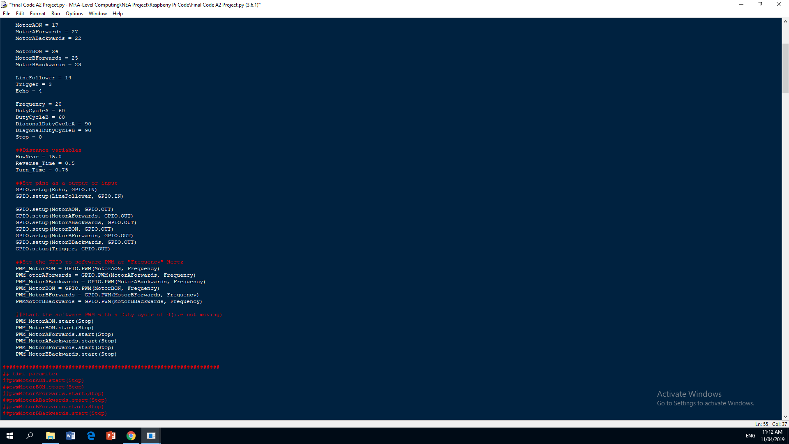

***Code After:***

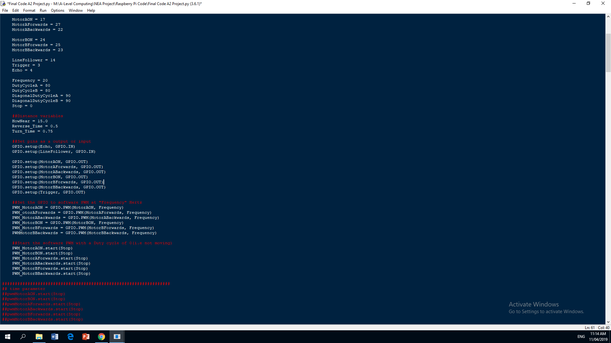

I increased the DutyCycle of the two motors by 20, as this would provide sufficient power to the motors to traverse the maze in a much faster time.

|  |  |
| --- | --- |
| Did these improvements resolve the problem? | Yes (7)  No (0) |

All seven members of the user group agreed that these improvements resolved the original problem and that they were happy with the development of the program.

***How do you want the menus to look like?***

***Does the robotic car feel that it has a quality build to it?***

***What camera quality would you expect from the robotic car to serve your needs?***

***Was the product easy to use?***

***How useful do you think this product was?***

***How much would you pay for this product?***

***Would this product solve any of your problems/needs?***

***How would you improve the look of the product?***

Iterative development of a coded solution (Max 15 marks)

**13-15 marks**

* Provided evidence of each stage of the iterative development process for a coded solution relating this to the break down of the problem from the analysis stage and explaining what they did and justifying why.
* Provided evidence of prototype versions of their solution for each stage of the process.
* The solution will be well structured and modular in nature.
* Code will be annotated to aid future maintenance of the system.
* All variables and structures will be appropriately named.
* There will be evidence of validation for all key elements of the solution.
* The development will show review at all key stages in the process.

Testing to inform development (Max 10 marks)

**9-10 marks**

* Provided evidence of testing at each stage of the iterative development process.
* Provided evidence of any failed tests and the remedial actions taken with full justification for any actions taken.

**Iterative development**

## Prototyping:

By using _eq_, I will make self.Position equal to other.Position, by using _eq_ it makes the attributes equal to each other compared to just the variable.

Here is where I created the main class called Node. I then initialised this with the attributes Parent, Position, Distance, Heuristic and TotalCost, I made all of these equal to zero.

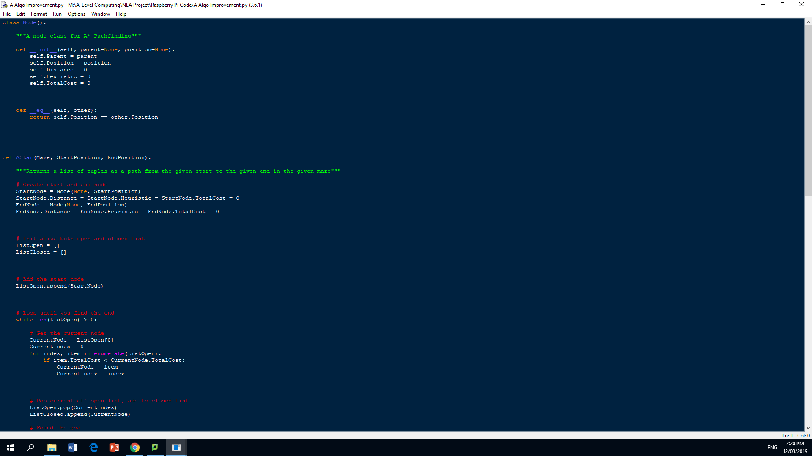

I then used a for loop as well as enumerate to go through ListOpen. This is done by using the index of the items. If the TotatlCost is less than CurrentNode TotalCost then the CurrentNode is then equal to item and the CurrentIndex becomes equal to Index as the index increases as it iterates through.

A while loop is used so that the section of code is repeated until the end has been found. You then get the CurrentNode from ListOpen by using the index, since we just appended StartNode to ListOpen it will be called at index 0. I did it like this as the program has started at the beginning node.

I then initialized both the open and closed list. This is where the nodes are appended. I then appended StartNode to ListOpen to store the places that it has travelled.

In this section of the code is where I create the start node and end node. Both the StartNode and EndNode will have their Distance, Heuristic and TotalCost equal to zero. This is so that you can change the values as the program develops.

Here is where I created the AStar function; it takes three parameters called Maze, StartPosition and EndPosition.

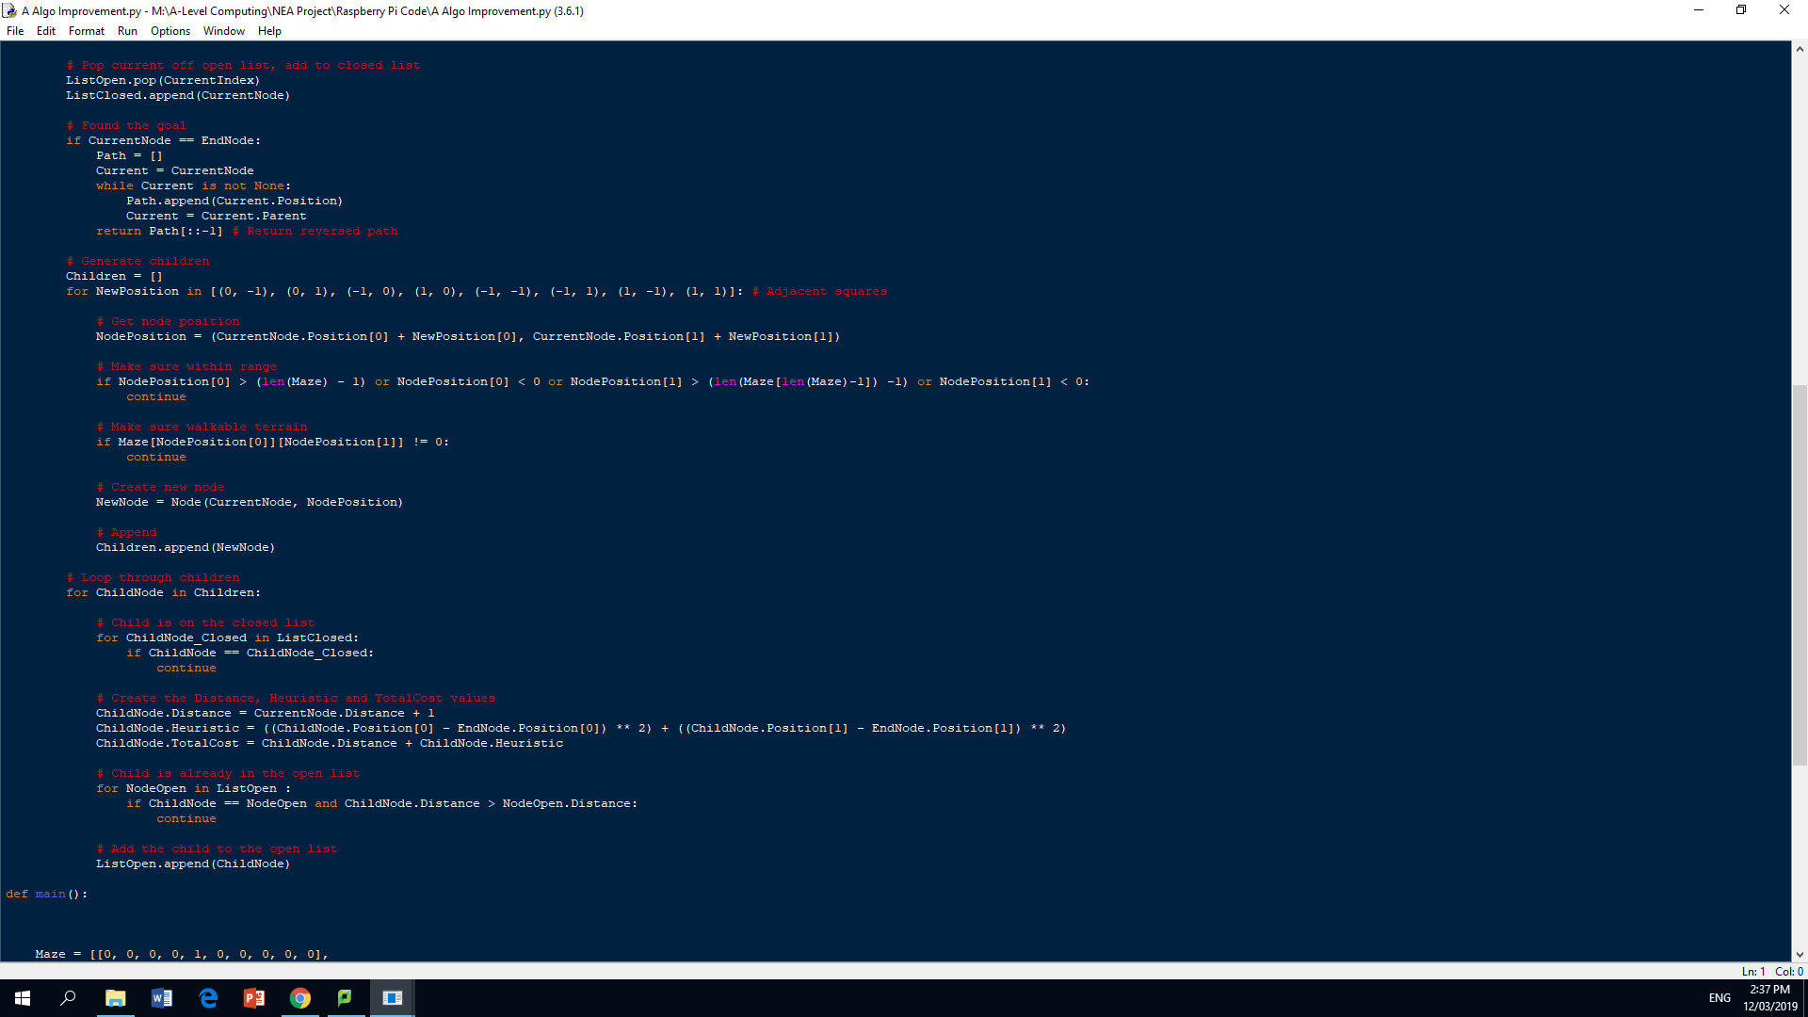

I then made NodePosition equal to the sum of the x and y co-ordinates of CurrentNode and NewPosition. To check whether the Node is within the range I check it against the length of the maze or whether the NodePosition is greater than zero.

I used pop to remove and return the CurrentIndex from ListOpen. This is done as it is the most recent node visited. You then append the CurrentNode to ListClosed.

I then used an if statement to check whether the program has found the goal. I did it by checking if CurrentNode and EndNode are equal. I then initialised the Path variable as an empty list. I then made Current equal to CurrentNode. I then used a while loop to check whether Current is empty or not. If the statement is true, the Current Position is appended to Path. I then made Current equal to Current.Parent, this is so that you know what nodes are linked to each other. The reversed path is then returned.

This section of code is where the children of the Nodes are created. To store the children nodes I created an empty list. I then used a for loop to check if a NewPosition is in the adjacent nodes. I did it like this, as I know there are eight different possible nodes that can be adjacent to the current node at any time.

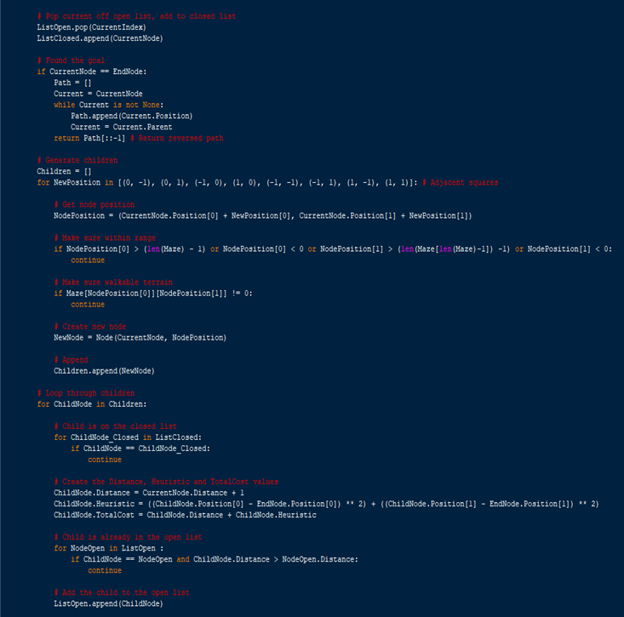

I then had to include something that checks whether the direction being taken is a walkable terrain. I did this by checking whether NodePosition at index 0 and 1 are not equal to zero. I then used continue again.

I then used a Continue statement so that if the condition is met it does not have to iterate through the rest of the for loop. This is so that it only runs the code that I need it to when a condition is met.



I then created another node called NewNode that gets the CurrentNode and the NodePosition. This is the new node you are visiting. It is then appended to Children as it is a child Node as there are parent nodes to it that the program has just visited.



The TotalCost is created by adding the Distance value and the Heuristic value together. This is done so that the program know the best direction to take.

The Heuristic value is created from taking the EndNode value from the ChildNode value for the x and y co-ordinates of their respective positions. This is to find the estimated distance between the two positions.

I then had to loop through the children nodes by using the following code, shown in the print screen below. This is to check if the Child is on the closed list. If the ChildNode is on ListClosed then it will continue with the program.

From the data collected about the nodes it is now possibile to create the Distance, Heuristic and TotalCost values of the Child Nodes.

To create the Distance value you make it equal to the CurrentNode’s Distance, this is because this value is changed as the program iterates through the program. The Distance is +1 as it is including the nodes that has been excluded from the calculation from the beginning or end.



As I have checked if the Child nodes is in the closed list, I am now checking if it is in the open list. By using a for loop and and an if statement I can check if the ChildNode Distance is greater than the NodeOpen Distance. This is so that the program knows what Node to choose from. The ChildNode is now appended to the open list.

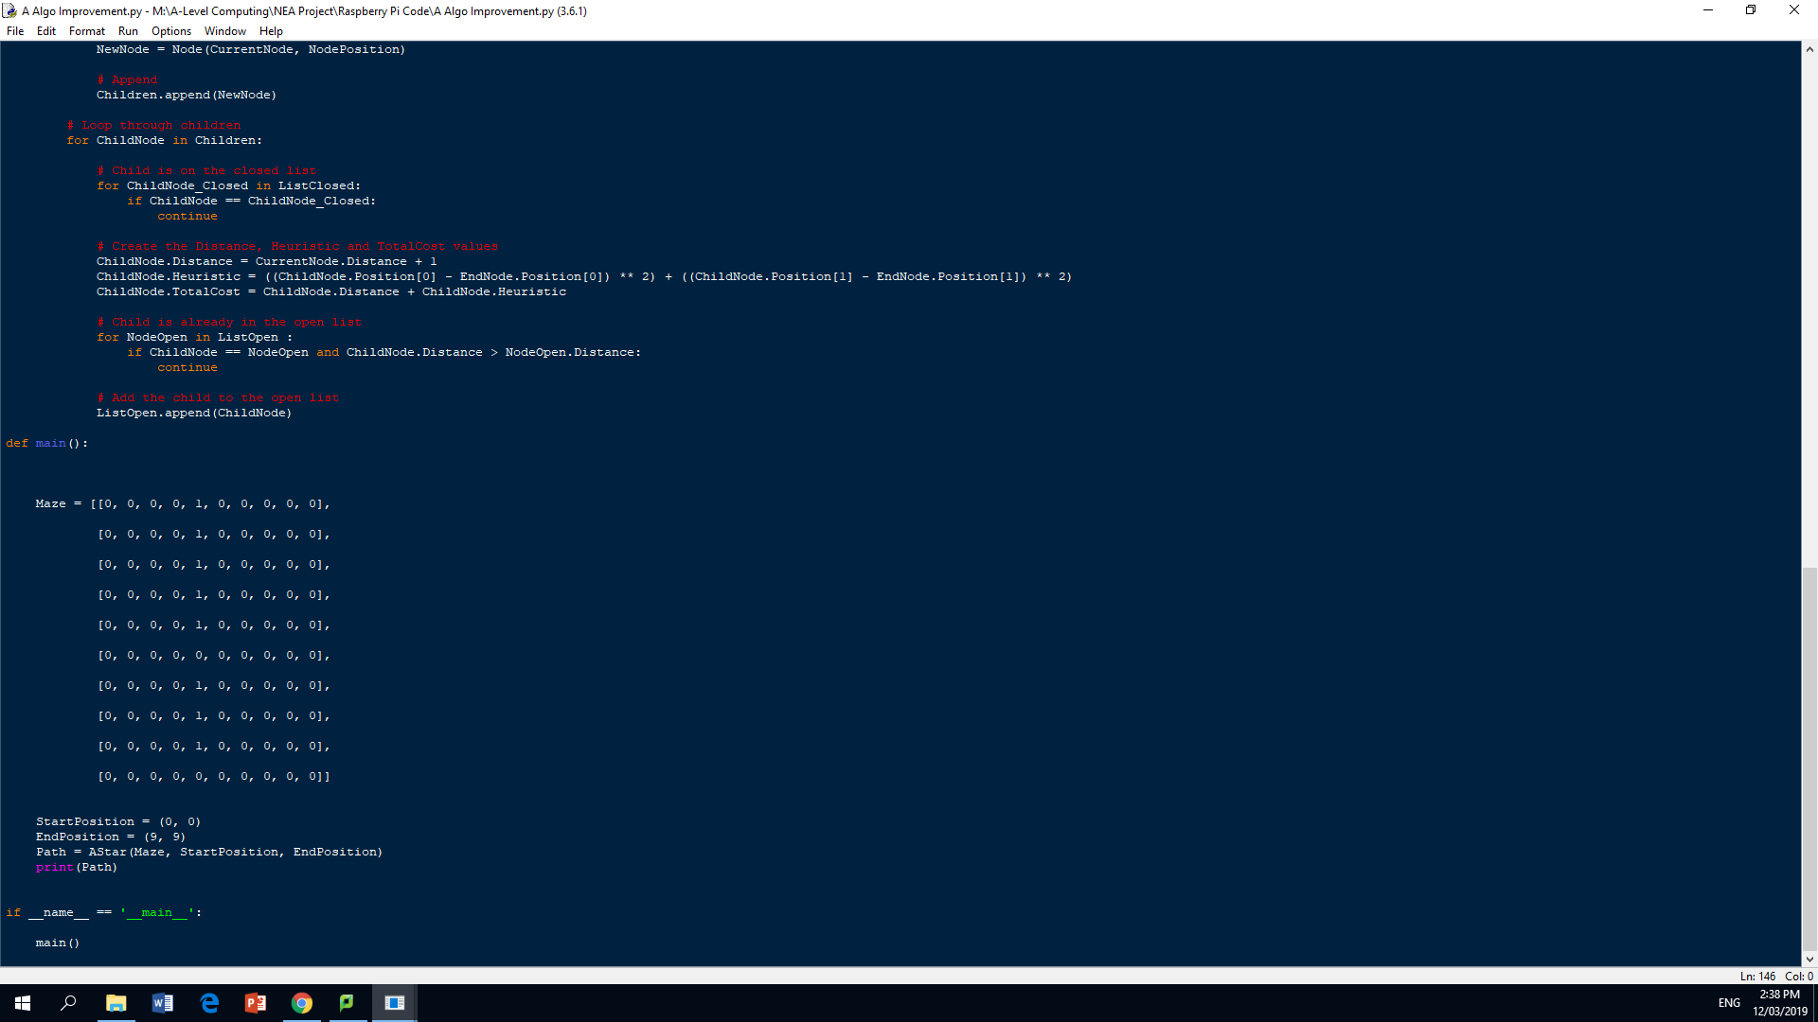

This is the main program. I created the maze being used as a 2D array. It is a 10x10 maze with 0’s representing open spaces that are walkable and 1’s representing a wall.

This section is a part of every program that follows the OOP paradigm. It is used to initialise the main sequence before any of the other functions.

This section is to initialise the StartPosition and EndPosition being used in the program. The AStar algorithm is called here, it is passed these parameters I just created. I then printed the Path that is being taken; this is what the user wanted from the user group interview.

Variables

I then set variables equal to the GPIO pin so that I would be able to understand the code afterwards because if I only used the numbers I would not know what it refers too.

This section of code is to setup the GPIO pins into the correct mode, which is GPIO.BCM. This option means that you are referring to the pins by the "Broadcom SOC channel" number; these are the numbers after "GPIO".

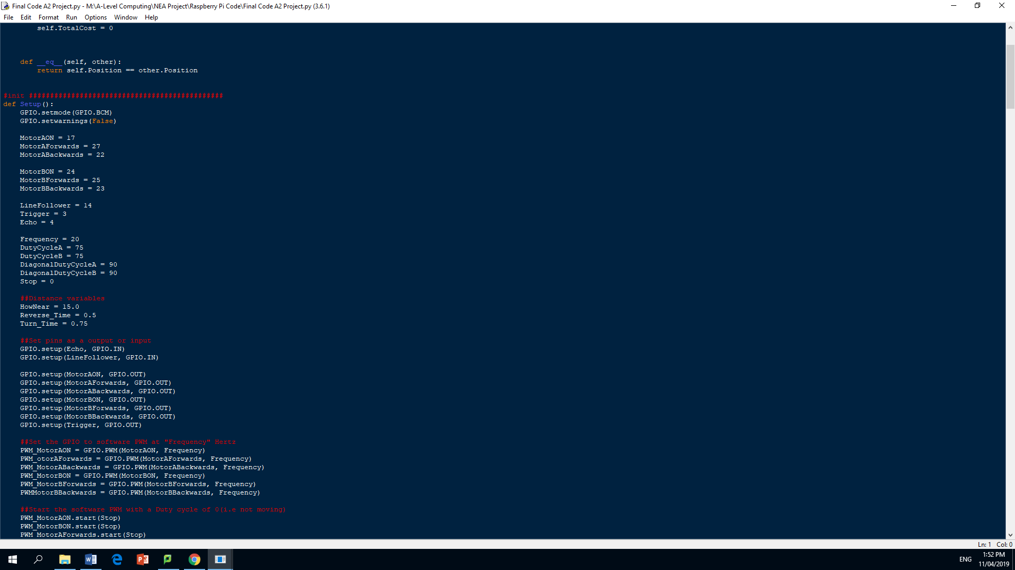

I made the Diagonal Duty Cycle greater than the normal Duty Cycle because I need the robotic car to move faster on one side compared to the other, this will create the diagonal movement of the car.

I then had to get the variables for the power and Distance initialised and setup. Like for the movement these will be constant throughout the program and will be called through various functions.

The Distance variables where created because the AvoidObstacle routine needed its own variables to control its movement when reversing and turning.

Setup the GPIO pins

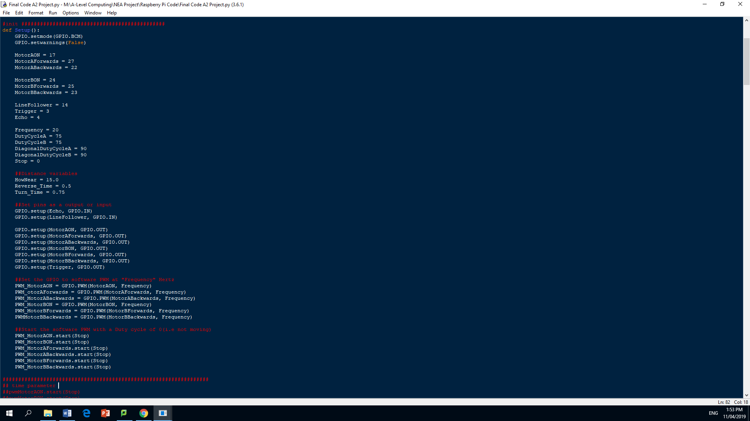

I then had to tell the Raspberry Pi what direction in which the data and power will be moving. All the pins are outputs except for the Echo and LineFollower, which are inputs.

I then set the GPIO software PWM at “Frequency” Hertz. This tells the software to switch the power on and off at the frequency given instead of being continuously on or off.

I then made the PWM variables start with the Stop variable, I did this so that the robot doesn’t accidently start when the program runs for the first time.

Distance Detector

I used a while True loop so the indented block of code is run forever, this is because we need a regular value for the calculated distance.

I then used a try and except to run through the code, this is to allow the user to stop the robotic car while the program is running.

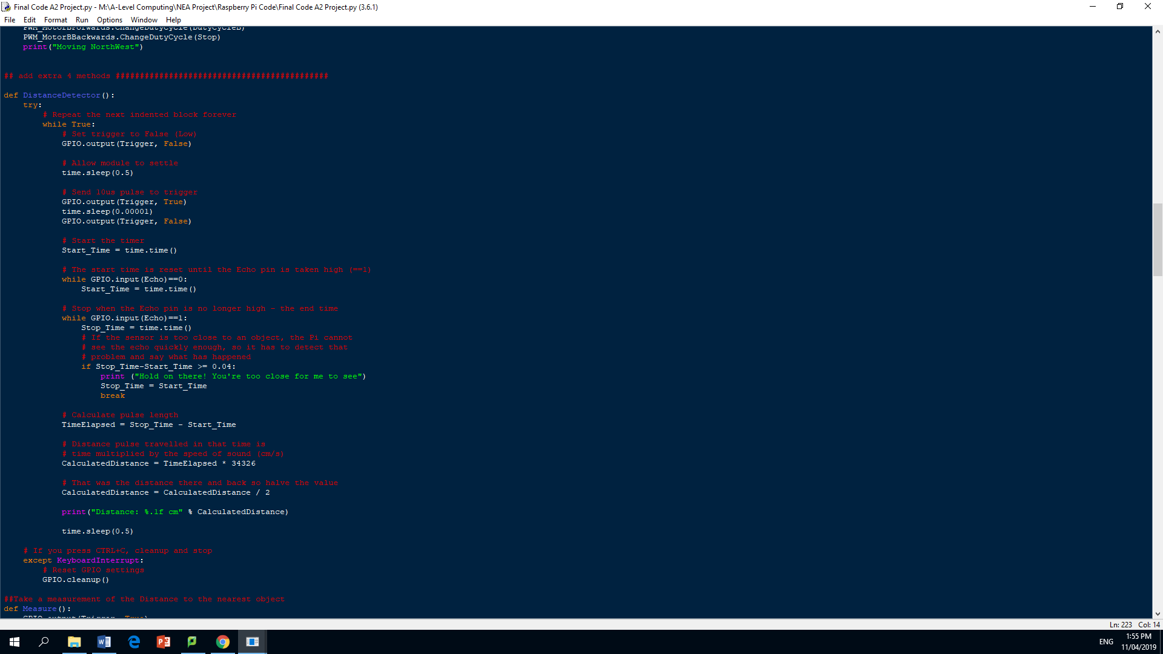

I then made the variable Start_Time equal to the time at that moment. This is taken from the time library. This is then used as a timer between when the signal was sent and when it was received.

I then let the program sleep for 0.5 seconds to settle before sending out a pulse through the Trigger. Which will then be changed back to False

I then set Trigger as False; the False in this command is equal to a low.

I then used a while loop to reset the start time until the Echo pin is taken as high, this means that the program is waiting until a signal is received before continuing

This is another while loop which is being used to stop the timing of the system when the Echo pin is no longer at high, this means that it has received the Echo is no longer picking any pulses up. I then created an if statement that is used if the robotic car is too close to the object and that it cannot seen the object in its way. It will then print any error message to the screen to inform the user. The Stop time is then made equal to the Start time so that the process can continue.A break is used to then exit that statement.

To calculate the pulse length, the time between sending and receiving, I have to minus the Start time from the Stop time, this was then assigned to the variable TimeElapsed.

To calculate the actual distance travelled in that time of sending and receiving the pulse, I will be multiplying the variable TimeElapsed, which is the time between sending and receiving the pulse, by the speed of sound. I am able to use the speed of sound as the pulse utilises ultrasound which also travels at the speed of sound. The speed of sound is given a value of 34326 cm/s. I used this value as I am working in centimetres with the distances.

I will then have to divide the CalculatedDistance by two as this is the distance travelled by the wave going there and coming back. By dividing by two it will give us just the distance to the nearest object. I then assigned this value back to CalculatedDistance. I then printed a message to the user to inform them of the distance to the nearest object.

Measure/isnearobstacle function

This function operats very similair to the Distance Detector, but this function returns the CalculatedDistance so that other functions and procedures are able to use that value.

I started this function by initialising all the variables that I would need to use. Like the Distance detector function I will start by outputting something from the Trigger pin. In this case I start by outputting a True value and then making it equal to a False value. I then made the variable Start time equal to the value of the time using the time library. I also made Stop Time equal to Start Time so that they cn be changed later on.

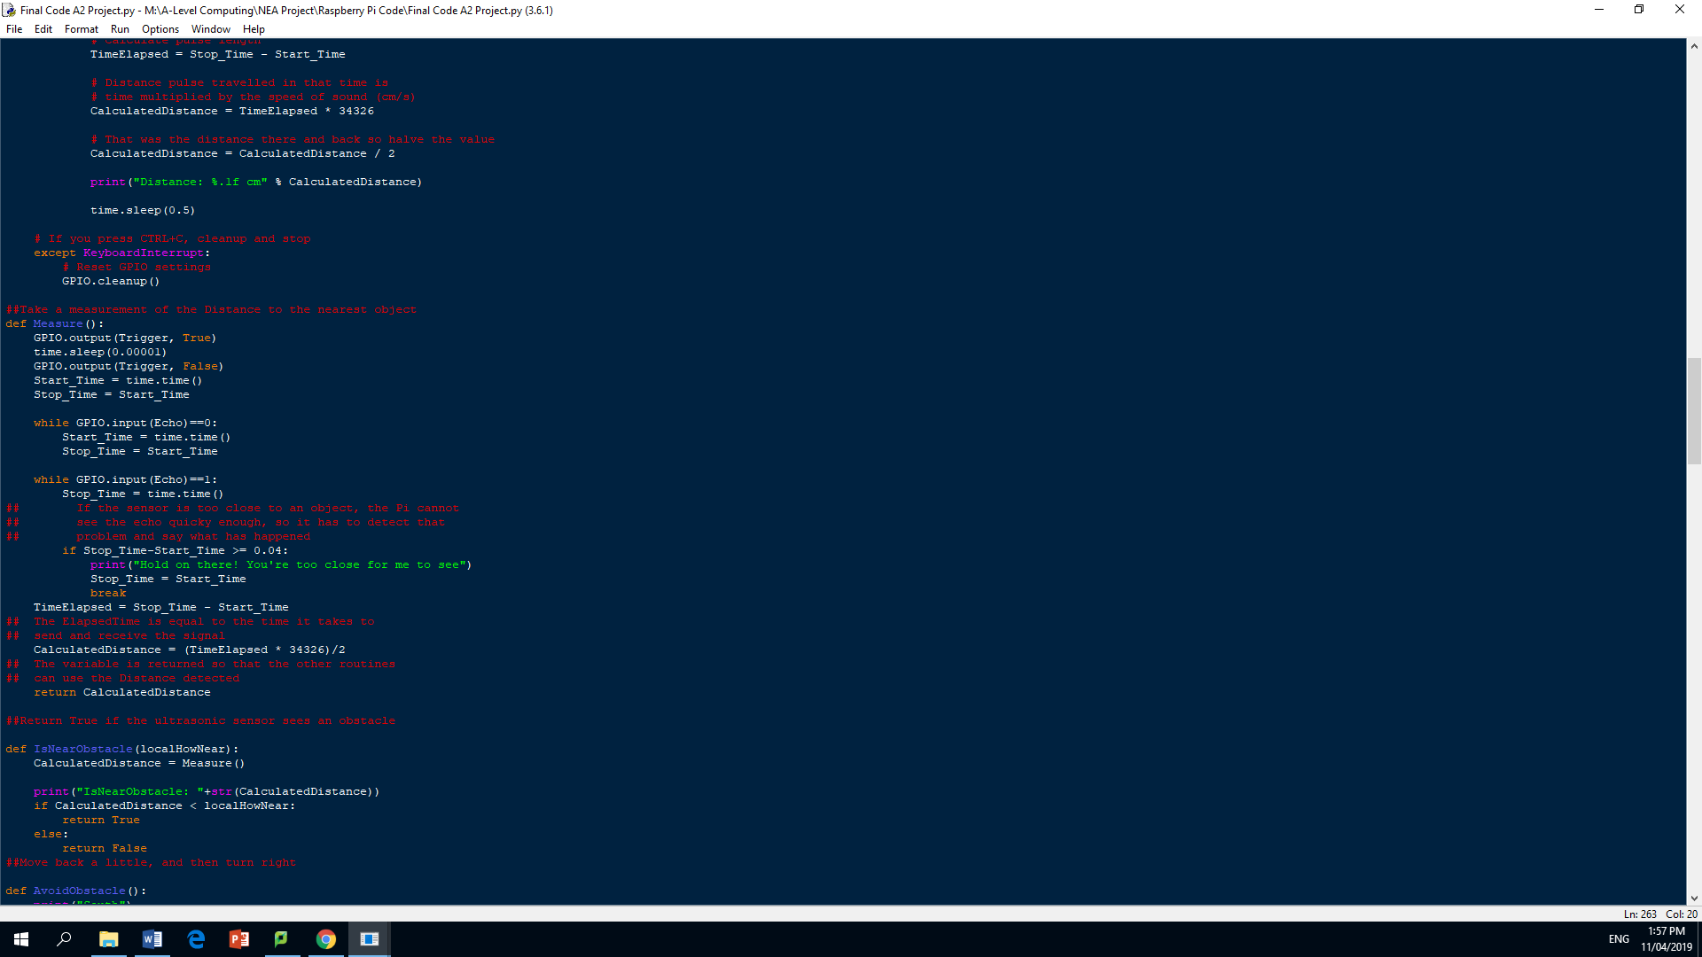

The IsNearObstacle function uses a local parameter which is local HowNear. In this function it calls the Measure function, and because I returned the CalculatedDistance I then assign it to itself in this function as well. I then print a message to the user’s screen, informing them on how close the robotic car is to and object.

I then used an if statement to check if the CalculatedDistance is less than the local HowNear, this is a constant that the program compares the measure values against to know whether an object is determined as to being too close. It does this by returning a Boolean value.

AvoidObstacle/IsOverBlack function

For the AvoidObstacle routine it will call other functions, these are the movement functions that are used to manouvre around an object in its way. It does this by reversing and then turning right,this is so that when it moves forwards its not in the same direction that it has just moved from.

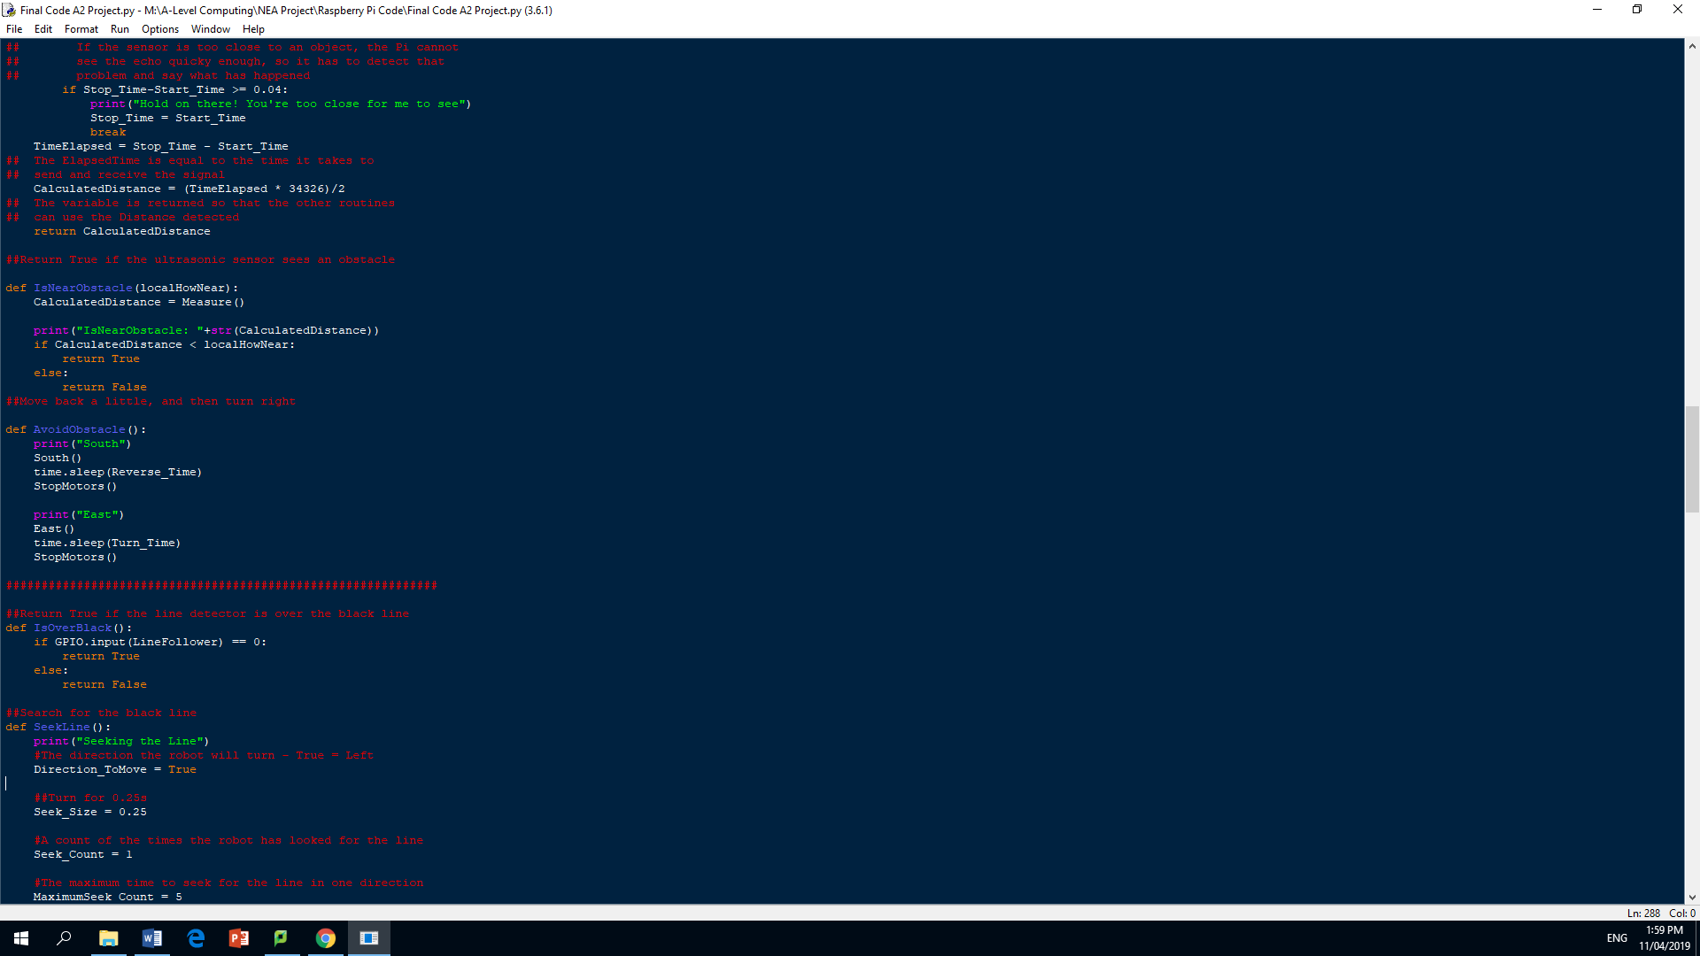

This function checks whether the line detector is over a black line, this is done by returning a Boolean value.

SeekLine function

The seekline function is used to search for the black line when the robotic car has lost it. I then use a Boolean value for the variable Direction_ToMove, this variable is self-explanatory as it describes the direction to search in. By using the Seek_Size constant, it knows to turn for 0.25 seconds. A count is then used to check how many times the robot has looked for the line. The variable MaximumSeek_Count is used to limit the amount of time the robot searches in a particular direction. I did this because it will stop the robot for searching for the black line when it is not their or cannot be found.

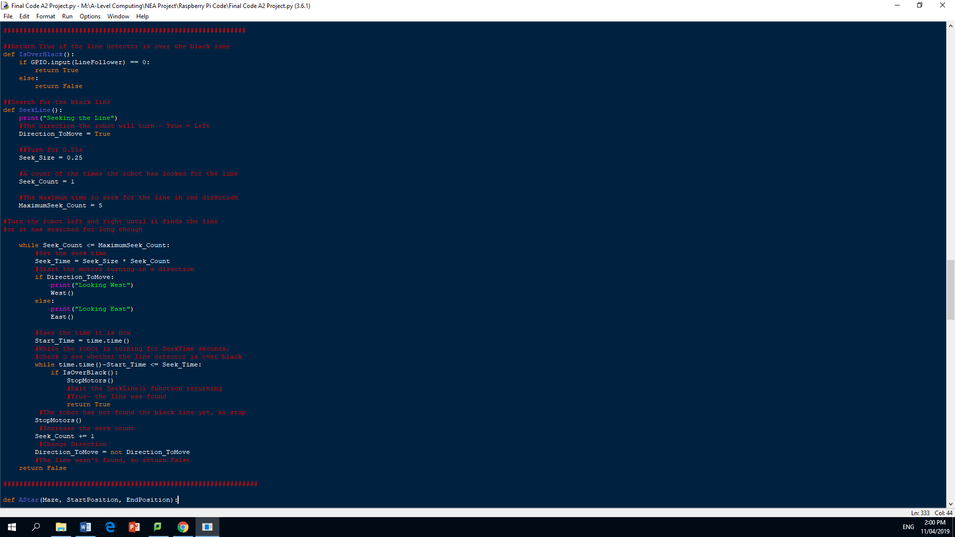

I used a while loop that runs when the Seek_Count is less than or equal to the MaximumSeek_Count, this is so that the section of code only runs if there is still enough time to find the line.

Within the while statement the Seek_Time is set by multiplying the Seek_Size by the Seek_Count. Inside the while statement an if statement is used to start moving the car in a direction. The Start_Time now becomes equal to the time taken from the time library.

I then checked if the time elapsed from the Start_Time and the current time is less than or equal to Seek_Time, this informs the program whether it has been searching for the black line long enough for the program to give up.

You then exit the Seekline function returning a True if it has detected the black line by using the IsOverBlack function, the motors are also stopped.

If the robot has failed to find the black line in time then stop the motors and increase the count by one and change to the opposite direction, this is so that the robot can now start to search in the other direction. The function will then return a False, as it has not found the black line.



The function Moving Cars

MovingCar function

For this function I used a try and except statement to calculate what directionn to take once the program knows the quickest route to the destination point. I then passed it the parameters of path, StartPosition and EndPosition.

I start by setting up some of the variables that I'm using to work out the positions of the route being taken. I do this by making the StartPosition equal to the CurrentVector and PreVector. I then initialised a variable called NextVector and count. I then printed a message to inform the user of the estimated number of turns needed to solve the maze.

In the ty statement I used a if statement that checks if something is within the path. If there is and the count is less than the length of the path then program calculates the correct direction to take.

Here I make the NextVector equal to the value of path at an index of count plus one, this is so that as the count increases later on in the for loop the NextVector changes to the adjacent value in the path list.

The variable X_coordinate is the x-coordinate of the NextVector and the variable Y_coordinate is the y-coordinate of the NextVector. This is so that I can use these values iother calculations.

I then made a variable called NewNextVector equal to path at an index of count plus two becuae this is the next position from the variable NextVector.

I did the same as before for the NewNextVector where I got the x and y coordinates of that position.

I then made a new variable called X_Direction and Y_Direction which is equal to the New(X/Y)_coordinate – the (X/Y)_coordinate. This is done as what is eft tells you what direction it is going. If a one is left then it is moving forwards, if it s a minus one then it is moving backwards etc.

I then used an if and elif statements to program all the possibile directions to a function controlling the movement, this makes for accurate control of the robotic car.

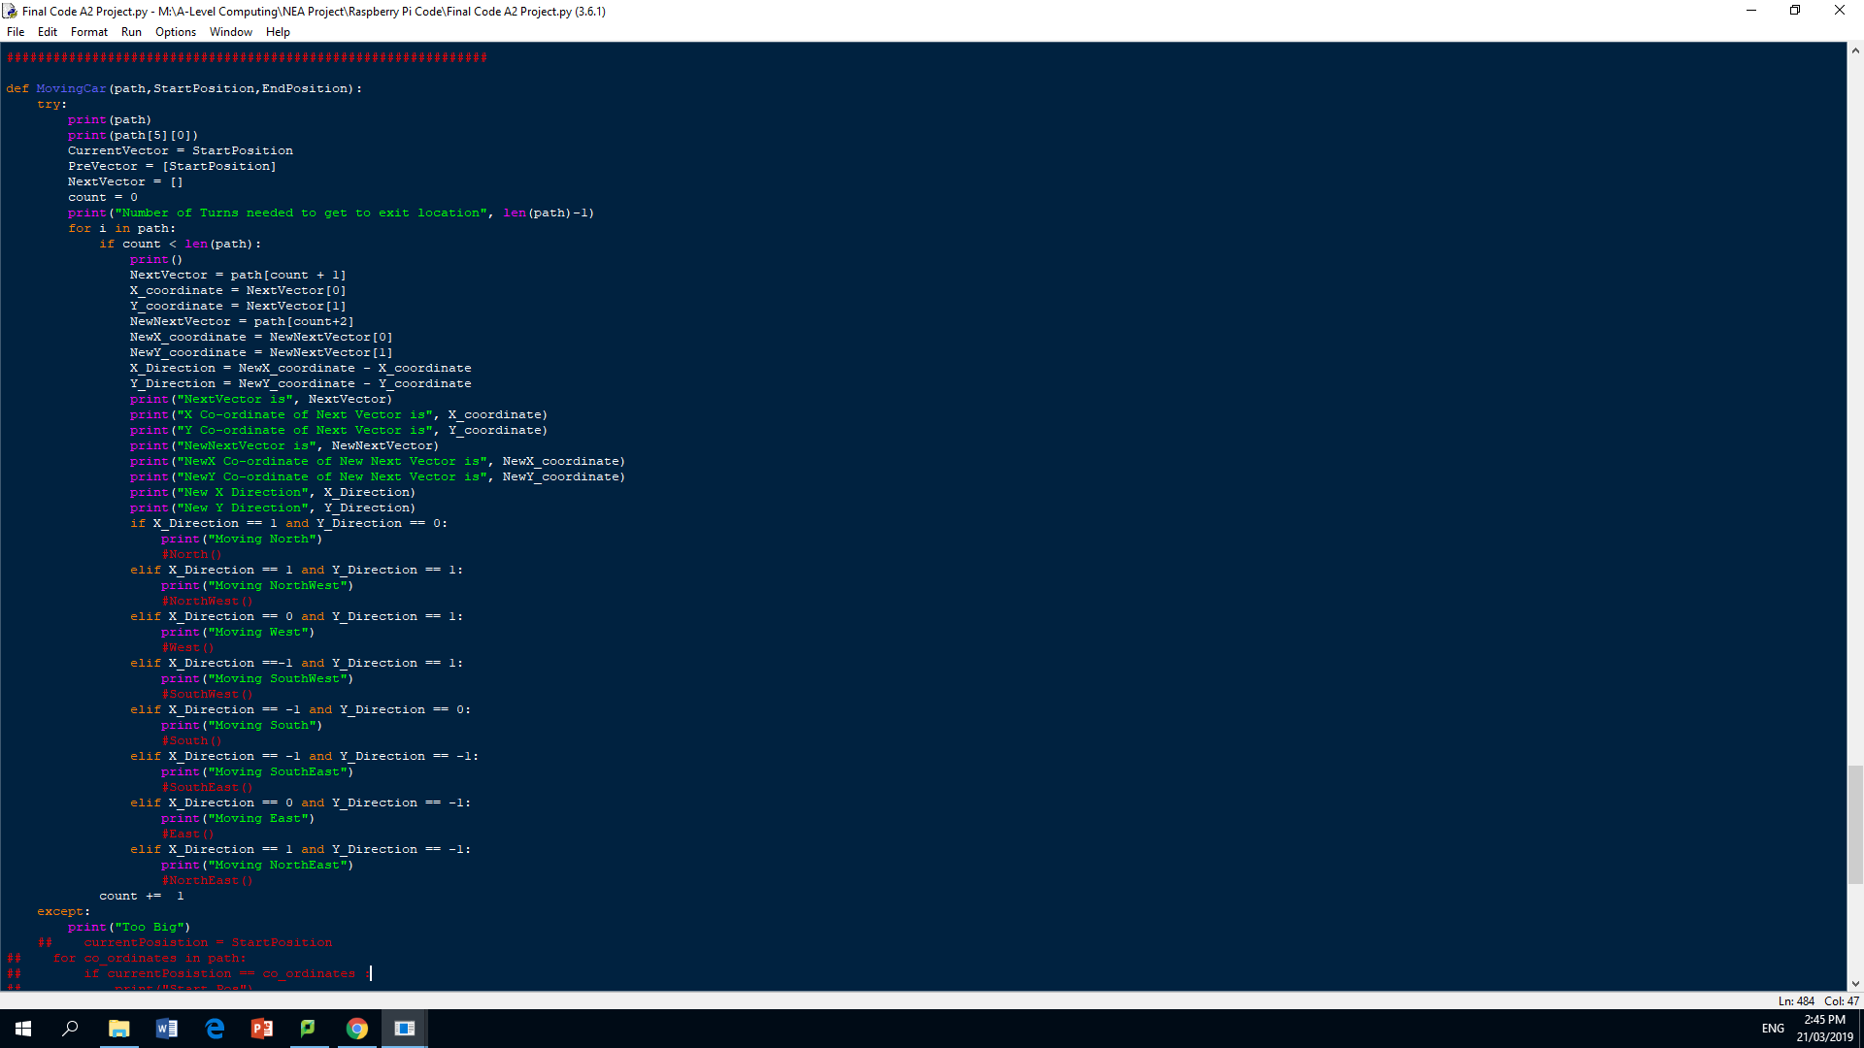

**Print screens**

**Validation**

**Try-except**

**Testing**

**Maze random generated**

**Reviews**

**Wirelessness**

**Added Maze Simulation**

Evaluation (Max 20 marks)

Testing to inform evaluation (Max 5 marks)

**5 marks**

* Provided annotated evidence of post development testing for function and robustness.
* Provided annotated evidence for usability testing.

Testing

Evaluation of solution (Max 15 marks)

**13-15 marks**

* Used the test evidence to cross reference with the success criteria to evaluate the solution explain how the evidence shows that the criteria has been fully, partially or not met in each case.
* Provided comments on how any partially or unmet criteria could be addressed in further development.
* Provided evidence of the usability features justifying their success, partial success or failure as effective usability features.
* Provided comments on how any issues with partially or unmet usability features could be addressed in further development.
* Considered maintenance issues and limitations of the solution.
* Described how the program could be developed to deal with limitations of potential improvements / changes.
* There is a well developed line of reasoning which is clear and logically structured. The information presented is relevant and substantiated.

**Testing**

**Usability features**

**The Degree of success in meeting the original Success Criteria:**

After having completed the system, I can conclude that I have met all of my requirements that I created in the design section using my user group’s opinion. While I have met all of my requirements, there is one in particular that does not function as well as it should, this is the criteria for storing and travelling the correct route. I refer to the requirements as those laid out in the analysis and design sections, these are the success criteria that I stated in that section that include the original requirements along with the variable requirements created from the second interview with the user group. The requirement was not met that well due to my lack of foresight when designing the way in which the robot will move. This is because the robotic car needs a program that would re-align the robot after every move, so that the direction the program is instructing the robot to take is correct. What causes this problem is that the previous movement direction may affect the new movement direction being taken as the robotic car is in a new place with a new direction instead of facing in the same direction that it was at the beginning. This problem is encounter as I programmed the robot with the assumption that the robotic car’s movement is relative to it always facing the same direction that it enters the maze in, which is north. This is so that the movement is consistent throughout. However, what I did not think of is that the instructions provided to the car is relative to it facing north, however if it is facing a different direction then the movement will be wrong. But this is only evident in very rare cases where the mazes require a lot of movement to solve, those that were used in my testing phase worked as intended as this effect didn’t come to fruition as the complexity was beyond what was necessary.

I only realised that this may be a problem when I was working through the logic of the system, the user group did not notice the problem when I was developing my code. While this is a problem, I do not believe that it is severe enough for me not to meet the criteria as I have interviewed the user group after I have developed the system and their replies suggest that it does meet their requirements as it only occurs for very complex mazes. My users, after having accepted my limited success in one of the criteria’s, unanimously agreed that the program has met all of the other requirements fully. The evidence for this is seen in the end-user testing section where the user’s responses are analysed. I am now going to discuss how each objective of the success criteria was successfully met.

|  |  |
| --- | --- |
| Requirement | Explanation of the Requirement met |
| Be able to solve the maze | The requirement was met as the robotic car was able to solve the maze by successfully traversing the maze from the entrance to the exit. The testing I went through showed that it worked correctly as it found the exit. |
| Be able to find the quickest way | Using the A* Algorithm which uses heuristics as a method to estimate distances, the program is able to find the quickest way as it does a series of calculations. I know the route given to the user is the fastest because I have traced through the program myself and have confirmed that the program works as intended, which meets the user requirement. |
| To be able to store all the data and print the route to the user | The data is stored in the Raspberry Pi along with the optimal route to take, this is evident in the screenshots of the information outputted to the user in the development phase. It shows all the data collected as well as the route taken. This meets the user requirements. |
| To be able to continue until the exit is found | The program was able to continue until it has found the exit, this was evident in the testing. However there needs to be a black line at the base of the maze to keep the robot aligned with the movement. But if there is a black line then it will meet the success criteria as it will continue until an exit is found. This meets the user requirements. |
| Avoid any objects in its way (collision detection) | This requirement was met as the robotic car tries to manoeuvre around the object in its path. It does this by utilising the distance detector and the movement functions. It does this for any object in its way. |
| Be able to be controlled by the user (phone or tablet) | By using SSH I can use that connection over the internet to control the movement and operations of the robotic car. While the user doesn’t control every aspect of the car, it does have control over what programs are run and when to exit a program. This is what the users wanted, so the requirement has been met. |
| Output the data on the user's phone or electronic device | The data is outputted to the user’s screen by using the same SSH connection that is used to control the robotic car. This meets the user requirements. |
| Move (Forwards/Backwards) | The robotic can move both forwards and backwards easily with varying power that can be altered from the source code, this is done by turning the power supply on and off at a certain frequency to provide a certain amount of power. This meets the user requirements. |
| Turn (Left/Right) | The robotic can move both left and right easily with varying power that can be altered from the source code, this is done by turning the power supply on and off at a certain frequency to provide a certain amount of power. By providing power to one side of the car and none to the other, it will produce a turning effect. This meets the user requirements. |
| Diagonal Movement | The robotic car utilises the same logic that turning left and right does, however for diagonal movement I would supply some power to one side of the car but more on the other. This meets the user requirements. |
| If collided with object, has it tried to correct its course | This requirement has been met as it will try to reverse when it has collided with an object, it will then try to search for the black line where it will continue traversing the maze. |
| It is able to follow the black line using the line follower | This requirement was met as the robotic car can follow the black line, this was evident in my testing as it can detect the black line and can use the movement function to stay aligned. |
| 8 Gb Memory | I expanded the Raspberry Pi memory capacity by using a SD card. This meets the user requirements. |
| Ultrasonic Distance Detector (Greater than 100cm Range) | I used the HC-SR04 Ultrasonic Distance Detector given in the Raspberry Pi starter kit. This meets the user requirements. |
| Find the shortest route to the exit | The shortest route is also the quickest route as there is no terrain or traffic that would change the calculation; therefore it already has been already achieved. This meets the user requirements. |
| Print the outputs to the user screen | All the necessary outputs that the user identified in the design section have been successfully printed to the user’s screen whilst the program is being run. This is evident in the print screen section. This meets the user requirements. |
| Print the Distance, Direction and Path Taken to user screen | The Distance, Direction and Path Taken have been successfully printed to the user’s screen whilst the program is being run. This is evident in the print screen section. This meets the user requirements. |
| Build a durable frame for the Robotic Car | The robotic car is built on a plastic and metal chassis that would provide adequate protection to the Raspberry Pi and other components from damage. |

**Maintenance**

<See H446-03 Project Advice Booklet for help and guidance of what must go here.>

## Systems diagram

# C. Developing the coded solution (“The development story”)

<See H446-03 Project Advice Booklet for help and guidance of what must go here.>

# D. Evaluation

<See H446-03 Project Advice Booklet for help and guidance of what must go here.>

# Project Appendixes

Insert as many project appendixes as you need for your project.

These might include, but are not limited to:

* Complete Code Listing (ESSENTIAL)
* Interview Transcripts
* Meeting notes
* Observation notes or questionnaires

At the beginning of the development of the robotic car, I encountered a problem that slowed the initial pace of the project significantly. While I was developing the project, I would use a pair of batteries to power the four electric motors. After I had finished, I would leave the batteries inside the pack which you could switch on and off from a switch on the outside. On one of the days, I forgot to switch the battery pack, which meant the batteries were drained. I was unaware of this, so I thought the problem lied elsewhere, which meant it took much longer than it should have. I tried many things to fix the problem; I tried replacing the Raspberry Pi, the power cables and the wiring. Here is a picture of how I re-did the wiring.

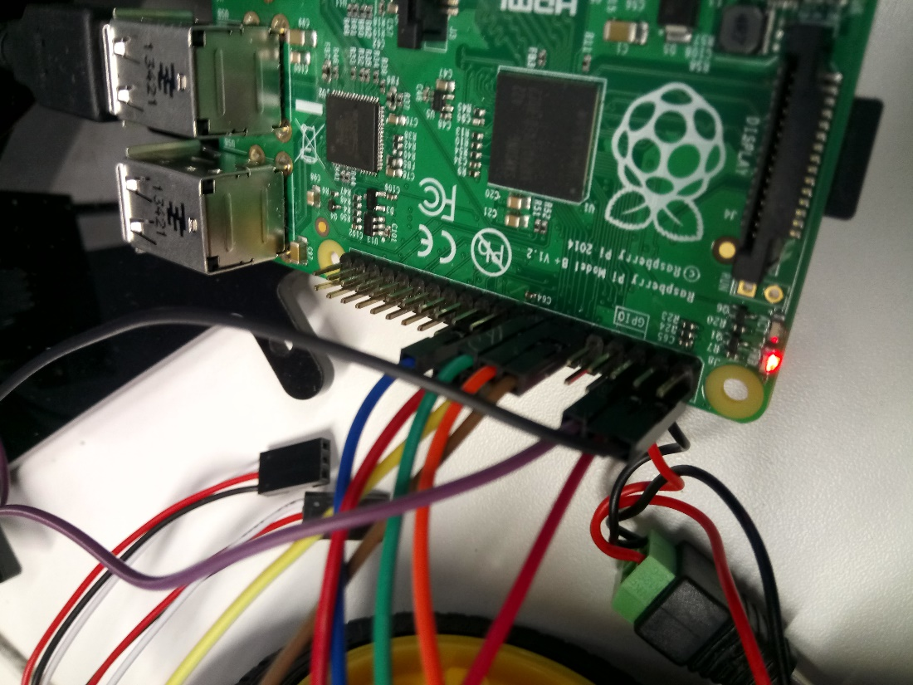

I found the cause of the problem when the power provided to the motor was not enough to move the wheels fast enough. When I checked the power left on the batteries on the battery charger, I found that one battery had no charge while the other had enough charge. This was strange as the charge on the batteries should have been lost at the same rate. I did not understand why this was, so I put it down as the battery being used before, I used it in the robotic car.

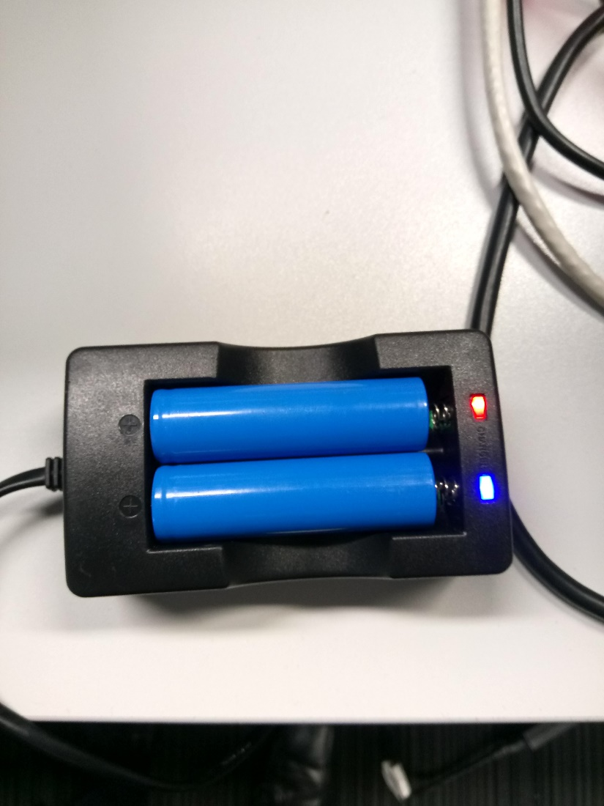

I then checked the voltage across the two batteries by using a Multimeter. The voltage across the batteries showed that the battery charger was right, and that only one battery didn’t have enough charge.

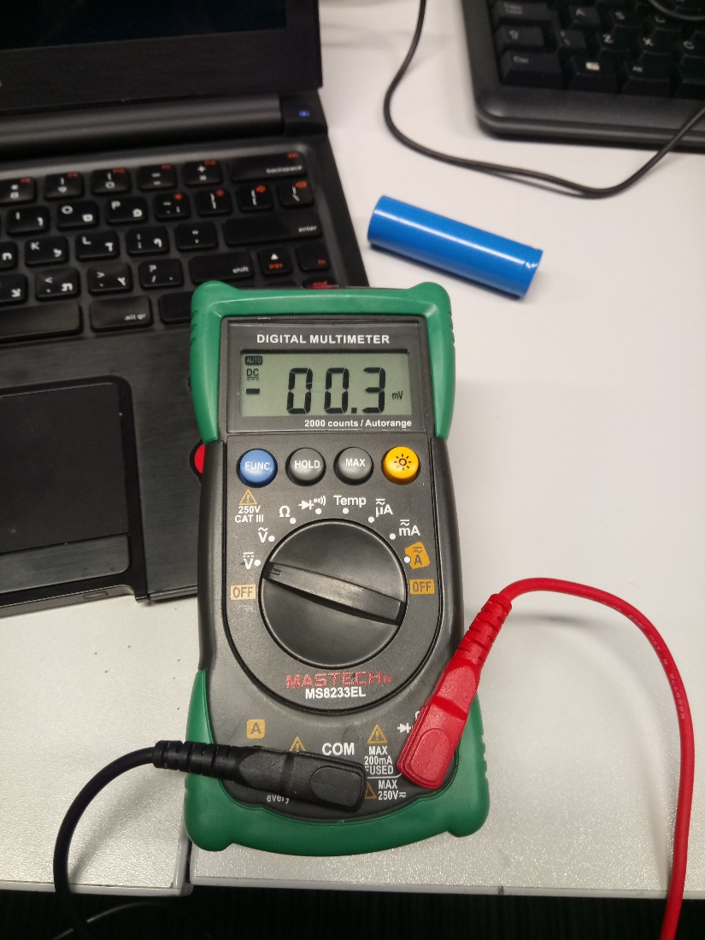

Here is the voltage across the battery that had enough charge to move the motors. It was 3V, which would have provided enough power.

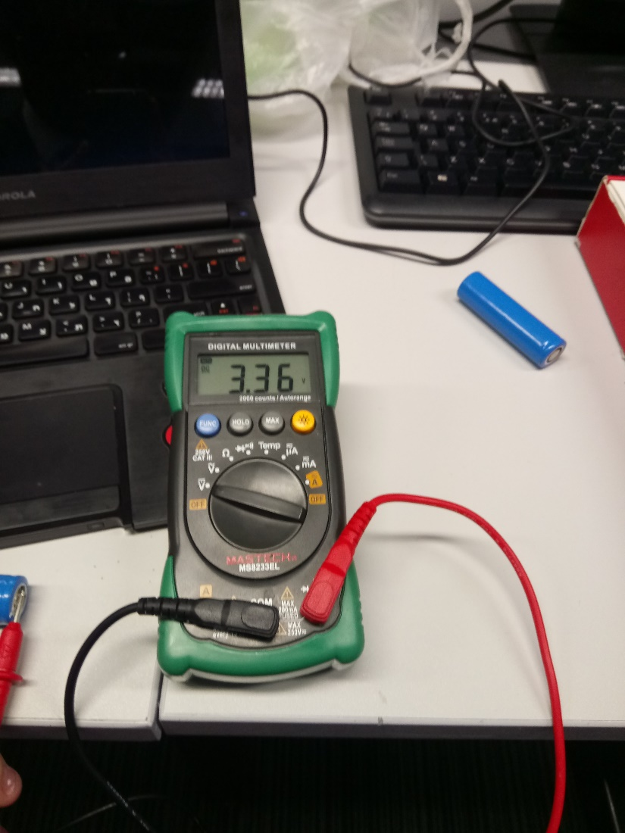

I then decided it was best to scrap the 3V batteries and instead use a 9V battery that is directly connected to the Raspberry Pi. These would be rechargeable that could be easily replaced to provide the most power to the motors.

